**QUANG BINH PROVINCIAL PEOPLE’S COMMITTEE**

**QUANG BINH DEPARTMENT OF AGRICULTURE AND RURAL DEVELOPMENT**

**\*\*\*\*\*\*\*\*\*\*\*\*\*\*\***

**FINAL REPORT**

**ENVIRONMENTAL & SOCIAL   
IMPACT ASSESSMENT**

**SUB-PROJECT: REPAIR AND REHABILITATION   
PHU VINH RESERVOIR, DONG HOI CITY**

Project: Dam Rehabilitation and Safety Improvement Project

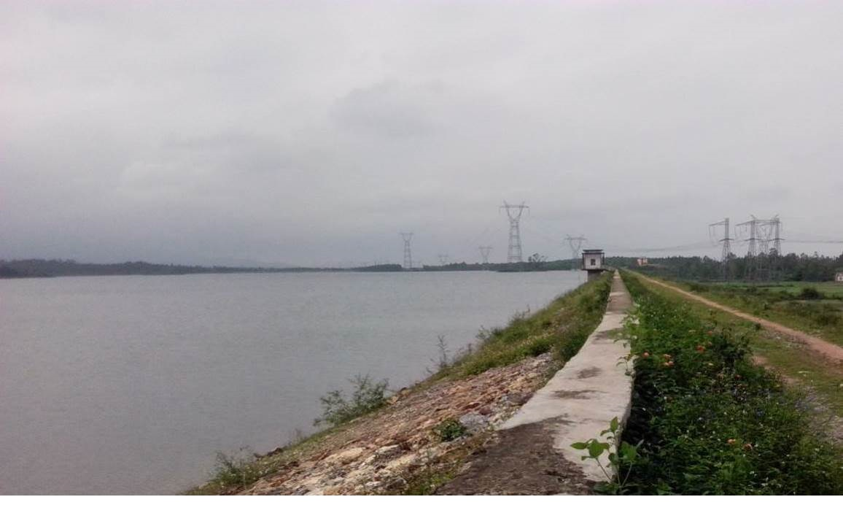

**QUANG BINH, –OCTOBER 2019**

**QUANG BINH PROVINCIAL PEOPLE’S COMMITTEE**

**QUANG BINH DEPARTMENT OF AGRICULTURE AND RURAL DEVELOPMENT**

**\*\*\*\*\*\*\*\*\*\*\*\*\*\*\***

**FINAL REPORT**

**ENVIRONMENTAL & SOCIAL   
IMPACT ASSESSMENT**

**SUB-PROJECT: REPAIR AND REHABILITATION   
PHU VINH RESERVOIR, DONG HOI CITY**

Project: Dam Rehabilitation and Safety Improvement Project

|  |  |
| --- | --- |
|  |  |

**QUANG BINH, OCTOBER 2019**

# EXECUTIVE SUMMARY

***1. Background:*** The Repair and Rehabilitation of Phu Vinh Dam is one of the 12 sub-projects identified for the funding during the first year implementation of the World Bank-funded Vietnam Dam Rehabilitation and Safety Improvement Project (DRSIP).Phu Vinh reservoir is located in Thuan Duc commune and Dong Son ward, 7km from Dong Hoi city in the West. The reservoir was built in 1992 and has not been repaired or upgraded. The catchment area of the reservoir is 38 km2, water storage capacity is approximately 22 millions cubic meters at normal water level. The headworks and auxiliary works of the Phu Vinh reservoir consist of the following:

* *Main Dam***:** it is a homogeneous earth dam with the maximum height of 27.6m, length of 1776 m. DamCrest elevation is at + 24.2m; width is 5.0m
* *Left auxiliary dam*: A homogeneous earth dam with the maximum height of 28.8m, length of 1259 m. Crest elevation is at + 25.4m; width of 6.0m
* *Right auxiliary dam*: A homogeneous earth dam with the maximum height of 28.9m, length of 400 m. Crest elevation is at + 25.5m; width of 5.0m
* *Spillway:* Spillway width Btr = 18.0m; covered by reinforced concrete; with chute and energy-relief tank; Qx1% = 380m3/s.
* *Outlet works*:areinforced concrete structure,located on the left side of the main dam; dimension B × H = 1.2×1.6 m. It is box sewer with regulator tower gate in upstream

***2. Due to long time operation***, the construction has seriously degraded. The recorded problems includes: (i) Upstream surface of the main dam has been degraded and sunken at many sections, creating many concave-convex areas and even some parts have been peeled off; (ii) downstream water drain ditches are degraded and damaged at many sections; (iii) Outlet works are leaked, pressured open/close motor is degraded, poses the danger in operation. That is a main reason why outlet works don’t gain the original design water volume and don’t supply enough water for irrigation areas. Concrete layers of inlet body are peeled and calcified. Therefore, it is necessary to build a new outlet works; and (iv) Spillway: stream directing wall has cracked and broken; some points on concrete ramp have stripped; flip lips to emergency valve have been damaged severely. Although several facilities had been reinforced, but many items from the work have been degraded, water reservation capability is low, and unsafely during the operation process may happen. If the dam is failed in flood season, the lives of people and existing infrastructures in the socio-economic centre of Quảng Bình province would be destroyed.

***3. Description of the project:*** The main purposes of rehabilitation and upgrading are: (i) to ensure the safety and stability of the dam and reservoir; (ii) to enhance the flood-prevention function of the dam for the city of Dong Hoi; and (iii) to supply irrigation water to the 1672-ha agricultural land and domestic water to the people of Dong Hoi city at a capacity of 18,000 m3/day.

The proposed structural works include: (i) repair and rehabilitation of the main dam expand the dam crest width from 5 to 6 m, raise the height 0.8 m, crest elevation will be changed from 24.2 to 25 m, replace weathered materials and broken lining layer of dam faces, build drainage systems for dam faces etc.; (ii) construction of a new inlet structure; (iii) the repair and strengthening of the the main channel with reinforced concrete; (iv) the rehabilitation of the lifting system and bulk heads of the spillway; and, (v) the installation of a new lighting system on the top of the main dam.

***4. Environmental and Social Screening***. There are no critical natural habitats near the dam and the area is not known to living habitat for any rare or endangered species. The local population is 100% Kinh people which is the mainstream ethnic linguistic group in Vietnam. The Dam is categorized as large dam and therefore subjected to review by a Panel of Expert. There are no grave, temple or any culture, belief, religious structures affected in the project area. The repair works will use a total of 6.78 ha of lands, about 1.2 hectares of which belong to private households; hence a Resettlement Action/Compensation Plan (RAP) was required. The sub-project is a Environmental Category A as per World Bank OP/BP 4.01.

***4. Environmental and Social Impacts.*** The subproject will bring in considerable benefits to local community, such as: (i) a stable and reliable irrigation and domestic water supply; (ii) improved dam safety, protecting infrastructure, lives, livelihood and property downstream of the dam; and, (iii) improved landscape in the dam headworks area.The following are the negative impacts:

***6. Loss of lands and crops*** - The land acquisition will affect seven (7) households who will lose a total of 1.2 hectares of agricultural land. No houses or residential lots will be affected. The affected households will be compensated and supported sufficiently in accordance with the RAP which was prepared in accordance with the World Bank Involuntary Resettlement Policy (OP/BP 4.12).

***7. Impacts of construction activities***– The repair works will involve significant excavation (176,000 m3) and embankment filling works (18,500 m3). An existing burrow pit/ embankment material source within 2 km from the dam has been identified to serve the sub-project needs. Surplus excavated materials and construction spoils will be dumped in a designated disposal area about 1.5 km from the site. About 40 workers will be mobilized at the peak of construction activities. The impacts of these activities would likely include the following:

* Temporary increased in sedimentation of the waterways during rainy days due to earthmoving activities
* Increase in dusts, nuisance within the construction site and along construction routes
* Increase in noise levels within the construction site
* Possible interruption in water supply during the repair works
* Possible damage of existing roadways due to heavy equipment traffic particularly the hauling of embankment materials
* Increase health and safety risks among local residents near the dam and along construction routes due to exposure to construction-related hazards; and,
* Occupation health and safety concerns for the workers.
* Increase of fertilizer and pesticide due to rehabilitated of irrigation area from 1,672ha up to 2,825ha (up by 1,153ha) during operation phase.
* Possible downstream impacts related to the increased designed water column at the spillway.

The amount of domestic wastes (i.e. wastewater and solid waste) will not be significant (solid waste: 6–20kg per day; waste water is 8.42 m3/day) but these would require standard containment (i.e. septic tank, soak pit), collection and disposal (i.e. solid wastes to the landfill).

***8. Long term impacts*** - The rehabilitation will result in additional irrigation coverage of about 1,153 hectares. The new irrigated areas will cover only existing agricultural lands and will not come from new forest clearings. However, the new irrigation areas will likely increase paddy rice and vegetable cultivation, resulting in increase use of pesticide and agrochemicals. Other impacts are the possible soil and land degradation (i.e. reduced suitability for agricultural production and change in landscape) of the lands around the construction sites and those used for temporary facilities and easements due to compaction, litters and deformation. There will be no new area to be inundated by the reservoir. While the dam crest height will be increased by about 0.8m, the effective height of the spillway will remain the same and hence the original designed capacity of the reservoir will remain the same.

***9. Mitigation Measures:*** A detailed Environmental and Social Management Plan (ESMP) has been prepared and included in the ESIA Report. A RAP has also been developed in consultation with the affected household to address loss of land and crops. The specific mitigation measures are as follows:

* To minimize sedimentation, the contractor is required to strictly use of designated burrow pit for the extraction of embankment materials and dispose excess materials to the designated landfill. Stockpiles of soil and sand materials should be placed away from waterways and runoff or provided with perimeter silt traps.
* To address dusts nuisance, the contractor is required to sprinkle water on affected areas at construction sites and along routes during dry days
* To minimize nuisance from noise levels, construction activities shall be avoided during the night times
* Cofferdam will be used during construction of the new inlet to avoid draining the reservoir.
* The contractor shall be required to undertake the necessary repairs of the construction routes, including provision of temporary detours round weak bridges
* OP/4.09 will be considered to enable for this sub-project to mitigate these impacts. An Integrated Pest Management will be done for this sub-project.
* To reduced health and safety risks for local residents, the contractor is also required to provide safe passageways for residents as well as barrier fences and warning signs in dangerous areas of the construction site; impose vehicular speed limits on residential areas; provide water and sanitation facilities at its campsite; undertake medical screening of its workers; and, strictly implements standard health and safety protocols for workers.
* To address possible land and soil degradation, the contractor is required to practice good housekeeping at construction sites, proper disposal of construction spoils, and clearing and restoration of sites upon completion of the construction.

To ensure that contractor can be held accountable for these measures, it will be required to submit its own Contractors Environmental and Occupation Health and Safety Plan adopting the above measures along with standard construction housekeeping and health and safety practices. To address possible long term increase in use of pesticide, the MARD/DARD will introduce and promote the Integrated Pest Management approach in the areas covered by the irrigation services.

***10. Consultation:*** In ESIA preparation, 02 community consultations were carried out: (1) Consultant for the sub-project preparation from March 02-04, 2015; and (2) Consultation about measures to minimize the environment and social impacts of subproject from March 24-26, 2015. Participants include representatives of Affected & Benefited Households, DARD, DoNRE, Quang Binh Irrigation Construction Company, Consultant and CPC. During the consultations, the local communities expressed full consensus and support for the sub-project implementation while the sub-project owner has committed to follow the proposed mitigation measures mentioned in the ESIA. It also committed to coordinate with local authority to manage workers on site and reduce conflict between worker and local residents, reduce traffic accidents following the sub-project Environmental Specifications. In addition, PAPs also recommend: (1) Ensure to fully and satisfyingly compensate for affected people; (2) The measure of loss has to be conducted transparently, clearly and accurately; (3) Do not work over night; (4) Only used truck with loading under 6 tonnes; (5) If rural roads are damaged, constructor must repair as before subproject; (6) Protect against pollution of the reservoir because it is supported for irrigation and domestic water for Dong Hoi city; (7) Ensure environmental sanitation during subprojects implementation; (8) Investor have to do mitigation measures as in the ESIA report. The project owner ensured to implement all above recommendations.

***11. Resettlement action plan (RAP):*** The land acquisition will acquire 202,639.2 m2 land, including:

- Agrilcutural land: 102,378.1 m2, specifically: 4,226.7 m2 annual plant agricultural lands, 96,461.8 m2 productive forest land (man-grown forest) that are managed by Thuan Duc CPC; 1,689.6 m2 productive forest land (man-grown forest) managed by Dong Son Ward People’s Committee.

- Grave yard: 2m2 managed by Thuan Duc CPC;

- River and natural water areas: 394.8 m2 managed by Thuan Duc CPC;

- Vacant land: 6,874.7 m2, specifically: 6,739.4 m2 managed by Thuan Duc CPC, and 135.3 m2 managed by Thuan Duc CPC;

- Transportation land: 2,050.7 m2 managed by Dong Son Ward People’s Committee;

- Water resources land: 89,439.2 m2 managed by Quang Binh Water Resources Exploitation One-member Ltd., in which, 89,466.5 m2 in Thuan Duc commune and 1,472.4 m2 in Dong Son ward.

All of these areas were acquired pursuant to applicable regulations of the Government of Vietnam and World Bank’s Involuntary Resettlement Policy (OP/BP 4.12).

***12. Risk of dam broken failure***: in case of dam failure, houses, lives and properties of 230 households, 3,650 people living at 600-700 away from dam toe would be affected directly; almost 1,672 ha of crops would be destroy. Infrastructure would be damaged or seriously affected: 87km concrete road, 3km irrigation canals, 09 schools, 02 clinics and one domestic water supply unit. The most affected region are Dong Son ward, Thuan Duc commune and Bac Nghia ward. Dong Hoi city is only inundated because it is far from the reservoir;

***13. Budget allocation:*** Both ODA fund and Counterpart fund of Vietnam Government are used for sub-project investment. Total budget estimation is: **110,052,924,000** VND. Budget for ESMP implementation including

* Environmental monitoring (VND 560,000,000, or approximately 25,900 USD, main for meeting environmental monitoring requirements of the Government of Vietnam)
* Capacity building (VND 220,000,000, or 10,200 USD)
* IPM Training (VND 120,000,000, or 5,600 USD)

# CONTENTS

[CONTENTS i](#_Toc422911181)

[LIST OF TABLES iv](#_Toc422911182)

[LIST OF FIGURES v](#_Toc422911183)

[ABBREVIATIONS vi](#_Toc422911184)

[PART 1. INTRODUCTION 11](#_Toc422911186)

[1.1. General information of the project 11](#_Toc422911187)

[1.2. Approaches and methodology for ESIA implementation 12](#_Toc422911188)

[1.2.1. Approaches and methodology for social assessment 12](#_Toc422911189)

[1.2.2. Methodology for environment assessment 13](#_Toc422911190)

[PART 2. SUBPROJECT DESCRIPTION 14](#_Toc422911191)

[2.1. Overview 14](#_Toc422911192)

[2.2. Proposed scope of work 19](#_Toc422911193)

[2.2.1. The Dam and auxiliary works 19](#_Toc422911194)

[2.3. Resources used 21](#_Toc422911195)

[2.4. Construction method 23](#_Toc422911196)

[2.5. Construction schedule 24](#_Toc422911197)

[2.5.1. Estimated costs 24](#_Toc422911198)

[2.5.2. EIA Consultant Team 25](#_Toc422911199)

[PART 3. POLICY, LEGAL AND ADMINISTRATIVE FRAMEWORK 26](#_Toc422911200)

[3.1. Country's Environmental and Social Safeguards Policies and Legislations 26](#_Toc422911201)

[3.1.1. Environment 26](#_Toc422911202)

[3.1.2. Dam safety regulations 29](#_Toc422911203)

[3.1.3. Land acquisition 30](#_Toc422911204)

[3.1.4. Indigenous/Ethnic minority people 31](#_Toc422911205)

[3.2. Implications of National Policies and Regulations on the Proposed Project 31](#_Toc422911206)

[3.3. World Bank Safeguard Policies 33](#_Toc422911207)

[3.4. Implications of World Bank Safeguard Policies on the Proposed Project 33](#_Toc422911208)

[PART 4. ENVIRONMENT AND SOSIO-ECONOMIC CHARACTERISTIC OF THE SUBPROJECT AREA 35](#_Toc422911209)

[4.1. Physical condition 35](#_Toc422911210)

[4.1.1. Natural conditions 35](#_Toc422911211)

[4.1.2. Water Resources, Hydrology 36](#_Toc422911212)

[4.1.3. Air quality 38](#_Toc422911213)

[4.1.4. Soil 38](#_Toc422911214)

[4.2. Biological Resources 39](#_Toc422911215)

[4.2.1. Flora 39](#_Toc422911216)

[4.2.2. Fauna 39](#_Toc422911217)

[4.3. Socio-economic and Culture 40](#_Toc422911218)

[4.3.1. General 40](#_Toc422911219)

[4.3.2. Features of AHs 40](#_Toc422911220)

[4.4. Gender features 45](#_Toc422911221)

[4.5. History of the Reservoir 46](#_Toc422911222)

[4.5.1. Issues 47](#_Toc422911223)

[4.5.2. Measures undertaken to address the issues 48](#_Toc422911224)

[4.5.3. Pending Issues 48](#_Toc422911225)

[4.6. Site-specific Characteristics in the subProject area 48](#_Toc422911226)

[PART 5. ENVIRONMENTAL AND SOCIAL IMPACT ASSESSMENT 50](#_Toc422911227)

[5.1. Sub-project environmental and social impacts screening 50](#_Toc422911228)

[5.1.1. Environmental and Social impacts screening 50](#_Toc422911229)

[5.1.2. Ethnic minority screening 50](#_Toc422911230)

[5.2. Positive impacts on environmental and social of sub-project 50](#_Toc422911231)

[5.3. Potential Impacts during Pre-construction 50](#_Toc422911232)

[5.3.1. Land Acquisition 50](#_Toc422911233)

[5.3.2. Loss of Vegetation Cover and trees 51](#_Toc422911234)

[5.3.3. Safety Risks related to UXO 51](#_Toc422911235)

[5.4. Potential Impacts and Risks during Construction Phase 52](#_Toc422911236)

[5.4.1. Solid Waste and Wastewater Generation 52](#_Toc422911237)

[5.4.2. Pollution Risks 53](#_Toc422911238)

[5.4.3. Increased level of dust and noise, and gas emision 53](#_Toc422911239)

[5.4.4. Safety risks for community and workers 55](#_Toc422911240)

[5.4.5. Increased Health risks for workers and local community 55](#_Toc422911241)

[5.4.6. Social conflicts 55](#_Toc422911242)

[5.4.7. Potential impacts on Water Wupply and Irrigation 56](#_Toc422911243)

[5.4.8. Damages to existing local roads and existing infrastructure 56](#_Toc422911244)

[5.4.9. Landscape changes, tree cutting and loss of vegetation cover 56](#_Toc422911245)

[5.4.10. Potential Biological Impacts 56](#_Toc422911246)

[5.5. Potential Impacts and Risks and Issues during Operation Phase 57](#_Toc422911247)

[5.5.1. Increases in erosion potentials and water level at downstream of spillway 57](#_Toc422911248)

[5.5.2. Environmental Flow 58](#_Toc422911249)

[5.5.3. Ecological Impacts 58](#_Toc422911250)

[PART 6. ALTERNATIVE ANALYSIS 60](#_Toc422911251)

[6.1. No action altenative 60](#_Toc422911252)

[6.2. With project implementation alternative 60](#_Toc422911253)

[6.3. Enhancing Dam Safety options 60](#_Toc422911254)

[PART 7. PUBLIC CONSULTATION AND INFORMATION DISCLOSURE 62](#_Toc422911255)

[7.1. Objectives 62](#_Toc422911256)

[7.2. Consultation activities carried out 62](#_Toc422911257)

[7.3. Public consultation feedbacks 65](#_Toc422911258)

[7.4. Social impact assessment consultation 66](#_Toc422911259)

[7.4.1. Public consultation activities on social impact assessment 66](#_Toc422911260)

[7.4.2. Received feedbacks from public consultation during preparation of ESIA 67](#_Toc422911261)

[7.5. Response and commitment of Project owner 68](#_Toc422911262)

[7.6. Disclosure 68](#_Toc422911263)

[PART 8. ENVIRONMENTAL AND SOCIAL MANAGEMENT PLAN (ESMP) 69](#_Toc422911264)

[8.1. Environmental Management Capacity of the Implementing Agency 69](#_Toc422911266)

[8.2. Mitigation Measures 69](#_Toc422911267)

[8.2.1. Mitigation measures in preparation phase 69](#_Toc422911271)

[8.2.2. Mitigation measures during construction phase 71](#_Toc422911272)

[8.2.3. Mitigation measures in operation phase 76](#_Toc422911273)

[8.2.4. Estimated cost of mitigation measures 78](#_Toc422911274)

[8.3. Environmental Monitoring Plan 79](#_Toc422911275)

[8.3.1. Environmental Compliance Monitoring 79](#_Toc422911276)

[8.3.2. Environmental Quality Monitoring Plan 79](#_Toc422911277)

[8.4. Capacity Building, Training activities 81](#_Toc422911278)

[8.5. Monitoring report requirement 82](#_Toc422911279)

[8.6. ESMP Implementation responsibilities 84](#_Toc422911280)

[8.7. ESMP Implementation budget 85](#_Toc422911281)

[REFERENCES 86](#_Toc422911282)

[APPENDIX A – ENVIRONMENT 87](#_Toc422911283)

[APPENDIX B – SOCIAL 145](#_Toc422911284)

# 

# LIST OF TABLES

[Table 2‑1 Proposed scope of work Phu Vinh reservoir 19](#_Toc422911358)

[Table 2‑2 Proposed scope of work Phu Vinh reservoir 20](#_Toc422911359)

[Table 2‑3 Construction material, excavation and filling 21](#_Toc422911360)

[Table 2‑4 List of machineries to be used 23](#_Toc422911361)

[Table 2‑6 Construction Schedule 24](#_Toc422911362)

[Table 2‑7 Total investment cost of the subproject 25](#_Toc422911363)

[Table 4‑1 Annual flow, P = 89,1% 36](#_Toc422911364)

[Table 4‑2 Design Flood flow 36](#_Toc422911365)

[Table 4‑3 Design flood curve – Phu Vinh reservoir 37](#_Toc422911366)

[Table 4‑4 Monitoring result of surface water quality 38](#_Toc422911367)

[Table 4‑5 Monitoring result of status air quality and noise 38](#_Toc422911370)

[Table 4‑6 Monitoring result of status soil quality 39](#_Toc422911371)

[Table 4‑7 Population status of the subproject area in 2014 40](#_Toc422911372)

[Table 4‑8 Main occupation of the affected households 41](#_Toc422911373)

[Table 4‑9: Monthly average income of the affected households 41](#_Toc422911374)

[Table 4‑10: Living standards of surveyed households 42](#_Toc422911375)

[Table 4‑11: Education levels 42](#_Toc422911376)

[Table 4‑13: The situation of the sample using living facilities 43](#_Toc422911377)

[Table 4‑14: Facilities in the subproject area 43](#_Toc422911378)

[Table 4‑15: The result of health issues of the sample 44](#_Toc422911379)

[Table 4‑16: Information source of HIV/AIDS disease of surveyed households 44](#_Toc422911380)

[Table 4‑18: Participation in public activities 46](#_Toc422911381)

[Table 5‑1 Permanent land acquisition 51](#_Toc422911382)

[Table 5‑2 Estimated dust generated from subproject implementation 54](#_Toc422911383)

[Table 7‑1 Summary of community consultation activities for completing ESIA 64](#_Toc422911384)

[Table 7‑2 Feedbacks about environmental issues (detail in Appendix B6) 65](#_Toc422911385)

[Table 7‑3 Social consultation contents 66](#_Toc422911386)

[Table 7‑4 Feedbacks on social issues 67](#_Toc422911387)

[Table 8‑1 Estimated cost of mitigation measures for Environmental 78](#_Toc422911388)

[Table 8‑2 Environmental Sampling Plan Requirements 79](#_Toc422911389)

[Table 8‑3 Estimated cost for Environmental and social monitoring 81](#_Toc422911390)

[Table 8‑4 Training program on environmental management 82](#_Toc422911391)

[Table 8‑5 Environmental and social monitoring reports 82](#_Toc422911392)

# 

# LIST OF FIGURES

[Figure 2‑1 Location of Phu Vinh’s reservoir 18](#_Toc422658200)

[Figure 2‑2 Phu Vinh reservoir and the surrounding areas 19](#_Toc422658201)

[Figure 2‑3 Existing status of Phu Vinh’s dam and appurtenant structures 21](#_Toc422658202)

[Figure 2‑4 Locations of Borrow pit, Disposal site and transportation routes 26](#_Toc422658203)

[Figure 2‑5 General background of Works 27](#_Toc422658204)

[Figure 4‑1 Mapping locations of status monitoring of air, water and soil 46](#_Toc422658205)

[Figure 4‑2 Borrow pits 48](#_Toc422658206)

[Figure 4‑3 Road in Thuan Duc and Dong Song Communes 48](#_Toc422658207)

[Figure 8‑1 Water drainage system in subproject construction site 90](#_Toc422658208)

# ABBREVIATIONS

|  |  |
| --- | --- |
| CPC | Commune People’s Committee |
| AH | Affected Household |
| AP | Affected People |
| CARB | Compensation, Assistance and Resettlement Board |
| CSC | Construction Supervising Consultant |
| DONRE | Department Of Natural Resources and Environment |
| CPMU | Central Project Management Unit |
| CPO | Central Project Office |
| DARD | Department of Agriculture and Rural Development |
| DCM | Department of Construction Management |
| DOF | Department of Finance |
| DOF | Department of Natural Resources and Environment |
| DPI | Department of Planning and Investment |
| DRSIP | Dam Rehabilitation and Safety Improvement Project |
| DWR | Dỉrectorate of Water Resources |
| EA | Executive Agency |
| GoV | Government of Vietnam |
| LURC | Land Use Right Certificate |
| MOLISA | Ministry of Labor, Invalids and Social Affairs |
| NGO | Non-Government Organization |
| RCS | Replacement Cost Survey |
| EIA | Environmental Impact Assessment |
| EMP | Environmental Management Plan |
| FSL | Full supply level |
| ICD | International Cooperation Department |
| MARD | Ministry of Agriculture and Rural Development |
| MONRE | Ministry of Natural Resources and Environment |
| MOF | Ministry of Finance |
| MOIT | Ministry of Industry and Trade |
| MONRE | Ministry of Natural Resources and Environment |
| MPI | Ministry of Planning and Investment |
| PC | People’s Committee |
| PPC | Province People’s Committee |
| PPMU | Provincial Project Management Unit |
| SVB | State Bank of Vietnam |
| UXO | Unexploded ordnance |
| VAWR | Vietnam Academy for Water Resources |
| WB | World Bank |

# 

# INTRODUCTION

## General information of the project

DRSIP is intended to improve the safety of the dams and related works, as well as the safety of people and socio-economic infrastructure of the downstream communities as defined in Decree 72 - governing the management of dam safety in Vietnam. The project will consist of the following components:

**Component 1: Dam Safety Rehabilitation (Expected cost of US$385 million)**

This component will improve dam safety through physical rehabilitation of existing infrastructure, including: i) Detailed design, supervision and quality control of rehabilitation works for prioritized dams and associated infrastructure; (ii) rehabilitation works, including civil works, hydro-mechanical works and installation of hydrological and safety monitoring equipment; (iii) preparation of Operation and Maintenance Plans and Emergency Preparedness Plans.

**Component 2: Dam Safety Management and Planning (Expected cost of US$ 60 million)**

This component will improve the planning and operational framework for dam management to ensure safeguard for the people and socio-economic infrastructure within downstream communities. This would include provision of support to: (i) hydrological observation network and information systems; (ii) integrated development planning and operational coordination mechanisms; (iii) regulatory and institutional support and strengthening on coordination mechanism; and (iv) capacity enhancement, basin-wide integrated dam reservoir operation plans, emergency preparedness plan. This component will support the Ministry of Agriculture and Rural Development, Ministry of Industry and Trade, Ministry of Natural Resources and Environment in the implementation of technical support for national programs, completion of coordination mechanisms between ministries, local authorities and stakeholders.

**Component 3: Project Management Support (Expected cost of US$ 15 million)**

The project was implemented with the participation of three Ministries and 31 provinces. The majority of dams located in the remote mountainous areas with very difficult traffic conditions. Project duration is six years, the allocation of limited management cost is also a difficulty in implementing the project.

The component will provide finance for the project management, monitoring and evaluation, technical assistance, procurement, auditing, information, training, equipment support in project management and implementation.

**Component 4: Disaster Contingency (US$ 0 million - no fixed allocation)**

This component will improve the response capacity of the Government in case of an emergency relating to dam failure during project implementation. In the event of having an emergency, this contingency component would facilitate rapid rapidly utilization of loan proceeds by minimizing the number of processing steps and modifying fiduciary and safeguard requirements so as to support rapid implementation.

The proposed project will be implemented over a period of six years – from December 2015 to December 2021. The draft Environmental and Social Impact Assessment (ESIA) of the first year subproject and the project Environmental Management and Social Framework (ESMF) and draft Environmental and Social Assessment of first year subprojects were been prepared and disclosed in May 2015.

## Approaches and methodology for ESIA implementation

### Approaches and methodology for social assessment

Approaches methodology

Social Impact Assessment is executed in accordance with policies and legislation of the Government and the World Bank. SA is based on economics, finance, institutions, society and technique of project to ensure environmental and social issues is sufficiently interested in the project and location selection, the decisions relating to technology solutions.

Forecasts and quantitative or qualitative assessment of the impact can be happened by subproject. The impact need to be described by specific data. The operations of the subproject should be considered in different phases: the preparation; construction; the operation, and maintenance.

Distinguish between pairs of positive-negative effect, indirect and direct impact, cumulative impact, medium- long term impact. Identifying potential impacts that may occur during the construction process; the unavoidable and irreversible impacts.

Describe quantitatively impacts about cost and environmental benefits. Assigning economic value if possible.

Methodology for social assessment

To ensure all potential impacts could be identified during project preparation, the SA was conducted through series of consultations with various project stakeholders. A particular focus was maintained on households who are potentially affected (both positively and adversely). The research techniques employed for this SA include 1) review of secondary data, 2) field observations, 3) focus groups discussions/ community meetings, 4) key informant interview, and 5) households survey (see Appendix B1 for how the Sampling Frame). A total of 75 respondents participated in the SA exercise for this subproject, of which 60 people in Thuan Duc commune and Dong Son ward participated in the households survey (quantitative), and 30 people participate in focus groups discussions, community meetings, key informant interview (qualitative).

In PART 4, we will present the results of socio-economic assessment in the subproject area, including the result of the gender analysis. In Article 0, we will present briefly the mitigation measures, along with the recommendations on the basis of the SA findings. Please note that a gender action plan and gender monitoring plan are presented at Appendix B4 of this ESIA), and the public health intervention plan and public consultation and communication plan were presented at Appendix B2 and Appendix B3, respectively).

Detail of methodology for social impact assessment is in Appendix B1.

### Methodology for environment assessment

* *Survey and field investigation*: Consultancy Unit conducted 2 field surveys *(1st phase)* from 2nd – 3rd March 2015 and (2nd phase) on 24th March 2015.
* *Sociological survey:* interview 60 households (affected directly and indirectly, benefit) in Thuan Duc commune and Dong Son ward, 15 local leaders in the level of commune/ ward and city*.*
* *Statistical method:* Data collection, processing and analysis: (i) the meteorological, hydrological, and environmental data for many years in the project area; (ii) The reports and data on the socio-economic and gender in 3 consecutive years of Thuan Duc commune, Dong Son ward, and Dong Hoi city*.*
* *Inherited method:* Inherit the research results of the relevant projects*.*
* *Expert method:* Consultancy unit participated and organized the meeting, the exposure to take comments on proposed measures to mitigate the negative impacts of the subproject of environmental experts, sociological experts, dam safety, and gender experts.
* *Analytic and synthetic method:* Analyse and synthesize the impact of the project on the components of the natural environment and socio-economic at the operational area of the project.
* *Rapid assessment method:* Use the pollution factors of the World Health Organization (WHO) to estimate the amount of waste and pollution forecasting*.*
* *Comparison method:* the impacts are evaluated by comparison with the norms and standards for the quality of soil, water, noise, air and other relevant environmental standards.
* *Figure model method*: Using Figure model to calculate and forecast the average concentration of pollutants in the exhaust gas of material transports to assess the impact of pollutants on the environment.
* *Matrix method*: To compare each activity of the project with each parameter or environmental and social component (air, water, health, economic, etc.) to assess the relationship of cause-consequences of the subproject implementation.

# SUBPROJECT DESCRIPTION

## Overview

The Phu Vinh reservoir is located seven kilometers to the west of Dong Hoi City, Quang Binh province of Vietnam as shown in Figure 2.1. The area has geographical coordination at 17’27’’24 N; 106’34’’31 E. Dong Hoi city is approximately 500 kilometers south of Hanoi capital. The reservoir is bordered with the mountains of the Truong Son mountain range with height from 50 to 100 m to the west. The Ho Chi Minh road is located 600 to 700 m to the east of the reservoir.

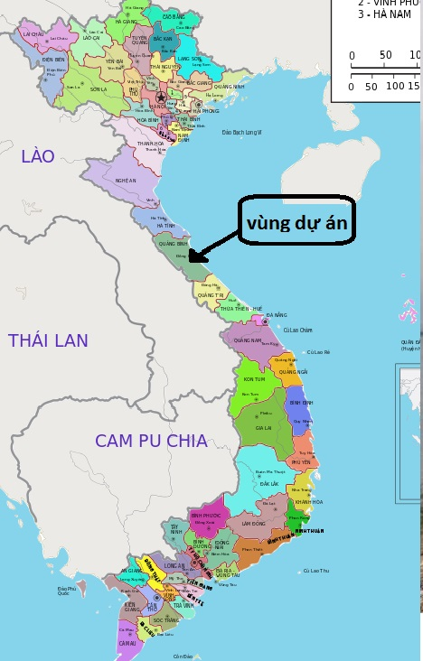

Sub-project

area

Figure 2‑1 Location of Phu Vinh’s reservoir

The Phu Vinh reservoir was built in 1992 and designed according to Vietnamese standard TCVN 5060-90 without test flood. It is a tributary of the Nhat Le river. Catchment area of the Phú Vinh reservoir is 38 km2, and that of the Nhật Lệ river is 2,650km. Therefore, the Phú Vinh contributes to flood control for the Nhat Le river.

The Phu Vinh reservoir has storage capacity is 22 millions cubic meters, the maximum height of the main dam crest is 27 m, which is classified as large dam according to the Vietnam government regulations. The maximum designed flood discharge is 840 m3/s, total maximum designed flood volume is 15.56 millions cubic meters. The normal water level is 22 m, designed flood water level is 23.1 m. The dead water level is 13.1 m equivalent to 3.2 millions cubic meters storage.

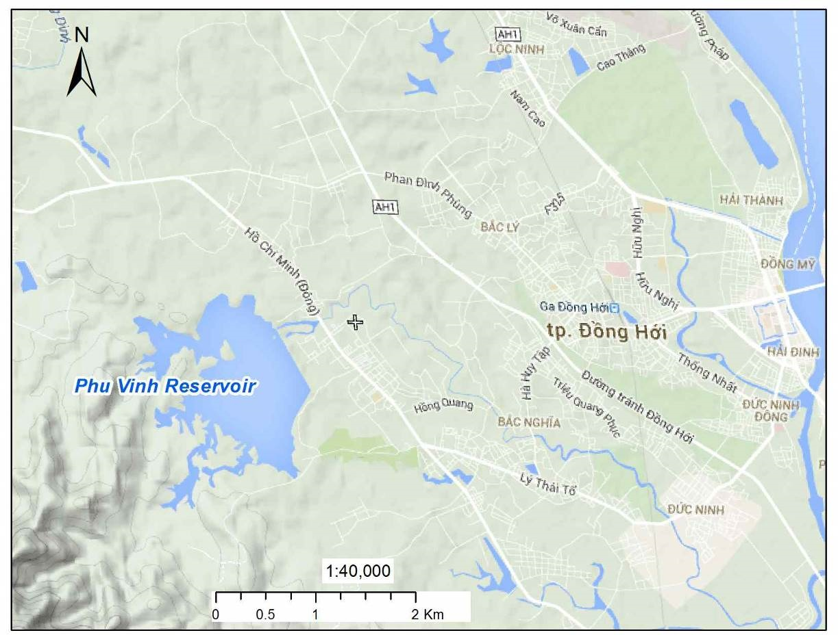

Figure 2‑2 Phu Vinh reservoir and the surrounding areas

**The main dam** is an earth filled with existing dam crest at elevation of 24.2 m, crest length is 1,776 m, and is 5 m wide at its crest. There are two coffer dams, both are earth fill. The coffer dam located on the left side of the main dam has crest elevation at 25.4 m, 400 m long and 6 m wide at crest. The one on the right side has crest elevation of 25.5 m, 400 m long and 5 m wide at its crest.

**The spill way** located on the left of the main dam, B = 18 m. The length of the chute is 60 m and operated by a gate valve. The coffer spillway is located on the left of the main dam, the top at elevation 23 m. The width is B = 100 m, design flood discharge Qx 1% = 51 m3/s.

In case of discharging flood water out of Phu Vinh reservoir, the flow goes to the spillway via the stilling-basin and spillway channel (L = 200m, B = 20, H = 6.7m) which is connected to the Phu Vinh river with length of 13 km and then discharges to the Nhat Le river, which finally emptied into the sea.

|  |  |
| --- | --- |
| Figure 4. 1: The trending process of flood discharge of Phu Vinh reservoir with flood probability P= 1% | Description: IMG_1792  Figure 4. 2: Canal behind spillway |
| Description: D:\Project\WB8.QuangBinh\PhuVinh.QuangBinh\2.Map.PhuVinh\kenh sau tran xa lu.png | |
| Phu Vinh downriver behind spillway | |

Phu Vinh downriver length is 13km with average depth of 6.7m; B = 20m and continues to widen toward downstream. Two side of the river are perennial tree, shrubs and small tree. There are some resident of Thuan Ha hamlet live along the river but field survey show that in many years of operations of the Phu Vinh reservoir, the Phu Vinh downriver have never been overflown as the result of flood water discharge from the Phu Vinh reservoir. Calculation in the section 5.5.7 also show that when designed flood discharge increase to 441m3/s due to the longer of string data, water level at downstream will increase to 5.71m < 6.7m, still within the safe limitation of Phu Vinh downriver.

**The outlet** located at the right side of the main dam. The outlet length is 11 m which has the dimensions B x H =1,2x1,6. Designed discharge of oulet is 2.5 m3/s. Elevation of outlet bottom is 11 m.

**Behind the spill way** and stilling-basin is 200m channel. Two side of the channel is consolidated by rubble rock, width B = 20m, height = 6.7m.

Water in the reservoir is taken from Phu Vinh River (detail in article b, section 4.1.1).

Phu Vinh reservoir is the main source of water for irrigating 925 ha of crop land. Currently, the headworks of the dam have been seriously degraded. Upstream slope of main dam has been subsided at some sections, so it is concavo-convex, some parts have been peeled off. Grass cover and layout at downstream slope has been degraded and damaged at many sections. The outlet works has been leaked, concrete layers of the outlet works has been peeled off or became rocky. The open/close control equipment and the gate have been degraded and are dangerous for operators. Water leakage is the main reason causing irrigation is below designed level. Therefore, it was proposed that a new outlet is built.

The spillway training wall was broken, some points on concrete ramp have stripped, flip lips to emergency valve have been damaged severely.

If the dam is failed in flood season, the lives of people and existing infrastructures in the socio-economic centre of Quảng Bình province would be destroyed.

|  |  |
| --- | --- |
| Description: Description: IMG_1718  ***Phu Vinh’s Reservoir*** | |
| Description: Description: Description: IMG_1736  ***Main dam*** | Description: Description: Description: C:\Users\SON\Desktop\anh phu vinh mua can\20140810_104717.JPG  ***Upstream roof of main dam*** |
| Description: Description: Description: IMG_1792  ***Spillway*** | ***Description: Description: IMG_1175***  ***Output of outlet works*** |
| Description: Description: IMG_1726  ***Parapet wall*** | ***Description: Description: IMG_1170***  ***Main channel*** |

Figure 2‑3 Existing status of Phu Vinh’s dam and appurtenant structures

The Phu Vinh Dam Safety and Rehabilitation subprojects were proposed in order to achieve the targets set in the provincial masterplan and the objectives set by the Quang Binh DARD and its Irrigation Management Company:

* The work is safe and stable
* Flood control for downstream, particularly Dong Hoi city
* Supply water for irrigation for 1672 ha of cultivation land, for 60 ha of aquaculture; supply water for industrial zone and raw drinking water at rate 18,000 cmd

## Proposed scope of work

### The Dam and auxiliary works

The proposed scope of work under this subproject is presented in the table below

Table 2‑1 Proposed scope of work Phu Vinh reservoir

|  | **Construction** | **Existing parameter** | **Proposed work** |
| --- | --- | --- | --- |
| 1 | Main dam | - Zdam = 24.2  - Z parapet wall = 25.2  - Bdam face = 5m  - Dam face: earth road  - L = 1,776m | Increase dam crest unto 25 m.  - Rebuilt parapet wall (remain height)  - Expand crest width from 5m to 6m, reinforced concrete road dam crest.  - Consolidate the upstream slope.  - Downstream face: remove weathered soil layer, and earth refill, plant grass and build drainage system.  - L = 1,853 m. |
| 4 | Spillway | - Designed flood discharge: Qx1% = 380m3/s  Water column on spillway: 6.1m | Repair and rehabilitate lifting system and the bulk heads.  Designed flood discharge Qx1% = 441m3/s  Water colume on spillway: 6.49m |
| 5 | Auxiliary spillway | - Test flood discharge: None  - Max flood discharge: None | Strengthened the top of auxiliary spillway with reinfoced concrete.  Test flood discharge: Qx0,2% = 155 m3/s, Max flood discharge: Qx0, 01% = 342 m3/s. |
| 6 | Outlet works | - Qtk = 2.5 m3/s  - BxH: 1.2m x 1.6m  - L = 67.6  - Slope: 0.4  - Operation motor: VD20 | - Construct new outlet 50m from the existing outlet works.  - Qtk = 2.61 m3/s  - Opening BxH: 1.2m x 1.2m  - L = 92.2  - Slope: 0  - Operation motor: HZV1200-6 |

The table below show the parameters “before” and “after” dam rehabilitation:

Table 2‑2 Proposed scope of work Phu Vinh reservoir

|  |  |  |  |  |
| --- | --- | --- | --- | --- |
|  | **Work Item** | **Unit** | **“before”** | **“After”** |
| **1** | **The reservoir** |  |  |  |
|  | Max designed flood flow Q1% | m3/s | 840.0 | 955 |
|  | Total designed flood flow W1.% | 106 m3 | 15.56 | 17.71 |
|  | Dead water level | m | +13.5 | +13.5 |
|  | Normal water level | m | +22.0 | +22.0 |
|  | Designed flood water level | m | +23.1 | +23.49 |
| 2 | Main dam |  |  |  |
|  | Height H | m | +24.2 | +25.0 |
|  | Height of water break wall | m | +25.2 | +26.0 |
|  | Max high | m | 27.6 | 28.2 |
|  | Length at dam crest L | m | 1.776 | 1.853 |
|  | Width at crest B | m | 5.0 | 6.0 |
|  | Length at dam crest L | m | 400 | 400 |
|  | Width at crest B | m | 5.0 | 5.0 |
| **5** | **Spillway** |  |  |  |
|  | Type |  | Has gate valve | Has gate valve |
|  | Design flood rate Qx1% | m3/s | 380 | 441 |
|  | Test flood discharge Qx0,2% | m3/s | none | 495 |
|  | Qx0,01% | m3/s | none | 579 |
|  | Height | m | +17.0 | +17.0 |
|  | Design water column above spillway | m | 6.1 | 6.49 |
|  | Width B | m | 18.0 | 18.0 |
|  | Length of the Chute | m | 60 | 60 |
| **6** | **Coffer spillway** |  |  |  |
|  | Design flood discharge Qx1% | m3/s | 51.0 | 51.0 |
|  | Spillway elevation | m | +23.0 | +23.0 |
|  | Water column above spillway | m | 0.5 | 0.49 |
|  | B | m | 100 | 100 |
| **7.** | **Sluice** |  |  |  |
|  | Design Flood discharge Qtk | m3/s | 2.5 | 2.61 |
|  | BxH (D) | m | 1.2x1.6 | 1.2 |
|  | L | m | 67.6 | 92.2 |
|  | Slope | % | 0.4 | 0 |
|  | Elevation at bottom of Outlet | m | +11.0 | +11.0 |

Source: Feasibility Study Report

## Resources used

The quantity construction materials used, the amount of excavation and filling materials are shown in Tables 2-3 and 2-4 below:

Table 2‑3 Construction material, excavation and filling

|  |  |  |  |  |  |  |
| --- | --- | --- | --- | --- | --- | --- |
| **No** | **Work items** | **Excavated rock** | **Filling soil** | **Excavation Soil** | **Concrete** | **Steel** |
| **(m3)** | **(m3)** | **(m3)** | **(m3)** | **Ton** |
| 1 | Main dam | 13,052 | 166,434 | 3,525 | 6,523 |  |
| 2 | Left auxiliary dam |  | 75 | 487 | 811 |  |
| 3 | Right auxiliary dam |  | 10 | 4,261 | 1,621 |  |
| 4 | Auxiliary spillway |  |  |  | 2,089 | 131 |
| 5 | Outlet works |  | 8,313 | 9,639 | 279 | 19 |
| 6 | Traffic routes |  | 1,161 | 556 | 384 |  |
| **Total** **(rounded-up)** | | **13,052** | **176,000** | **18,500** | **11,700** | **150** |

The borrow pit is located 2 km from the spillway. Land area of the borrow pit is 7ha with estimated exploitation height 3.0m. The exploitable volume is 210,000 m3, equivalent to 250,000 tons (specific weight is 1.2 tons/m3). The project will extract 199,600 T or 166,400 m3 (Figure 2‑4). Other materials needed for the work will be purchased from dealers in Dong Hoi city, 7 km from the construction site.

The disposal site is located in Thuan Phong’s village, opposite to the Thuan Duc CPC. It is accessible through a 1.5km road passing Thuan Duc commune and Dong Son road. Land area at the disposal site is 20,000 m2, storage capacity is 50,000m3; The project will dispose 21,881 m3 of stockpile to this site.

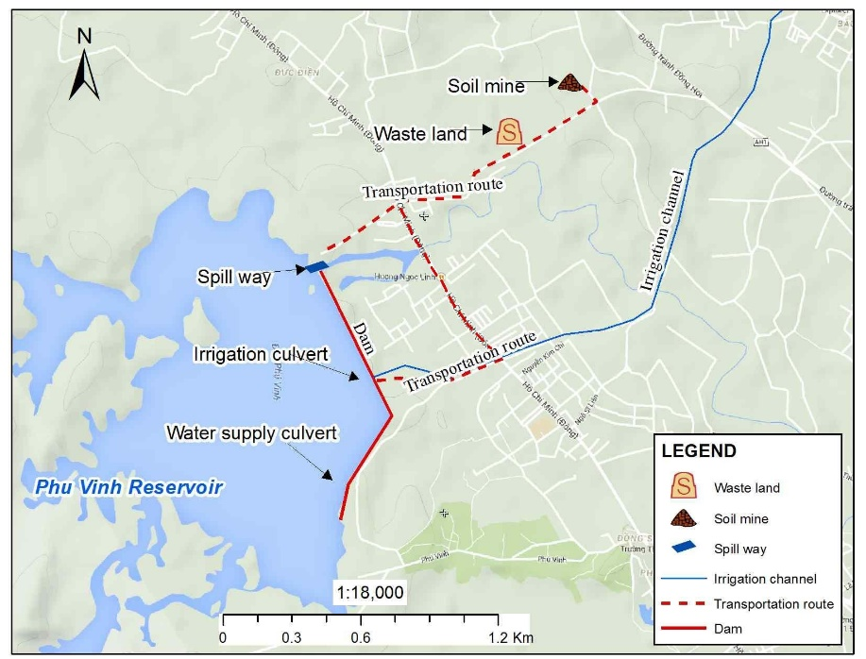

Figure 2‑4 Locations of Borrow pit, Disposal site and transportation routes

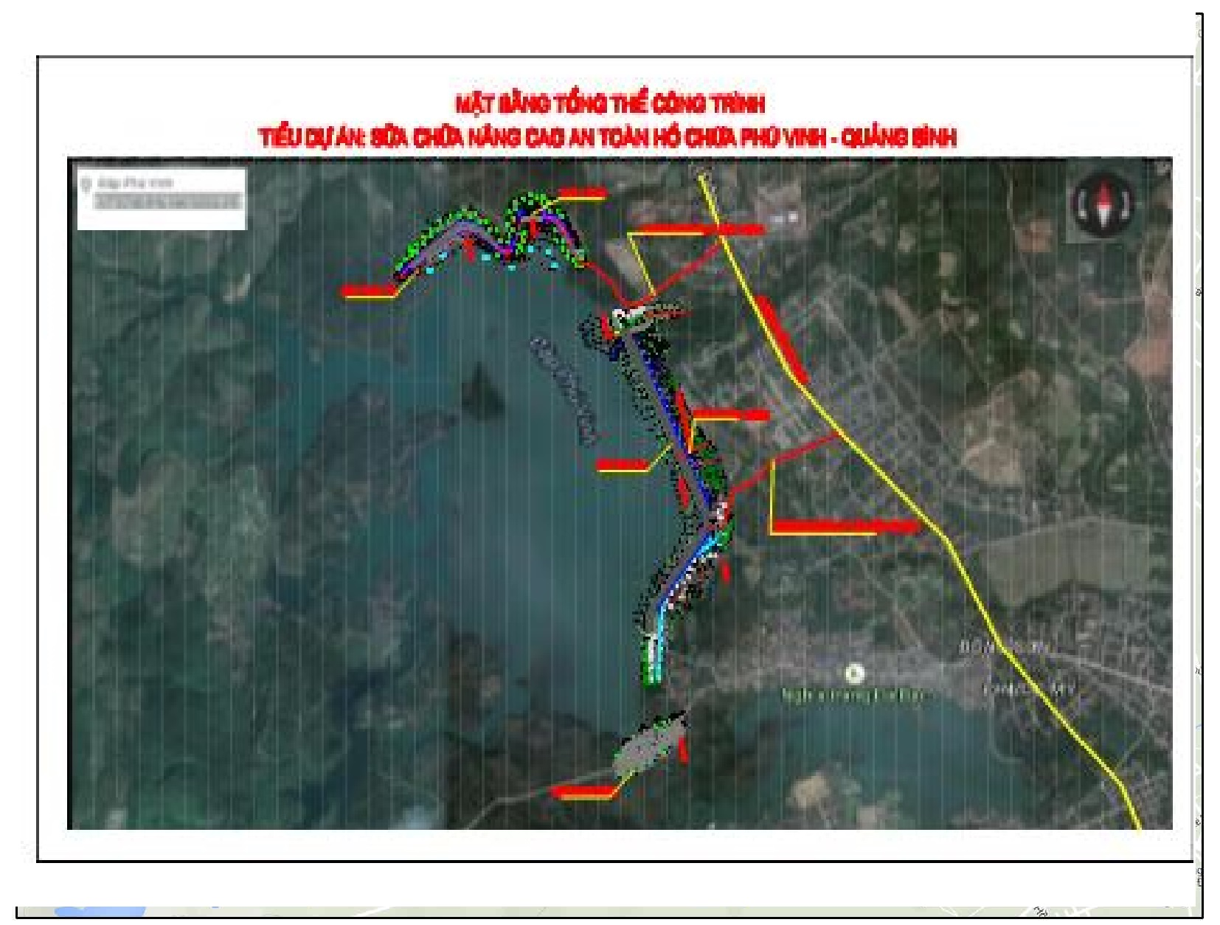

Figure 2‑5 General background of Works

The proposed locations of worker’s camps and material storage are on the left abutment dam, with the land area of 2,000m2. The site is located within the dam safety corridor.

Electricity source for construction activities will be shared with that for the operation of the spillway gate. Water for daily activities of workers at the construction site is supplied from the dam management house. The construction stage will use electricity from source for operation of spillway.

Table 2‑4 List of machineries to be used

| **No** | **Machine** | **Quantity** |
| --- | --- | --- |
| 1 | Excavator, one bucket, Chain wheel with volume of 1.25m3 | 4 |
| 2 | Grader with the capacity of 108 CV | 4 |
| 3 | Concrete mixer 250-500 lit | 2 |
| 4 | Concrete vibrator, 1,5Kw | 4 |
| 5 | Mortising slot machine | 2 |
| 6 | Self vibration 25T | 2 |
| 7 | Tilting car with volume of 6T | 4 |
| 8 | Water car with volume of 5m3 | 1 |
| 9 | Generator, 8 Kw | 1 |
|  | Total | 24 |

*Source: Feasibility Study Report of the subproject*

## Construction method

With the headworks, construction will be implemented from the bottom to the top. Construction will be implemented in dry season.

Drilling, which will be implemented on the dam crest, will be done mechanically and manually. Clay powder will be used. The existing stone lining layer at upstream face will be removed by excavator combined with manual works. Excavated materials will be loaded temporarily at the right side of the main dam. Then the dam face will be levelled before geotextile materials and lining materials are laid on top. Concrete will be mixed on-site.

Construction of the outlet will take place in dry season. Coffer dam will be built surrounding the new outlet during construction phase before construction is started. Piles will be placed surrounding the foundation and water will be pumped out before excavation is started. Excavated soil will be temporarily loaded at the right side of the main dam, 300 m from the outlet. Reuse part of the excavated materials for refill. Vibrators less than <9T will be used to avoid damages that may be caused to the pipe. The existing outlet will be removed after the water is discharged through the new outlet.

Construction of upstream slope: elevation of surrounding-frame is higher than dead water level from 1-3m. Therefore, upstream slope will be constructed in the driest month of the reservoir (after the end of summer-autumn crop, combine low water level) to construct tray foot, beam foot, reinforced concrete frame and stone surface under normal water level (detail of construction methods will be setup in the construction drawing design report base on irrigation schedule to ensure not to affect crops.)

Part of the excavated soil will be reused. The total amount to be disposed off is 21,900 m3. Filling materials needed is 166,000 m3 or 199,600 tones

## Construction schedule

The construction phase of the subproject is estimated to be twelve months, starting in October. The construction of temporary access and management road will be from November to December in the first year. Cofferdam will be constructed in January of the second year when there is no water demand for agriculture. Sealing of the old outlet will be done in the end of the dry season (August) when water level of the reservoir is minimum.

Table 2‑6 Construction Schedule

|  |  |  |  |  |  |  |  |  |  |  |  |  |  |  |  |  |
| --- | --- | --- | --- | --- | --- | --- | --- | --- | --- | --- | --- | --- | --- | --- | --- | --- |
| **No** | **Work items** | **Year 1** | | | **Year 2** | | | | | | | | | | | |
| **10** | **11** | **12** | **1** | **2** | **3** | **4** | **5** | **6** | **7** | **8** | **9** | **10** | **11** | **12** |
| 1 | Preparation |  |  |  |  |  |  |  |  |  |  |  |  |  |  |  |
| 2 | Transportation route |  |  |  |  |  |  |  |  |  |  |  |  |  |  |  |
| 3 | Cofferdam |  |  |  |  |  |  |  |  |  |  |  |  |  |  |  |
| 4 | Outlet works |  |  |  |  |  |  |  |  |  |  |  |  |  |  |  |
| 5 | Sealing old outlet works |  |  |  |  |  |  |  |  |  |  |  |  |  |  |  |
| 6 | Consolidation upstream dam face |  |  |  |  |  |  |  |  |  |  |  |  |  |  |  |
| 7 | Anti-absorption grout |  |  |  |  |  |  |  |  |  |  |  |  |  |  |  |
| 8 | Repairing the valve of spillway |  |  |  |  |  |  |  |  |  |  |  |  |  |  |  |
| 9 | Top of main dam and parapet wall |  |  |  |  |  |  |  |  |  |  |  |  |  |  |  |
| 10 | Downstream dam face |  |  |  |  |  |  |  |  |  |  |  |  |  |  |  |

*Source :* Feasibility Study Report

### Estimated costs

Total estimated cost Phu Vinh subproject is approximately 110 billions VND (or 5.1 millions USD equivalents).

Table 2‑7 Total investment cost of the subproject

|  |  |  |
| --- | --- | --- |
| **No** | **Category** | **Cost (VND)** |
| I | Civil Work cost | 82,381,100,972 |
| II | Equipment | 1,800,000,000 |
| III | Compensation cost | 1,239,212,539 |
| IV | UXO Clearance | 700,000,000 |
| V | Administration cost | 1,387,057,925 |
| VI | Construction investment cost | 9,632,176,397 |
| VII | Capacity building training | 220,000,000 |
| VIII | Environmental monitoring cost | 560,000,000 |
| IX | Other cost | 2,128,564,727 |
| X | Contingencies | 10,004,811,256 |
|  | TOTAL | 110,052,923,816 |
|  | **ROUNDED-UP** | **110,052,924,000** |

### EIA Consultant Team

The EIA report was prepared by the consultant from Vinacontrol Environment Consultancy and Appraisal Joint Stock Company (VIECA), with the following team members:

|  |  |  |  |
| --- | --- | --- | --- |
| **No** | **Full name** | **Education level/ Degree** | **Position** |
| 1 | Mai Thai An | Master of Environment and Ecology | Director of VIECA (specialist in environment and irrigation) |
| 2 | Doan Man Hung | Master of Environment | Environmental expert |
| 3 | Nguyen Vu Kien | Engineer of Water Supply and Drainage | Specialist in Water Supply and Drainage |
| 4 | Le Thi Thanh Hoa | Master of Environment | Specialist in Environment |
| 5 | Nguyen Thanh Hieu | Engineer of Environment | Expert in Social |
| 6 | Nguyen Duy Phu | Engineer of Irrigation | Expert in Gender |

# POLICY, LEGAL AND ADMINISTRATIVE FRAMEWORK

## Country's Environmental and Social Safeguards Policies and Legislations

This chapter provides the brief of the relevant environmental and social policies of the GoV and the World Bank. Annex-I includes the detailed description and discussion.

### Environment

Law on Environmental Protection (No.55/2014/QH13) dated June 23, 2014 and Decree on Environmental Protection Planning, Strategic Environmental Assessment, Environmental Impact Assessment and Environmental Protection Plans (No. 18/2015/ND-CP) dated February 14, 2015 are key legal framework for environmental management in Vietnam. Law on Environmental Protection (LEP) provides statutory provisions on environmental protection activities; measures and resources used for the purpose of environmental protection; rights, powers, duties and obligations of regulatory bodies, agencies, organizations, households and individuals who are tasked with the environmental protection task. LEP is applicable to regulatory bodies, public agencies, organizations, family households and individuals within the territory of the Socialist Republic of Vietnam, including mainland, islands, territorial waters and airspace. LEP is on regulating strategic environmental assessment, environmental impact assessment and environmental protection commitment. According to Article 10, chapter II of LEP, the responsibility for preparing the planning for environmental protection are as following:

1. The Ministry of Natural Resources and Environment shall prepare the national-level planning for environmental protection.
2. People’s Committees of centrally-governed cities and provinces (hereinafter referred to as provincial People’s Committee) shall take charge of formulating processes or preparing the local planning for environmental protection.

Furthermore, the law also indicated to consultation on, inspection and approval of the planning for environmental protection (Article 11, chapter II) as well as the list of entities subject to strategic environmental assessment in appendix I and II of the Decree No. 18/2015/ND-CP dated February 14, 2015 of the Government:

* The Ministry of Natural Resources and Environment shall consult with Ministries, regulatory agencies and provincial People’s Committees in writing and hold an official consultation with relevant regulatory agencies and organizations during the preparation of the national-level planning for environmental protection.
* Provincial People’s Committees shall consult with departments, regulatory agencies, and People’s Committees of a district, town or city (hereinafter referred to as district-level People's Committee) in writing and hold an official consultation with relevant regulatory agencies and organizations during the preparation of the provincial-level planning for environmental protection.

Inspection and approval of the planning for environmental protection shall be required as follows:

* The Ministry of Natural Resources and Environment shall establish a Council for interdisciplinary inspection and prepare the national-level planning for environmental protection for submission to the Prime Minister with the intent to seeking the approval for that planning.
* Provincial People’s Committee shall inspect and approve the report on the provincial-level planning for environmental protection after obtaining written advice from the Ministry of Natural Resources and Environment.

Ministries, ministerial agencies, and Governmental bodies shall have the responsibility to establish the council or organize the selection of review service organizations to review environmental impact assessment reports of the projects within their competence of decisions and approvals, except inter-sector and inter-provincial projects

Provincial People’s Committees shall have the responsibility to establish the council or organize the selection of review service organizations to review environmental impact assessment reports of the projects that take place within their territories and subject to their competence of decision and approval and that of the People’s Councils of the same level.

Management: Unit for Industrial Parks, Export Processing Zones and Hi-tech Zones: Provincial people’s committee can authorize the Management Unit for Industrial Parks, Export Processing Zones and Hi-tech Zones as regulated in Decree 29/2008/ND-CP dated 14/03/2008 by the Government on industrial parks, export processing zones and economic zones.

The Section 3 of Chapter II of LEP describes the requirements of Environmental Impact Assessment. Owners of projects regulated in Clause 1 Article 18 of this Law shall carry out, on his own, or hire an advisory organization to carry out the environmental impact assessment and take statutory responsibility for the conclusive result after carrying out such assessment. The environment impact assessment must be performed in the preparatory stage of the project. The conclusive result yielded after carrying out the environment impact assessment shall be expressed in the form of the report on environmental impact assessment. Expenses incurred from the formulation and inspection of the report on environmental impact assessment, and included in total investment budget shall be covered by the project owner.

According to Article 21 of LEP, the consultation to be required in the process of environmental impact assessment is aimed at completing the report on environmental impact assessment. It emphasis that consultation helps minimize the negative impacts on the environment and human beings and ensure the sustainable development of the project. Project owners are obliged to consult with regulatory agencies, organizations and communities that are directly affected by the project.

The Article 22 of LEP describes the scope of EIA reporting. It will include: (i) origin of the project, project owners, and the competent authority's approval of the project, method of the environmental impact assessment; (ii) evaluation of technological choice, work items and any activity relating to the project which can cause bad effects on the environment; (iii) assessment of current status of natural and socio-economic environment carried out at areas where the project is located, adjacent areas and demonstration of the suitability of the selected project site; (iv) assessment and forecast of waste sources, and the impact of the project on the environment and community health; (v) assessment, forecast and determination of measures for managing the risks of the project posed to the environment and community health; (vi) waste disposal measures; (vii) measures for minimizing the impact of the project on the environment and community health; (viii) consultation result; (ix) environmental management and supervision programs; (x) budget estimate for the construction of environmental protection facilities and measures to be taken to minimize the environmental impact; and (xi) alternatives to the application of measures for the environment protection.

The Article 23 of LEP defines the authority to verify the report on EIA. The Ministry of Natural Resources and Environment shall arrange to verify the report on environmental impact assessment in respect of the following projects: (a) Projects subject to the decision on investment intentions made by the National Assembly, Government and the Prime Minister; (b) Interdisciplinary or inter-provincial projects stipulated at Points b and c Clause 1 Article 18 in this Law, exclusive of those classified as the secret projects in the field of national defence and security; and (c) Projects verified by the Government’s authorized entities. The Ministries and quasi-ministerial agencies shall inspect the report on environmental impact assessment in respect of projects that shall be permitted under their decision and approval, but are not specified in regulations mentioned at Points b and c Clause 1 of this Article. The Ministry of National Defence and the Ministry of Public Security shall arrange to verify the report on environmental impact assessment in respect of projects that shall be permitted under their decision and approval, and those classified as the secret projects in the field of national defence and security. Provincial People’s Committees shall arrange to verify the report on environmental impact assessment in respect of investment projects within their territories that are not regulated at Clause 1, 2 and 3 of this Article.

The Article 26 of LEP describes the responsibility assumed by the project owner after being granted the approval of their report on the environmental impact assessment. These include – Clause 1: comply with the requests specified in the approval of their report on environmental impact assessment. Clause 2: where any change in the project size, capacity and technology applied in the project execution is blamed for the negative impact on the environment in comparison with the alternatives given in the approved report on environmental impact assessment, but is not too serious to make another report as stipulated at Point c Clause 1 Article 20 puff this Law, the project owner must send their explanation to the agency who grants the approval of the report on environmental impact assessment, and the project shall be commenced only after obtaining the permission from such agency.

The Article 27 of LEP explains the responsibility assumed by the project owner before bringing the project into operation. These include - Clause 1: apply measures for the environmental protection under the decision on the approval of their report on environmental impact assessment; and Clause 2: notify the agency who grants the approval of the report on environmental impact assessment of the developmental process of environmental protection works functioning as an ancillary part of major projects that can cause bad impacts on the environment in accordance with the Governmental regulations. These projects will be commenced only after the agency in charge of the approval of the report on environmental impact assessment has inspected and certified the completion of environmental protection works.

The Article 28 of LEP mentions the responsibility of the agency in charge of approving the report on the environmental impact assessment. These include – Clause 1: Bear the statutory responsibility for their conclusive result and decision on the approval of the report on environmental impact assessment. Clause 2: Within a period of 15 days as from the date on which the project owner’s report on the completion of environmental protection works under the regulations specified in Clause 2 Article 27 of this Law, the agency in charge of approving the report on environmental impact assessment must examine and issue the certificate of completion of environmental protection works. Where an analysis of complicated environmental criteria is required, the time span for the issuance of the certificate of completion of environmental protection works can be extended for less than 30 days.

The Article 13 of the Decree (No. 18/2015/ND-CP) explains the requirement of the pertaining EIA agencies. Clause 1: the project owner or the advisory organization conducting EIA must meet all requirements – (a) there are staff members in charge of EIA meeting requirements prescribed in Clause 2 of this Article; (b) there is specialist staff members related to the project obtaining at least Bachelor’s degrees; and (c) there are laboratories, inspection and calibration devices eligible for performing measurement, sampling, processing and analysis of environmental samples serving the EIA of the project; if there is not any laboratory with decent equipment for inspection and calibration, it is required to have a contract with a unit capable of carrying out inspection and calibration. Clause 2: the staff members in charge of EIA must obtain at least Bachelor’s degrees and Certificate in EIA consultancy and Clause 3: the Ministry of Natural Resources and Environment shall manage the training and issuance of Certificates in consultancy of EIA.

In addition, the following Articles are important for EIA approval and reporting.

Article 14: the authorities for different scales of EIA report approval with deadlines

Article 15: re-compilation of EIA reports

Article 16: responsibility of project owners pertaining to the approved EIA reports

Article17: inspection and confirmation of environmental protection works serving the operation phase of the projects

Article 21: Reporting

### Dam safety regulations

Decree no.72/ND-CP on date 07/05/2007 of the government of Vietnam regarding on dam safety management. According to the decree, a big dam is the dam with the height calculating from the floor face to the top of the dam equal to or greater than 15 meters or dam of water reservoirs with the scale of capacity equal to or greater than 3,000,000 m3 (three million cubic meters). Small dam is the dam with the height calculating from the floor face to the top of the dam smaller than 15 meters. Dam owners are organizations and individuals owning dams to harness the benefits of water reservoirs or assigned to manage, operate and harness water reservoirs by the competent state agencies. Ministry of Agriculture and Rural Development takes responsibility before the Government for the implementation of state management of dam safety. The Ministry of Industry presides over and coordinates with ministries, branches and relative localities to appraise, approve or submit to the Prime Minister for approval of the process of operating hydropower reservoirs. The provincial-level People's Committees implement its state management on dam safety in the areas.

In chapter 4 of Decree no.18/2015/ND-CP on date 14/02/2015, from the article 12 to article 17 were specified in the formulation, evaluation and approval of environmental impact assessment reports, the implementation of projects and the designed mitigation measures to protect environment before and after a project officially operation. In the article 12 of this Decree also regards on environmental impact assessment process to the project implementation, the project owner have to organize meetings to public consultants, such as Provincial People's Committees, local authority (Commune People's Committees level- CPC), affected (direct or indirect) people or committees in the local by the project implementation, mandatory; analysis the feedbacks, comments obtained from the affected groups, and consider advantage or disadvantage the impacts of the project to community and to design the mitigation measures to reduce the negative impacts on natural environment, biodiversity, community. According to the annex no.2 of the Decree, the project has to make EIA if the reservoir capacity is of 100,000m3 or more. According to the regulations of Vietnam Government, the all proposed subprojects under DRSIP project have to perform the report of Environment Impact Assessment (ESIA).

### Land acquisition

The GOV’s Legal Framework: The legal framework with respect to land acquisition, compensation and resettlement is based on the Constitution of the Socialist Republic of Vietnam (2013), and the Land Law 2013 (revised), and other relevant decrees/guidelines. The principal legal documents applied for this RPF include the followings:

* Constitution of Vietnam 2013;
* The Land Law 45/2013/QH13 which has been effective since July 1, 2014;
* Decree No.43/2014/ND-CP dated on May 15, 2014 guiding in detail some articles of Land Law 2013;
* Decree No.44/2014/ND-CP dated on May 15, 2014 provides on method to determine land price; make adjusted land price brackets, land price board; valuate specific land price and land price consultancy activities;
* Decree No. 47/2014/ND-CP dated on May 15, 2014 providing compensation, assistance, resettlement when land is recovered by the State;
* Decree No. 38/2013/ND-CP dated on April 23, 2013, on management and use of official development assistance (ODA) and concessional loans of WB;
* Decree No. 72/2007 / ND-CP dated on May 07, 2007 of the Government on management of dam safety;
* Decree No. 201/2013 / ND-CP dated on November, 27, 2013 of the Government detailing the implementation of some articles of the Law on Water Resources;
* Circular No. 36/2014 / TT-BTNMT dated on 30 June 2014, regulating method of valuation of land; construction, land price adjustment; specific land valuation and land valuation advisory;
* Circular No. 37/2014/TT-BTNMT dated on 30 June 2014, regulating compensation, assistance and resettlement when the State acquires land;
* Decision No. 1956/2009/QD-TTg, dated on November 17, 2009, by the Prime Minister approving the Master Plan on vocational training for rural labors by 2020;
* Decision No. 52/2012/QD-TTg, dated on November 16, 2012, on the assistance policies on employment and vocational training to farmers whose agricultural land has been recovered by the State;
* Others.

Other laws, decrees and regulations relevant to land management, land acquisition and resettlement include the Construction Law 50/2014/QH13, dated on 18 Jun 2014, on construction activities, rights and obligations of organization and individual investing in civil works construction and construction activities; Decree 102/2014 / ND-CP on sanctioning of administrative violations in the field of land replaced by Decree No. 15/2013 / ND-CP dated on February, 06, 2013 on quality management of constructions;, Decree No. 12/2009/NĐ-CP of the Government, dated 12 February 2009 on the management of construction investment projects and replacing the Decree 16/2005/ND-CP, the Decree 38/2013/ND-CP of the Government on the management and use of Official Development Assistance (ODA) fund, and Decree 126/2014/ND-CP of the Government on marriage and family Law implementation, stipulating that all documents registering family assets and land use rights must be in the names of both husband and wife; Decisions of project provinces relating to compensation, assistance and resettlement in provincial territory will be also applied for each relevant project province.

### Indigenous/Ethnic minority people

Viet Nam has a large number of policies and programs specifically designed to assist ethnic minorities’ development. The Government of Viet Nam (GOV) has paid much attention to the welfare of ethnic minority groups. There is a ministerial-level government body, the Committee for Ethnic Minority and Mountainous Area Affairs (CEMA), which is in charge of management functions for ethnic minorities and mountainous areas. A country profile of Viet Nam published by the International Work Group for Indigenous Affairs (IWGIA) reports that:

“Indigenous peoples are full citizens of the Vietnamese state and enjoy constitutionally guaranteed rights to their languages and cultural traditions....On the legislative level, the “Council on Ethnic Minorities” has the mandate to advise the National Assembly on ethnic minority issues and to supervise and control the implementation of the government’s ethnic minority policies and development programs in ethnic minority areas.”

The document also reports that since the 1960s, a number of policies and programs have been designed specifically for ethnic minorities, but these are mainly aimed at integrating them into mainstream society rather than enabling them to strengthen their own institutions. Regarding land issues, it reports that “it is important to highlight that the present legislation in Viet Nam allows for obtaining use right certificates for land and forest and that in 2004 the National Assembly passed a new land law which, most relevant for indigenous peoples, now includes the category of ”communal land”. By introducing the concept of communal land, the new law provides for the possibility of communities to apply for certificates over communal land.

## Implications of National Policies and Regulations on the Proposed Project

Based on the analysis of the national legal framework, the project will have to fulfil the following minimum requirement and process:

* PPMU or the consulting firm conducting EIA must have staff members in charge of EIA must obtain at least Bachelor’s degrees and Certificate in EIA consultancy. They will also have or arrange adequate laboratory facility for performing measurement, sampling, processing and analysis of environmental samples serving the EIA (Ref. Article 13 of Decree).
* Considering the nature of the subproject, the Provincial People’s Committee (PPC) shall assess and approve EIA reports (Ref. Article 14 of Decree). PPC shall arrange to verify the report on environmental impact assessment in respect of investment projects within their territories (Ref. Article 23 of LEP).
* The assessment of EIA report shall be conducted by the EIA report assessment council established by the Heads of the EIA report assessment authority with at least 07 members. Members of EIA report assessment council shall consist of 01 President, 01 Vice President where necessary, 01 Secretary member, 02 Opponent members and other members, which at least 30 per cent of the Assessment council members having at least 06 years' experience in the EIA field (Ref. Article 14 of Decree).
* Deadlines for assessment of EIA report is within 30 working days from the date on which the satisfactory application is received (Ref. Article 14 of Decree).
* PPMU will have to comply with EIA. For any change, the project owner must send their explanation to PPC (Ref. Article 26 of LEP).
* PPMU will have to notify PPC and the rehabilitated dam will be commenced only after the agency in charge of the approval of the report on environmental impact assessment has inspected and certified the completion of environmental protection works (Ref. Article 27 of LEP).
* PPMU will prepare a completion report for environmental protection work and within 15 days of receiving the report, PPC must examine and issue the certificate of completion of environmental work (Ref. Article 28 of LEP).
* The inspection of environment protection works serving the operation phase of the subproject shall be carried out by an Inspectorate which is established by the Head of PPC (Ref. Article 17 of Decree).
* The PPC shall send a report on assessment and approval for EIA report, registration and inspection of specific environment protection plans, inspection and approval for environment protection works in the province of the previous year to the Ministry of Natural Resources and Environment before every January 15 (Ref. Article 21 of Decree).
* MARD shall send reports on assessment and approval for EIA report, inspection and approval for environment protection works of the previous year related to project under their management to the Ministry of Natural Resources and Environment before every January 15 (Ref. Article 21 of Decree).

## World Bank Safeguard Policies

The objective of safeguard policies is to prevent and mitigate undue harm to people and their environment in the development process. Safeguard policies provide a platform for the participation of stakeholders in project design, and act as an important instrument for building ownership among local populations.

The effectiveness and development impact of projects and programs supported by the Bank has substantially increased as a result of attention to these policies. The World Bank Safeguard policies are available in its website: <http://web.worldbank.org/WBSITE/EXTERNAL/PROJECTS/EXTPOLICIES/EXTSAFEPOL/0,,menuPK:584441~pagePK:64168427~piPK:64168435~theSitePK:584435,00.html>.

## Implications of World Bank Safeguard Policies on the Proposed Project

Eight World Bank policies have been triggered for the project. These are: Environmental Assessment (OP/BP 4.01), Natural Habitats (OP/BP 4.04), Pest Management (OP/BP 4.09), Physical Cultural Resources (OP/BP 4.11), Indigenous Peoples (OP/BP 4.10), Involuntary Resettlement (OP/BP 4.12), Safety of Dams (OP/BP 4.37) and Projects on International Waterways (OP/BP 7.50).

According to WB Operational Policy (OP 4.01), the nature of environmental assessment to be carried out for a particular sub-project would largely depend on the category of the sub-project. As mentioned earlier, The World Bank Operational Policy (OP) 4.01 classifies projects into three major categories (category A, B and C), depending on the type, location, sensitivity and scale of the project, and nature and magnitude of potential impacts. Considering the environmental risk and complexity related to a large number of subprojects to be implemented in a widespread area, the project has been classified as category ‘A’. However, the subprojects to be funded under the projects can be categorized as ‘A’ or ‘B’ or ‘C’ depending on the extent, scope and impact of the specific subproject.

The project physical activities would only work on existing dams and are not expected to lead to conversion or degradation of critical or semi-critical natural habitats. However, it is required to scope, screen and assess potential impacts to natural habitants as part of the subproject ESIA. The project will not finance any procurement of fertilizers and pesticides. However, since the dam rehabilitation work will increase the agriculture command areas, there are chances of more uses of fertilizers and pesticides in the project influence areas. The project will promote the application of Integrated Pest Management (IPM) and guidance has been included in ESMF.

Since the exact subproject locations are unknown at this stage, there is possibility that some rehabilitation work and access road may pass through areas with physical cultural resources. The impacts will be examined as part of the environmental screening/assessment of different subprojects. In addition, ‘Chance find’ procedures conforming to local legislation on heritage would be evaluated so that any physical or cultural resources are not impacted.

The project may intervene in areas where indigenous people live (specific subproject locations will be determined during implementation). In addition, the project may require land acquisition and resettlement. As such, an Ethnic Minority Policy Framework (EMPF) and Resettlement Policy Framework (RPF) are required for the project and will be prepared separately.

The project will not finance construction of any new dams or significant change in dam structure. This policy is triggered as the project will finance rehabilitation and improvement of existing dams including large dams (15 meters or more in height). Thus, it requires to arrange for one or more independent dam specialists to (a) inspect and evaluate the safety status of the existing dam, its appurtenances, and its performance history; (b) review and evaluate the owner's procedures for operations and maintenance; and (c) provide written report of findings and recommendations for any remedial work or safety-related measures necessary to upgrade the existing dam to an acceptable standard of safety. Policy and practice relating to dam safety needs to meet international benchmarks, such as those are laid out by ICOLD and the World Bank regulatory frameworks for dam safety. These measures are designed into the project, which includes the establishment of a national dam safety review panel (DSRP). Also the project will establish an independent Panel of dam safety Experts (PoE) who will carry out independent review of dam safety reports and proposed mitigation measures. This PoE will be working closely with the to-be-established DSRP to ensure the technical integrity of investment interventions. Each subproject will have separate Dam Safety Plan (DSP) in addition to the ESMP.

There are six transboundary river basins in the country; however Vietnam is an upstream riparian only in the Sesan-Srepok basin – a tributary of the Mekong, upstream of Cambodia, and the Bang Giang-KyCung basin, upstream of China. So, it is expected that some of the dams will be located on international river basins, and therefore the policy is triggered.

The WBG guidelines provide guidance on certain EHS issues, which include standards for environmental parameters (ambient air quality, water and wastewater quality, noise level, waste management), hazard and accident prevention, occupational and community health and safety (during commissioning and decommissioning works) etc. These guidelines will be directly applicable to the proposed project. As a general rule, the WBG guidelines should complement the existing Vietnam guidelines or standards. In case the Vietnam guidelines or standards differ from the WBG guidelines, project is expected to follow the more stringent ones.

The World Bank access to information policy would be directly followed. The project will make the environmental/social assessment and ESMF documents available to the public by publishing it in their websites. In addition, hard copies of these documents in English (including Vietnamese language) will be made available in the MARD and all DARDs.

# ENVIRONMENT AND SOCIO-ECONOMIC CHARACTERISTIC OF THE SUBPROJECT AREA

## Physical condition

### Natural conditions

***Topography.*** In general, the terrain of Phu Vinh reservoir is narrow and lower from the West to the East. The west of the reservoir borders with the East side of Truong Son Range with series of mountains exceeding 1,000 meters. Towards the East, terrain is gradually lower, but slope is high because of small width. Hills and mountains extending with many branches near the sea, which narrow large area of the coastal plain.

The Phu Vinh River is formed from an upstream creek which is high steep and meandering. The stream shape is complex with extended or narrowed cross sections along the flow. Survey results show that topography of Phu Vinh River near the reservoir is narrow with small slope. Two side of mean dam are two hills with bowl shape. Elevation surround is from 8.0 to 40,2m.

Geology. The Quarterly sediment comprises of

* Original of this soil levels is from Pluvial: Mainly composed of sand mixed with gravel & sandy gravel. They was found at the bed of streams. During the construction, this class was completely removed;
* This layer originates dQ + EQ (undivided): These classes appear in two side of dam’s abutments. Thickness of this layer range from 2.0 - 4.5 m.
* Bed Rock: The rock in the area is in Devonian age, Eipely rank (D2e), Annamite Range. The main component is alternate layer of powder-clay and quartz vessels. Thickness of weathered layer is large and not uniformity (thickness of weathered layer is from a few meters to 15 m).

From the surface of dam body to the depth 20.9 m is from clay to clay with a little gravel; color is gray and pale yellow; tightly structured; semi-hard to hard state. The depth from 16.0 - 18.0 m appears rock and rubble rock which was left from the last construction.

***Hydrogeology.*** Water exists in the unconsolidated sediments of Neocene and Quaternary and distribution limitedly in the study area. Water exists and moves in the holes of rocks, sand, and gravel. Aquifer distributed very limited, mainly in the alluvial, extended terrain along the flow of the river. Mainly component is bicarbonate sodium - calcium. Because of the limited distribution, thin, and usually dry in the dry season, therefore, groundwater only meets requirement of small scale (family or family groups).

Composition of the material is alternately, distributed complex which mainly is sandy, salty sand, sandy clay, sand and gravel, clay. Water capacity depends on these characteristics, rich water in raw grain, and poor water in the fine-grain.

***Meteorology.*** Sub-project is located in the tropical monsoon religion. Every year, there are two distinguished seasons: dry and rainy season. The area has two prevailing wind regimes: southwest and northeast monsoon. From May to August is mainly dry southwest winds; from October to March in the following year is northeast monsoon. The average annual temperature is 24.6 oC, the highest and lowest temperature is 28.1 oC and 22.0 oC, respectively. The hottest months in Dong Hoi are from June to August, coldest months are from December to February. The average number of hours of sunshine per year in the area is 1794 hours; an average is 5 hours per day. The relative humidity in Dong Hoi is high with average humidity at 83%. The month with the highest humidity is in January to March and June has lowest average humidity.

The average annual rainfall is 2,100 mm/year. The number of rainy day is 152 days/year. Rainy season lasts from September to November, accounts for 80% of the total annual rainfall; Heavy rain often lead to widespread flooding. The dry season starts in December and last until August, coinciding with the baking of sun and Southwest wind (dry and hot); evaporation in this period is large (960 - 1.200mm / year) because frequent droughts, sand-filled fields and land residential.

### Water Resources, Hydrology and Ecology

The Phú Vinh reservoir is part of the Phu Vinh river which originates from the Truong Son mountain range. The Phu Vinh river joins with a tributary of the Cau Rao river in Duc Ninh commune, then this tributary joins with the Nhat Le before emptying into the sea. The catchment has complex topography, changes from mountainous area at upstream to a narrow floodplain strip in the downstream. The river wanders around in a catchment of 60km2. The location where the Phú Vinh river enters the Cau Rao river is 11 km from the Phu Vinh reservoir and is only 2 km from the estuary, this river section is under the influence of tide.

The Phu Vinh river is originated from creeks in the mountain, river bed is steep and the with of the river changes a lot along its wandering length. The mountains are steep, mountain up to 250 m high intersects with lower ones, about 50 m high, and are covered with a diverse vegetation cover. The reservoir is formed by a valley which is created by the mountain ranges running from west to east. At the dam site, the river is narrow, not steep, the two sides of the main dam are the two rows of hills from +8,0 to +40,2m high. Annual flow at P89.1% and the design flood flow of the Phu Vinh reservoir are shown in the tables below

Table 4‑1 Annual flow, P = 89,1%

|  |  |  |  |  |  |  |  |  |  |  |  |  |  |
| --- | --- | --- | --- | --- | --- | --- | --- | --- | --- | --- | --- | --- | --- |
| **Month** | **IX** | **X** | **XI** | **XII** | **I** | **II** | **III** | **IV** | **V** | **VI** | **VII** | **VIII** | **TB** |
| Q89,1% | 3,574 | 2,623 | 2,742 | 1,226 | 0,566 | 0,404 | 0,280 | 0,166 | 0,238 | 0,476 | 0,093 | 0,093 | 1,04 |

Table 4‑2 Design Flood flow

|  |  |  |  |  |  |  |
| --- | --- | --- | --- | --- | --- | --- |
| **Parameter** | **P (%)** | | | | | |
| **0,01%** | **0,20%** | **0,50%** | **1%** | **5%** | **10%** |
| HnP(mm) | 933,7 | 690,74 | 605,9 | 548,2 | 423,3 | 366,4 |
| QmP(m3/s) | 1770 | 1241 | 1070 | 955 | 714 | 605 |

Table 4‑3 Design flood curve – Phu Vinh reservoir

| **T(h)** | **Q(m3/s)** | | | | | |
| --- | --- | --- | --- | --- | --- | --- |
| **P=0.01%** | **P=0.2%** | **P=0.5%** | **P=1%** | **P=5%** | **P=10%** |
| 0 | 0 | 0 | 0 | 0 | 0 | 0 |
| 0.5 | 280 | 186 | 158 | 139 | 101 | 84 |
| 1 | 561 | 373 | 316 | 278 | 201 | 167 |
| 1.5 | 841 | 559 | 474 | 417 | 302 | 251 |
| 2 | 1122 | 746 | 632 | 556 | 403 | 334 |
| 2.5 | 1402 | 932 | 790 | 695 | 503 | 418 |
| 3 | 1683 | 1118 | 948 | 834 | 604 | 501 |
| 3.16 | 1770 | 1178 | 998 | 879 | 636 | 528 |
| 3.33 | 1722 | 1241 | 1052 | 926 | 671 | 556 |
| 3.39 | 1705 | 1230 | 1070 | 943 | 683 | 566 |
| 3.43 | 1694 | 1222 | 1064 | 955 | 691 | 573 |
| 3.5 | 1675 | 1209 | 1053 | 945 | 705 | 585 |
| 3.55 | 1661 | 1200 | 1045 | 938 | 714 | 593 |
| 3.62 | 1630 | 1179 | 1027 | 923 | 703 | 605 |
| 4 | 1534 | 1116 | 974 | 876 | 669 | 573 |
| 4.5 | 1394 | 1023 | 895 | 806 | 618 | 531 |
| 5 | 1254 | 930 | 816 | 737 | 568 | 490 |
| 5.5 | 1114 | 837 | 737 | 667 | 518 | 448 |
| 6 | 973 | 743 | 658 | 598 | 467 | 406 |
| 6.5 | 833 | 650 | 579 | 528 | 417 | 364 |
| 7 | 693 | 557 | 500 | 459 | 367 | 323 |
| 7.5 | 553 | 464 | 421 | 389 | 316 | 281 |
| 8 | 413 | 371 | 342 | 320 | 266 | 239 |
| 8.5 | 272 | 277 | 263 | 250 | 216 | 197 |
| 9 | 132 | 184 | 184 | 181 | 165 | 156 |
| 9.47 | 0 | 96.6 | 110 | 115 | 118 | 116 |
| 9.5 |  | 91.0 | 105 | 111 | 115 | 114 |
| 9.99 |  | 0 | 27.5 | 42.9 | 65.5 | 72.9 |
| 10 |  |  | 25.9 | 41.5 | 64.5 | 72.0 |
| 10.16 |  |  | 0 | 19.2 | 48.4 | 58.7 |
| 10.3 |  |  |  | 0 | 34.3 | 47.0 |
| 10.5 |  |  |  |  | 14.2 | 30.3 |
| 10.64 |  |  |  |  | 0 | 18.6 |
| 10.86 |  |  |  |  |  | 0 |

The table above shows that the duration of flood in the reservoir varies between 9 to 10 hours.

The length of the downstream stretch before the confluence with Nhat Le River is about 12 km. Flow goes through the spillway is controlled by three control gates (Plan of operation gate in section 8.1.1). During the operation of PhuVinh reservoir, water level of PhuVinh reservoir rarely match dead water level.

Test results of surface water samples taken at three locations shown in shown that the water quality is good, all tested parameters including BOD, COD, TSS, Total N, total P have value below the Vietnamese standard for surfacewater TCVN 08:2008/BTNMT, column B1

Table 4‑4 Monitoring result of surface water quality

| **No** | **Indicator** | **Unit** | **NM1** | **NM2** | **NM3** | **08:2008/BTNMT (B1)** |
| --- | --- | --- | --- | --- | --- | --- |
| 1 | pH | - | 5.5 | 6.3 | 6.0 | 5.5-9 |
| 2 | BOD5 | mg/l | 9 | 9 | 8 | 15 |
| 3 | COD | mg/l | 17.5 | 15.0 | 13.5 | 30 |
| 4 | DO | mg/l | 6.5 | 5.0 | 6.3 | ≥4 |
| 5 | TSS | mg/l | 25.5 | 23.0 | 24.5 | 50 |
| 6 | P Total | mg/l | 0.15 | 0.2 | 0.1 | 0.3 |
| 7 | N Total | mg/l | 3.5 | 3.2 | 2.1 | 10 |
| 8 | Coliform | MPN/ 100ml | 1,350 | 1,550 | 1,256 | 7,500 |
| Sampling location: Coordination VN2000  NM 1 =600m behind spillway, X = 558,827; Y = 1,931,561  NM2 = Near domestic outlet works; X = 558,512; Y =1,930,538  NM3 = Main canal, 600m away from outlet works (Dong Son ward) X = 559,049; Y = 1,931,029 | | | | | | |

### Air quality

Overall, air quality around Phu Vinh reservoir is clean and unpolluted; concentration of CO, NO2, SO2 and dust lower than the lower than the permitted standard many times.

Table 4‑5 Monitoring result of status air quality and noise

| **No** | **Indicator** | **Unit** | **KK1** | **KK2** | **KK3** | **KK4** | **KK5** | **TCVN 05:2013/BTNMT** |
| --- | --- | --- | --- | --- | --- | --- | --- | --- |
| **I** | **Meteorology** | | | | | | | |
| 1 | Win direction |  | N | N | N | N | N | - |
| 2 | Win speed | m/s | 1.3 | 1.2 | 1.2 | 1.7 | 1.5 | - |
| **II** | **Air quality** | | | | | | | |
| 3 | SO2 | µg/m3 | 16.5 | 17.3 | 18.5 | 22.2 | 25.4 | 350 |
| 4 | NO2 | µg/m3 | 13.5 | 14.6 | 13.7 | 21.5 | 23.2 | 200 |
| 5 | CO | µg/m3 | 5156 | 9180 | 8220 | 5765 | 5275 | 30,000 |
| 6 | TSP Dust | µg/m3 | 15.7 | 18.3 | 19.8 | 17.0 | 16.1 | 300 |
| **III** | **Noise** | | | | | | | |
| 7 | Leq | dBA | 52.3 | 54.3 | 51.4 | 47.0 | 49.6 | 70\* |
| KK1 = On the transportation route, 600m behind spillway. X =558,666; Y = 1,931,641  KK2 = On the transportation route, 600m behind irrigation outlet works; X = 559,111; Y = 1,931,029  KK3 = On the main dam, near irrigation outlet works; X = 558,685; Y = 1,930,987  KK4 = Residential area, in in the downstream area; X = 558,899; Y = 1,931,284  KK5 = Borrow pit; X = 559,525; Y = 1,932,239 | | | | | | | | |

### Soil

There are two soil system in Dong Hoi city: alluvial in plain and feralit in mountain region with 15 categories of land belonging to 04 different groups: (i) Sandy soil; (ii) Salinity soil; (iii) Alluvial soils; and (iv) Yellow-red soil which is mainly soil in the sub-project area. Nutrient contents in the soil is generally poor.

Table 4‑6 Monitoring result of status soil quality

|  |  |  |  |  |  |
| --- | --- | --- | --- | --- | --- |
| **No** | **Indicator** | **Unit** | **D1** | **D2** | **TCVN 03:2008/BTNMT** |
| 1 | Cd | mg/kg | 0.005 | 0.015 | 2 |
| 2 | Pb | mg/kg | 0.05 | 0.075 | 100 |
| 3 | Cu | mg/kg | 0.01 | 0.03 | 70 |
| 4 | Zn | mg/kg | 25 | 20 | 200 |
| 5 | As | mg/kg | KPH | KPH | 12 |
| D1 = 600m behind spillway; X= 558,672; Y =1,931,788  D2 = 600m behind outlet works; X = 559,086; Y = 1,930,913 | | | | | |

Concentrations of heavy metals in soil in the sub-project area is rated at a low level compared with the National technical regulation on the allowable limits of heavy metals in the soils.

## Biological Resources

### Flora

Vegetation around the Phu Vinh reservoir is divided into two distinct areas. From the dam to the Ho Chi Minh Road is residential area so most of plants are fruit trees and perennials such as acacia, and eucalyptus ... This is the main area affected by the implementation of the sub-project. In the upstream of Phu Vinh reservoir, within 20km around the boundary of the reservoir is perennial land that the government authorised households to use in the long term. Further area is protected forest with an area of 6,749 ha and diverse species including 138 families, 401 genera and 640 species. There are many kinds of precious wood such as ironwood, mahogany, ebony, and various types of bamboo and other plant. This is a protected area and is not affected by the implementation of the sub-project.

### Fauna

Wild animal can be found in upstream area of Phu Vinh reservoir, about 30 km from the project area. There are many species of wildlife such as Ha Tinh langur, Sao La, white-tailed lophura, imperial pheasant, pheasant. In project area there are only farm animals such as cattles, pigs, chickens, ducks.

Surveys and consultations with government, the local people, the Department of Natural Resources and Environment of Dong Hoi city shown that in Phu Vinh River has no aquatic animals and plants that need protection or in the prohibited list. The present ecology of the downstream stretch of Phu Vinh river can be characterized as unimportant both biologically and economically. The River basin at downstream of the Phu Vinh Reservoir has vegetation mainly consisting of overgrowths usually found on the banks and rice fields.

On the other hand the reservoir is habitat for many species, particularly the introduced commercial and edible species of fish. The species to be found in the reservoir as well as in the receiving channel includes traditional freshwater fish like tench, grass carp, unisex perch and crustaceans such as shrimps and small crabs. There are no fish species of endemic, rare, or species listed as endangered.

Vegetation around the PhuVinh reservoir is divided into two distinct areas. From the dam to the Ho Chi Minh Road: This is residential area so most of plants are fruit trees and perennials such as acacia, and eucalyptus ... This is the main area affected by the implementation of the sub-project.The upstream of PhuVinh reservoir: within 20km near the reservoir is perennial land. Further area is protected forest with an area 6,749 ha and diverse species including 138 families, 401 genera and 640 species. The vegetation is mainly reforested with a part of primary forest and a small portion of perennial tree. There are many kinds of precious wood such as ironwood, mahogany, ebony, and various types of bamboo and other plant. This is a protected area and is not affected by the implementation of the sub-project.

## Socio-economic and Culture

### General

In 2014, the economic situation in the locality is also dynamic development. In Thuan Duc commune and Dong Son ward, handicraft, trade and services occupies a large proportion in the economic structure. In 2014, the per capita income was 17.5 million/ year, increasing by 1.5 million/ person/ year compared with in 2013. Meanwhile, the per capita income in Dong Son ward is 22 million/ year, increasing by 2 million/ person compared with in 2013. In recent years, the economic development trend in Thuan Duc commune is increasing the proportion of the handicraft, trade, and services; reducing the proportion of agricultural production. Meanwhile, the economy in Dong Son ward tends to gradually increase the proportion of the handicraft, trade, services, and agricultural production. In recent years, the roads in Thuan Duc and Dong Son have been gradually concreted, so people could travel easily. In the sub-project area, 100% of households use electricity from the national grid. Electricity is sufficient supply to all resident demand. There are two electricity system at the dam: one of clean water firm and other is from the management house to control the lifting crane on the spillway.

### Features of AHs

***Demographic.*** According to the survey results on socio-economic in 2014, population of Thuan Duc commune and Dong Son ward as follows:

Table 4‑7 Population status of the subproject area in 2014

|  |  |  |
| --- | --- | --- |
|  | **Thuan Duc commune** | **Dong Son ward** |
| Population (people) | 4,758 | 9,353 |
| Population density (person/km2) | 89 | 476 |
| Number of household | 1125 | 2533 |
| Rate of natural population growth (o/oo) | 11.76 | 10.08 |
| Male/Female ratio (%) | 100.2 | 101.0 |

*Source: result of Socio-economic survey*

A household survey was conducted in March, 2015 with a sample size of 60 households (equivalent to 263 people). The average household size in the subproject area is 4.38 persons, which are higher than the average household size of Dong Hoi city (3.5 persons) (*Quang Binh statistical yearbook, 2013*). For households affected directly by the subproject (24 households-106 individuals), the size is 4.4 individuals, being equal to that of the sample. The average size of male-headed households is higher than female-headed households (4.5 people as against 4.2 people). The majority of the sample has from 3 to 5 people (accounts for 76.67%), 18.33% of investigated households have between 6 and 8 individuals; some households within the sample have 1-2 people (3.33%). Only 01 household in the sample has over 9 people (1.67%). Numbers of individuals of male-headed households are higher than that in female-headed households. In the sample, the proportion of male-headed households having from 3 to 5 people is higher than in households headed by females (56.67% as against 20.00%).

***Occupation.*** occupations of 60 households/263 people in the area are described below:

Table 4‑8 Main occupation of the affected households

|  |  |  |  |
| --- | --- | --- | --- |
| **No.** | **Occupation** | **Number of people** | **Percentage (%)** |
| 1 | Agriculture, forestry, and fishery | 133 | 50.5 |
| 2 | Trade and service | 12 | 4.6 |
| 3 | State officials | 3 | 1.1 |
| 4 | Student | 67 | 25.5 |
| 5 | Worker | 12 | 4.6 |
| 6 | Military | 2 | 0.8 |
| 7 | Housewifery | 5 | 1.9 |
| 8 | Hired labor | 22 | 8.4 |
| 9 | Unemployment | 3 | 1.1 |
| 10 | Children | 4 | 1.5 |
|  | **Total** | **263** | **100** |

The above table showed that the agriculture, forestry and fishery is the most popular occupation of the people in the survey area. Therefore, after the implementation of the subproject, irrigation water will be provided sufficiently to develop the local economy.

Income and living standards

Most of sampled households have average income from 1 to 3 million VND per person/month (33/60 household-equivalent with 55%), there are 18 asked households (30%) having income between 3 and 5 million VND per person/month. Only 09 households of the respondents have the average income over 5 million VND per person/month.

Table 4‑9: Monthly average income of the affected households

|  |  |  |  |
| --- | --- | --- | --- |
| **No.** | **Income**  **(million VND)** | **Number of households (household)** | **Percentage (%)** |
| 1 | 1 - 3 million VND | 33 | 55 |
| 2 | 3 - 5 million VND | 18 | 30 |
| 3 | >5 million VND | 9 | 15 |
| 4 | **Total** | **60** | **100** |

*Source: Survey data in March 2015*

55/60 people giving answers on their living standards, of which 43 households (78.19%) self-rated as medium; 6 households self-rated as well-off; 3 households still are poor. There are 6 of poor and primary- poor households are not affected by land acquisition and property on land due to the implementation of subproject. The results of living standard assessment of households are summarized in the following table:

Table 4‑10: Living standards of surveyed households

|  |  |  |  |  |  |
| --- | --- | --- | --- | --- | --- |
| **Content** | **Self-evaluation** | | | | **Total** |
| **Wealthy** | **Medium** | **Near poor** | **Poor** |
| Number of households | 6 | 43 | 3 | 3 | 55 |
| Percentage (%) | 10.91 | 78.19 | 5.45 | 5.45 | 100 |

*Source: Survey data in March 2015*

***Education.*** There is one primary school and 01 secondary school in Thuan Duc commune; in Dong Son ward, there are 02 primary schools, 02 secondary schools and 01 high school. The equipment is supplied completely to service for teaching and learning. 100% of people in the subproject area are literate. In recent years, the quality of teaching and learning is increasingly enhanced and improved. Interview 60 households indicated that 57.41% of people graduated secondary school (151/263 people); 14.45% of people finished primary school (38/263 people).

The proportion of people graduated from college and university was 10.65% (28/263 people) **and 4.56% of children under 6 years (12/263 people).**

Table 4‑11: Education levels

|  |  |  |  |
| --- | --- | --- | --- |
| **No.** | **Content** | **Number of people** | **Percentage (%)** |
| 1 | Primary school | 38 | 14.45 |
| 2 | Secondary school | 151 | 57.41 |
| 3 | High school | 34 | 12.93 |
| 4 | College, university | 28 | 10.65 |
| 5 | No school ever | 12 | 4.56 |
|  | **Total** | **263** | **100** |

*Source: Survey data in March 2015*

The percentage of drop-out children in 6-18 age group in the subproject is not significant (under 1%). There are 01 children belonging to the group in the polled people. The main reason why they stop their education that they have not enough ability to learn higher, some children have to leave school to earn living.

***Water Supply.*** The majority of asked households use drilling well/dug well for their living activities (53.33%); 25% of the sample access tap water. The percentage of respondents use storm water for their daily activities is 11.67%. the remaining households use pond, reservoir, river water to wash or cook (accounts 10%). In general, the result of survey shows that the quality of living water in the subproject is relatively clean. However, number of households being accessed clean water are limited due to the scattered distribution of population in the subproject area leading to the fact that it is difficult to supply clean water for people here. Moreover, cost of clean water supply is still expensive so low-income groups don’t have enough money to use tap water.

***Energy Supply.*** 100% households in the subproject area use electricity from national grid. The majority of households in the sample as well as in the subproject area use gas to cook meals and use electricity to cook rice. The result of the survey indicates that over 56.67% of the polled households use gas to cook their meals (34 households), the proportion using electricity for the activity is 25% (15/60 households). Only 02 households use straw/tree leaves to cook their meals. By locality, the share of households using gas in cooking activities in Dong Son ward is higher than that in Thuan Duc commune (33.33% and 23.33% respectively). At currently, there are still some households in Thuan Duc commune cooking meals by straw (2/60 households). The result of cooking fuel use is described in the table below:

Table 4‑12: Type of cooking fuels

|  |  |  |  |  |  |  |  |
| --- | --- | --- | --- | --- | --- | --- | --- |
| **Type of fuel** | **Firewood** | **Coal** | **Gas** | **Straw, tree leaves** | **Electricity** | **Other** | **Total** |
| Rate (%) | 10 | 3.33 | 56.67 | 3.33 | 25 | 1.67 | 100 |
| Number of households | 6 | 2 | 34 | 2 | 15 | 1 | N=60 |

*Source: Survey data in March 2015*

***Household Facilities.*** In recent years, economic condition of households in the subproject has been gradually improved. Thus, living facilities of surveyed households have been increasingly rich. The majority of those sampled own television and electricity fan. There are only some households using an air conditioner and a water heater. The results of accessing living facilities are indicated in the following table:

Table 4‑13: The situation of the sample using living facilities

|  |  |  |  |  |  |
| --- | --- | --- | --- | --- | --- |
| **Type** | **Number of HH** | **Rate (%)** | **Type** | **Number of HH** | **Rate (%)** |
| Television | 58 | 96.67 | Electric fan | 59 | 98.33 |
| Internet | 8 | 13.33 | Washing machine | 15 | 25 |
| Motorbike | 38 | 63.33 | Air-conditioner | 3 | 5 |
| Fixed-telephone | 32 | 53.33 | CDs/ players | 15 | 25 |
| Refrigerator | 27 | 45 | Water heater | 12 | 20 |

*Source: Survey data in March 2015*

***Health and access to health services.*** Facilities in the subproject area are shown in the following table. Facilities as well as people meet the requirements of health care for the people.

Table 4‑14: Facilities in the subproject area

|  |  |  |  |
| --- | --- | --- | --- |
|  | **Clinic** | **Medical station** | **Employer (people)** |
| Thuan Duc commune | - | 01 | 4 |
| Dong Son ward | 01 | 01 | 8 |

According to the survey, there is no person in the sample being a serious disease in the last 12 months. There are 26 cases being health problems The main reasons of health issues are the surprising change of the weather and unsafe foods. Most of the people asked buy self-medicine or go to a local medical service unit to treat their diseases. Some high-income households often go to for a medical examination at a district/town hospital. The result of health issues of the households polled is described in the following table:

Table 4‑15: The result of health issues of the sample

|  |  |
| --- | --- |
| **Health problems** | **Number of cases (n)** |
| Cold/flu | 12 |
| Respiratory diseases | 7 |
| Malaria | 0 |
| Diarrhea | 1 |
| Hepatitis | 1 |
| Food poisoning | 2 |
| Accidents | 2 |
| **Total** | **26** |

***Knowledge of people asked about HIV/AIDS.*** In recent years, thanks to the development of mass media, most of local people know the disease. There are 53/60 people give answers about information of HIV/AIDS disease. The majority of people polled know the disease through television (55%- 33 households), 18.87% of the sample know HIV/AIDS disease through newspaper/radio/internet, 05 others through the Ministry of Health. The result of HIV/AIDS disease information source is indicated in the following table:

Table 4‑16: Information source of HIV/AIDS disease of surveyed households

|  |  |  |  |  |  |  |
| --- | --- | --- | --- | --- | --- | --- |
| **Source** | **Newspaper/radio**  **/internet** | **Television** | **Ministry of Health** | **Public meeting** | **Other** | **Total** |
| Rate (%) | 18.87 | 62.27 | 9.43 | 0 | 9.43 | **100** |
| Number of households | 10 | 33 | 5 | 0 | 5 | **53** |

*Source: Survey data in March, 2015*

***Ethnic.*** 100% of people living in the project area are Kinh, there is no ethnic minority people living in the project area.

***Communication.*** Communication is one of the critical issues affecting the project success. An assessment activity on the project communication will contribute to the development of communication strategies, provided information and capacity building for people in the project area. Most representatives of households (household heads) are knowledgeable about the project implementation. Such good source of information is mainly disclosed in village meetings (54.17%), hearing from CPC officials (33.33%) and hearing from other people (12.5%). No available sources of radio, newspapers, and TV.

## Gender features

***Labour Arrangement.*** The proportion of female heads of households are now in Thuan Duc commune and Dong Son ward was 14.5% and 12.5% respectively. Results of the survey also show that the sex ratio in the region is balanced relatively (101 men/ 100 women in 2014). The proportion of female participating in labor is about 63.5%. Women in the subproject area mainly active in the field of agriculture, free trade, and housework.

Results of the survey of 60 households in the project area include the affected and benefited households show that: income of males are more than females (male 60%, female 40%) and having land use rights corresponding to the head (male 70%, female 30%). This difference shows that women have an important role in the household economy while 70% of women manage family economic and decision making of women is respected.

The role of women in the region are assigned specific: family care, childbirth, economic management, in addition they also earn more income by planting fruit tree, trade and manufacturing. The hard work is done by men and they keep the economic key of households. Results of the survey of 60 households in the subproject area about division of labor are described in the following table:

Table 4‑17: Labour arrangement in the family

|  |  |  |  |
| --- | --- | --- | --- |
| **Participation in family activities** | **Percentage (%)** | | |
| **Both** | **Male** | **Female** |
| Childcare | 92 | 0 | 8 |
| House cleaning | 77 | 5 | 18 |
| Cooking/ housework | 75 | 3 | 22 |

*Source: Survey data in March 2015*

***Education.*** In recent years, in the subproject area particularly and Dong Hoi city generally, the sex ratio in the education is balanced relatively, female students accounted for nearly half of all levels of education (47.5% ). Both men and women have equal rights in the access to education services. 100% of the populations in the subproject area are literate.

***Health.*** Recently, the infrastructure conditions as well as the professional qualifications of the local physician has been enhanced and improved, so the mortality rate of children and mothers was significantly reduced. In the last 3 years, no deaths of children and mothers. Health stations at communes/ wards regularly organize health care for women.

***Participation in Social organisations.*** The participation of women in social organizations is evaluated based on the summary of the situation of civil servants, specialized and non-specialized staffs in the project area.

In general, women play an important role in their household and social organizations, the proportion of women in the People's Assembly in Thuan Duc and Dong Son accounted for 38%, many women take leadership positions in organizations, governments (Famer’s Union, Women's Union, Youth Union, the Vietnam Fatherland Front, Inner Elderly Society, Agriculture Extension Union), gender equality is taken seriously not discriminate, women are always been priority for social services: health, education, agriculture, development family economics, etc.

***Participation in community activities.*** The division of labor by gender in the project area is quite obvious. Although, all the activities have the participation of women and men but in each sector, there are several assignments. In the field of agricultural production, the male jobs include: working the land, transportation; and the women jobs are family care and husbandry. The division of labor in the subproject area is not different with the researchers and analysis of the division of labor by gender in Vietnam today: Women engaged on the production, reproduction and care activities while men are mainly engaged in production activities. Besides, women have begun to participate more actively in community activities such as meetings, training sessions on farming techniques or health care. However, the participation rate is also low. With community activities such as community meetings, training on production and activity of political organizations, the participation rates of both husband and wife are over 50%; the participation rate of men in the remaining works also higher than women (8% community meetings; 19% training in production and 22% activities of political organizations). Commune Women's Union plays an important role in the economic development activities and environmental protection in the local. However, the participation of women in social work encountered some barriers as the burden of housework, child birth, the values ​​and traditional attitudes about women's roles, traditional rules and regulations, etc.

Table 4‑18: Participation in public activities

|  |  |  |  |
| --- | --- | --- | --- |
| **Participation**  **in public activities** | **Percentage (%)** | | |
| **Both** | **Male** | **Female** |
| Community meetings | 89 | 8 | 3 |
| Training in production | 69 | 19 | 12 |
| Activities of political organizations | 74 | 22 | 4 |

***Domestic Violence.*** Since there are laws to protect women as the Law on Domestic Violence Prevention and Control, the status of domestic violence in the subproject area was significantly reduced compared with 5 years ago. The results of in-depth interviews with women staff and households in Thuan Duc commune and Dong Son ward show that the rate of domestic violence in this region is about 3%. Among the 60 households interviewed, there are only 1 household that existing the status of domestic violence. The main causes of this situation are the ignorance of women about their rights, and the negative preconceptions of gender.

## History of the Reservoir

Phu Vinh reservoir was designed in in 1992 in compliance with the national technical regulation TCVN 5060 – 90, designed flood level (P= 1.0%).

### Issues

Since 1992, Phu Vinh reservoir has never had any incidents such as cracks, breaks of dam or any incident related to dam safety. However, some components have been degraded in can lead to dam safety problems if not repaired. Water leakage can be observed at downstream face of the dam, at the section near the outlet work. However, as the leak water is still clear and not turbid, it does not pose any immediate safety threat to the dam, but in long-term, if there is no atomization point installed to prevent water leakage, dam safety may be threatened.

|  |  |
| --- | --- |
| Dam face has been eroded and degraded, especially after the storm number 10 in September 30th, 2013. From elevation of 18m to 19.5m, 1.7km of main dam has eroded; paving rocks have slipped and choke-aggregated.. | Description: Description: Description: C:\Users\SON\Desktop\anh phu vinh mua can\20140810_104717.JPG |

Spillway: spillway training wall has been cracked, some sections on concrete water slide is stripped, flip lips of emergency valve have been damaged. Handrail system of spillway is broken.

During operation of the reservoir, there has been no incident related to storms and floods that leads to severe consequences. However, in recent years with big floods, water level in the reservoir increased and water discharge led to floods in some areas in Thuan Duc commune at depth of 30cm, made it difficult for transportation, affected crops and farm animals of about 30-40 households living only 600-700m downstream of dam foot. Big floods in recent years include: flood in October 1999, storm number 4 in September 2010, storm number 6 in 2011.

Though flood turn in downstream area has been complicated, the causes of flood can be identified:

* Flood warning has not been performed promptly because upstream of reservoir has not had climatic station to measure rain and flow. As a result, flood warning is mainly based on weather forecast and time-point measurement of water level in rainy season. These factors make it difficult for reservoir operation and lead to flood in downstream area when discharge floodwater.
* In storm season, it rains continuously in many days. Therefore, the aquifer layer is often saturated. As a consequence, the amount of rain water absorbed into soil is very small and the remaining becomes storm water, creates flood.
* This area’s topography is narrowed, high slope so the speed of flow collection toward downstream area is very high.
* The subproject area is under many influences of tide regime, as a result, is easily flooded in storm.

Current outlet works has been damaged and leaked severely, hence, can only ensure irrigation rate of 60%, lower than the designed irrigation rate of 75%. However, this still meet the demand for irrigation of downstream area because the productive area is smaller than designed area. However, the damage of outlet works still significantly affect socioeconomic development plan of Dong Hoi city to 2020 and vision for 2025 (ensured irrigation rate of 85%).

Results of field investigation in Phu Vinh reservoir suggest that if the construction is not repaired timely, there are risks in term of dam safety, which will directly affect safety of 230 households, 1150 residents, ecosystem and infrastructures that locate only 600-700m away from dam foot in downstream area.

Currently environmental flow is not maintained in Phu Vinh reservoir.

### Measures undertaken to address the issues

In order to ensure safety for flood discharge, in year 2000, a 100m-emergency spillway was constructed at left dam abutment. In 2014, the Province arranged VND 3.2 billion to temporary repair some severely eroded face to ensure safety for the reservoir in flood season in 2014. Annually, Irrigation Structure Exploitation One Member Limited Liability Company of Quang Binh Province prepares a Dam Safety Report.

Annually, Provincial People’s Committee proposes and take actions means to prevent floods, storms, dam safety measures and flood prevention for downstream area of Phu Vinh reservoir before storm season. The main canal system has been consolidated by management unit by stacking stone. 13.4km out of 15 km of level 1 canals of the system have been consolidated.

### Pending Issues

Degraded components of Phu Vinh dam have not been repairs; only some sections of main dam are temporarily consolidated. Water penetration on dam body, erosion of dam face,… have not been repaired. Designed flood discharge is only calculated for designed flood of 1%. The existing outlet works is non-pressured and has been broken, unable to repair and needs to be replaced. Environmental flow at downstream channel has not been calculated.

The proposed subproject will be implemented to address these issues.

## Site-specific Characteristics in the subproject area

There are 230 households (of Thuan Ha, Tieu Khu 10 and Tieu Khu Con Chua hamlet) living within 600-700m from the toe of the dam. In which, 43 households living within 250m from the construction site. Main sources of income of these households are from freelance works, temporary hire (70%) and agricultural production (30%). Most of the plant of these households are acacia, fruit tree and paddy rice.

The main construction site is along the dam and 50m from the toe of the dam. Currently, local resident cultivate annual crop and perennial plant on this area without authority. During the site clearance phase, AHs will be compensated and supported for the loss of land and assets on land (see details in RAP report of the subproject).

The *Borrow pit* is a hill with average height of 3m. The borrow pit was used to supply filling materials for original dam construction. Currently, there are only shrub trees, feral trees at the site. There is no house within 500m from the disposal site.

|  |  |  |
| --- | --- | --- |
| Description: Description: http://dothi.net/image_svr_1_2.20150109165442759.jpg |  |  |
| Figure 4‑2 Borrow pit | | |

*The disposal site* was an old pit for brick production in the past. Currently, it is disposal site has been being used by CPC.

|  |  |  |
| --- | --- | --- |
| Transportation routes: There are two commune roads along Dong Son and Thuan Duc communes. The road in Thuan Duc commune is 2.5 km concrete road, there are 70 houses along this route and many acacias and eucalyptuses trees along two sides of the road. Transportation route in Dong Son wards is an earth road with 800m of long. There are 10 houses along this route. There are many perennial trees (acacia and eucalyptus) along two side of this road. |  |  |
| Figure 4‑3 Road in Thuan Duc and Dong Song Communes | | |

# ENVIRONMENTAL AND SOCIAL IMPACT ASSESSMENT

## Sub-project environmental and social impacts screening

### Environmental and Social impacts screening

According to the result from environmental and social screening of the sub-project, most potential impacts of the proposed sub-project assessed at medium to low level and reversable (Appendix A3). According to the screening results, the following documents must be prepared for Phu Vinh sub-project:

* ESIA report and its annexes to cover Gender action plan, Public health intervention plan, and communication strategy, Grievance Redress mechanisms
* Resettlement action plan (RAP) report
* Dam safety report

### Ethnic minority screening

As part of the social assessment, where ethnic minority (EM) people present in the subproject area –as confirmed by the EM screening (as per Bank’s OP 4.10), consultation with them were carried out in a free, prior, and informed manner, to confirm if there is broad community support from affected EM peoples for the subproject implementation. EM screening was conducted as per Bank’s OP 4.10, and was done the scope and coverage of the social assessment vis-à-vis the environmental assessment (OP 4.01).

The results of ethnic minority screening showed that there are no ethnic minority people living in the subproject area (including affected communities and beneficiaries). Therefore, it does not need to prepare an ethnic minority development plan for this subproject.

A gender analysis was also done as part of the SA to understand underlying gender dimensions (from project impact perspective) to enable gender mainstreaming to promote gender equality, and enhance further the development effectiveness of the subproject, and the project as a whole. A gender action plan was prepared in the Appendix B4 of this Report).

## Positive impacts on environmental and social of sub-project

The subproject ***“Repair and rehabilitation Phu Vinh reservoir, Dong Hoi city”*** upon completion will bring benefits, enhance dam safety and contribute to socioeconomic development in the local area as summarised below:

* Enhance safety of dam, provide better protection to the residents and properties in downstream areas, particularly Dong Hoi city;
* Enhance reliability of irrigation service for 2825 ha of crop lands, help improving productivity of crops.
* Enhance reliability of domestic water supply for 30,000 households in Dong Hoi city;

## Potential Impacts during Pre-construction

### Land Acquisition

In preparation phase, main activities of the subproject are land acquisition and compensation for land clearance. The land acquisition will acquire 202,639.2 m2 land, including:

Table 5‑1 Permanent land use

*Unit: m2*

| **No.** | **Land type** | **Area (m2)** | | | **Total** |
| --- | --- | --- | --- | --- | --- |
| **Thuan Duc commune** | **Dong Son ward** |  | |
| **I** | **Agricultural land** | **100,688.5** | **1,689.6** | **102,378.1** | |
| 1 | Annual plant agricultural land | 4,226.7 |  | 4,226.7 | |
| 2 | Productive forest land (man-grown forest) | 96,461.8 | 1,689.6 | 98,151.4 | |
| **II** | **Non-agricultural land** | **96602.7** | **3658.4** | **100,261.10** | |
| 1 | Grave yard | 2 |  | 2.00 | |
| 2 | River and natural water areas | 394.8 |  | 394.80 | |
| 3 | Vacant land | 6,739.40 | 135.3 | 6,874.70 | |
| 4 | Transportation land | 0 | 2,050.70 | 2,050.70 | |
| 5 | Water resources land | 89,466.50 | 1472.4 | 202,639.20 | |
| **III** | **Total** | **197,291.2** | **5,348.0** | **202,639.2** | |

*Source: Decision number 3461/QD-UBND by Quang Binh People’s Committee dated Sebtember11h, 2019*

No households are relocated, and no household severely affected (i.e. loss from 20%, or 10% in term of poor or vulnerable HH, of total production land). All of these areas were acquired pursuant to applicable regulations of the Government of Vietnam and World Bank’s Involuntary Resettlement Policy (OP/BP 4.12).

### Loss of Vegetation Cover and trees

Some vegetation cover will be loss and some trees will be cut off during site clearance at construction sites, particularly at the borrow pits and quarries. 7ha of land will be acquired for borrow pit and disposal site. In addition to natural vegetation cover, which is mostly shrubs, the types of trees and crop loss includes gum trees and acacia plants (4.26ha); gum trees and acacia plants scatter (2,700 trees); mature jack fruit trees (10 trees); Sour sop trees (10 trees); (v) Immature banana trees (50trees); and 11,673m2 of rice field land; These vegetation and trees are not rare or endangered, and they do not have biological values. Therefore, biological impact during pre-construction phase is minimal.

### Safety Risks related to UXO

Quang Binh province were severely affected during the war, thus there is high risks of UXO left on land in the province. UXO clearance was carried out at the dam site before the construction of Phu Vinh reservoir 1992 and all head-works including the main dam, saddle dam and spillway. The remaining area, 7 ha of land at the borrow pit and 2 ha of disposal site have not been clear and may have the risks of having some UXO left from the war. As standard construction practice in Vietnam, UXO clearance will be conducted by a specialised military unit appointed by the Quang Binh Provincial Military Committee. The estimated cost of UXO clearance is 700 millions VND or approximately 325,000 USD.

## Potential Impacts and Risks during Construction Phase

During construction phase, excavation, filling, loading/unloading and transportation and of construction materials and wastes, masonery works, etc. are the sources of potential social and environmental impacts and risks. The typical social and environmental impacts during construction phase are:. Landscape changes, tree cutting and loss of vegetation cover related to land acquisition, particularly at borrow pits and disposal sites

* Solid Waste and wastewater generation
* Water and pollution risks, particularly increased turbidity of water reservoir if construction materials follow rain water/wastewater to enter the reservoir
* Increased level of dust and noise, particularly along the transportation route;
* Safety risks for community and workers related to temporary loading and loading of materials, transportation, and machinery operations;
* Damages to existing local roads due to high frequency of heavy trucks;
* Social conflicts and increased STD/HIV/AIDs transmission risks between workers and local community
* Health risks for workers to work and live in remote mountainous area
* Fire and environmental hazards
* Damages to existing local road
* Interrupt existing water supply and irrigations services.
* Long term impact, such as landscape changes at borrow pit and quarry

The issues and potential impacts are discussed in detail below:

### Solid Waste and Wastewater Generation

There are three sources of solid wastes from construction activities, including: (i) excavated materials from the dam site; ii) construction wastes such as cement bags, used cloths, broken formworks, etc. and (ii) domestic waste from workers camp.

Rehabilitation of the dam and auxiliary works will involve excavation of 13,052 of rocks and 18,500 m3 of soil. Some of the rocks will be reused for liming the dam face, the unused 21,888 m3 of materials will be generated and disposed of at the landfill. A disposal with land area of 2 ha has been selected for permanent disposal of the excavated material.

The amount of construction wastes such as packaging materials is quite small.

In peak construction period, there will be around 40 people working in construction site. It is estimated that each person will generate 0.3 to 0.5 kg of solid waste each day. Thus the total of municipal waste generated from workers’ accommodation would be 12 –20 kg per day;

Solid waste and generated during construction period, if not properly managed, may cause water pollution and sedimentation in water bodies if they enter surface runoff. This potential impact is moderate due to the large quantity of excavated materials. However, the potential impact would be manageable. The project will use 2ha of land as disposal site to safely dispose of the excavated soil. Municipal waste and other construction waste can be managed through site and camp management rules such as provisions of bins with lids, and disposed off the garbage regularly.

It is estimated that the volume of waste water generated by workers at peak time is 8.42 m3/day. Wastewater from camp is manageable with septic tanks toilet and drainage ditches surrounding the camp for graywater.

Some hazardous materials may be used during construction phase such as chemical used for drilling or termite treatment. Their packaging materials can be toxic. Used oil and fuels may also be leaked from storage areas. Such materials, if spread out or enter surface runoff may cause serious soil and water pollution. However, the risk is not high as machines and vehicles will be repaired and maintained at a garage located 1 km away from the construction site, no maintenance work would be allowed on site. Chemicals and hazardous materials including wasted oil, cloths contaminated with oil and oil containers will be stored safely at the site and treated by authorised dealers.

### Pollution Risks

Clay and drilling solutions will be used for dam rehabilitation. Four excavators, two concrete mixers, other construction machines, cars and trucks will also be used during construction phase. Large quantity of excavation and filling materials will also be used during construction phase. If construction materials and fuels used for construction plants enter water bodies, water would be polluted and affect aquatic ecosystems. The impacts would be significant as the Phu Vinh reservoir also a raw water source of drinking water supply to Dong Hoi city. This potential impacts can be avoided or mitigated through proper construction method and practices.

Water pollution risk related to wastewater from workers camp and storage yard is low are these sites are far from water sources. On the other hand, construction of the subproject will take place in dry season when rainfall is minimal. Therefore, the possibility of oil, grease or compounds washed and swept into water source is very small.

The reservoir’s water pollution risks is low, it would be manageable with proper construction method, e.g. using coffer dams, and proper site management practice.

### Increased level of dust and noise, and gas emission

***Dust from excavation and filling***

Based on Table 2-4, total amount of soil in excavation is 31,500m3; total amount of filling materials is 176,000m3. Hence, total amount of excavated and filled soil for this subproject is estimated at 207,500m3. According to Environmental Impact Assessment Guide by World Bank (Environmental Assessment Sourcebook, Volume II, Sectoral Guidelines, Environment, World Bank, Washington D.C 8/1991), dust pollution coefficient E = 0.012 kg/m3. Thus, total amount of dust generated in these activities is 3,706 kg (total amount of dust in the whole period of excavation and filling).

***Dust from transportation vehicles in transportation process***

With total construction materials to be transported of 17,780 tonnes; total filling soil is 199,600 tonnes; total disposal soil is 18,234 tonnes. Because the burrow pit is near the disposal site, hence vehicle after dump weathering soil will take filling soil from burrow pit to construction site to reduce transportation trips. Thus, number of transportation vehicle trips is (17,780 + 199,600 - 18,234)/6 = 33,191 trips (capacity of each vehicle is 6 tonnes, use diesel fuel). Transportation is conducted over one year. Construction time for main works is 8 months. As a result, the average amount of vehicle each day is 33,191/8/30 = 138 turns of vehicle/day. Materials will be transported to the construction site on two inter-village roads Thuan Ha and Tieu Khu 10. Thus in one day will have 69 trucks operate on each route inter-village

Number of vehicle trips in a working day is 138 trips/day. The transporting distance for each trip is 4km on average (for a return trip). Based on the dust pollution coefficient in Handbook of Emission, Non-industrial source, Netherlands, US Environmental Protection Agency (USEPA) and World Health Organisation (WHO), the amount of dust created by transportation vehicles in transportation process can be calculated based on the travelling distance. Pollution coefficient for 6 tonnes vehicle is 0.9kg/1000km; total vehicle trips is 33,191 trip, hence, total amount of dust generated from transportation is 119 kg.

Table 5‑2 Estimated dust generated from subproject implementation

| *Works* | dust pollution coefficient *[[1]](#footnote-1)* | *Quantity* | *Dust (kg)* |
| --- | --- | --- | --- |
| Dust generated from filling and excavation | 0.0178 *kg/tonnes* | 207,500 *tonnes* | 3,706 |
| Dust generated from transportation activities | 0.9 kg/1000km | 33,191 trip | 119 |
| **Total** |  |  | **3,825** |

***Emission of construction machines and transportation vehicles***

Emissions generated from machines and equipment in construction sites depend on the quantity and quality of the machines and equipment in use and construction techniques. Emission coefficients of some main gases are presented in Appendix 5. Using results of calculation in the Partabove, with 138 vehicle trips a day, emissions of diesel-fuelled vehicles are: SO2: 4.29S (kg/1000 km.1vehicle) with S = 0.05%; CO: 6.00 (kg/1000 km/1vehicle); NOx : 1.18 (kg/1000 km.1vehicle)

Total number of transportation trip is 33,191 trip, distance for each trip is 4km. Therefore, total pollution emission from transportation vehicles is: SO2 : 0.07kg; CO : 199kg; NOx:39kg

These gases will be dispersed in the air with wind, the impact is temporary, shortem and reversible.

***Noise***

In pre-construction phase, three types of construction machines will be used. Average noise of bulldozer varies from 77-95 dBA, soil excavator is 72-96 dBA and truck is 70-96 dBA, while the permitted noise for bulldozer and excavator is 90 dBA, truck is 88 dBA. Thus, the level of noise generated from these construction machines will be below the allowable level.

During construction phase, with a set of 24 machines and equipment working on site, this impacts generating from clearing, grading, excavation, levelling, truck hauling, stockpiling, waste disposal, road development, transport vehicle, and on site construction. It contributes an inconvenience condition to the people living around the sites and to the workers. If high frequency and high level of noise in long time exposure, some negative impacts will occur to the people and worker, reduce the yield of words, causing fatigue, stress, etc. But these impacts are most likely insignificant impact due to the resident areas located far away from construction areas (1km).

The duration of impact is anticipated to be low as appropriate mitigation measures shall be applied during the construction phase.

### Safety risks for community and workers

Loading, unloading and transportation of construction materials and wastes, particularly the rocks for paving the dam faces, the operations of vehicles and construction plants, may have safety risks to the workers and the community living near the construction sites and along the transportation route, particularly along the inter-commune roads and construction sites at night time when visibility is limited; However, the potential impacts and risks are low and temporary as the transportation routes of construction materials pass through the sparsely populated areas, traffic density is low,. The number of vehicles/equipment for road construction is 138 turns of trucks per day, which is at moderate level. The risk can be further mitigated by the measures applied during construction site.

### Increased Health risks for workers and local community

The temporary presence of workers residing in local households or in the camps and their interaction with local people may lead to increased risks of infectious diseases transmitted among workers with local people and vice versa.

During construction phase, if workers’ camp does not have adequate accessibility to clean water, workers may be caught with gastrointestinal disease; stagnant water surround the camp and construction sites, if any, may create breeding ground for mosquitoes, the vector to transmit dengue fever, malaria, etc.). On the other hand, both workers and local community may also exposed to increased risks of STDs transmission such as HIV/ AIDS. However, this potential impact is low, short term and manageable through site and camp management requirements and workers codes of conducts specified in Bidding document.

### Social conflicts

During construction period, approximately 40 technical workers from other provinces will be living and working locally. During this time, there may be conflict between the local people and the contractor’s workers due to the differences in their cultural background or communication, or disputes from employment opportunities. However, this potential impacts are low and temporary because according to Vietnamese regulations, the contractor will have to register their workers to Thuan Duc commune and Dong Son ward; This potential impact would further be addressed by briefing workers about codes of conducts, and hiring some local people, possibly from Thuan Duc commune and Dong Son ward to do manual work.

### Potential impacts on Water Supply and Irrigation

Rehabilitation of upstream face and the construction of a new outlet for irrigation may affect water supply and irrigation service if the water level in the reservoir is released to downstream to get the space for construction. However, this potential impact is avoidable as the new outlet is located 50m from the existing irrigation outlet and from 1,000m from the existing domestic water supply intake, construction of the new outlet would not interrupt the operation of these existing facilities. On the other hand, construction will be implemented in dry season, it is possible to optimise construction schedule so as water for irrigation and supply would not be interrupted.

Construction method and schedule that would not interrupt irrigation and water supply is discussed in detail in the Social and Environmental Management Plan.

### Damages to existing local roads and existing infrastructure

Approximately 176,000 m3 of filling materials and 21,000 m3 of excavated materials will need to be transported to or from the construction site. The access roads from the construction sites to the borrow pits and disposal area are concrete and asphalt roads except three sections with length of 98 m 166 m and 335 m. Local authority has plan to upgrade these roads with M300 concrete. Intensive trucks travelling on these roads may cause damages to these roads and pose increased traffic accident risks. The potential impact is moderate and compensable.

### Landscape changes, tree cutting and loss of vegetation cover

Major changes in landscape would be at the borrow pit. The subproject proposes a 7 ha borrow pit located 2 km from the main dam. The estimated exploitable volume is 250,000 m3 or approximately 210,000 m3. The estimated excavation depth is 3m. Excavation depth is 3 meters. The project would need 176,000 m3 of filling materials. Therefore, the land area of the borrow pit should be sufficient to supply filling material for the project. The 0.3-.4 m of top soil will need to be removed and can be left at the site for reinstatement. Therefore, after construction the landscape will be changed from low hill to flat as the existing ground elevation at the borrow pit is 3 meters higher than the ground elevation surrounding the borrow pit. Vegetation cover and shrubs will be removed before for borrow pit operation.

### Potential Biological Impacts

Noise from construction activities can affect some terrestrial faunas living near the reservoir. However, there is no rare, vulnerable, migratory or endangered species at risk of extinction in surrounding the Phu Vinh reservoir. Construction activities undertaken near the water may can affect aquatic lives if construction materials or waste from construction sites enters water bodies. This potential impact is low, temporary and manageable.

The Phu Vinh reservoir’s basin (38km2) is a sub-system of Nhat Le river with very limited number of ponds, lakes, and canals. Topography is steep, water concentrates to water bodies very quickly. Therefore, the composition of aquatic fauna and flora in water bodies near the dam foot and in the reservoir is quite poor.

During construction phase, dust caused by construction and transportation activities will cover plants close to construction sites and along two transportation routes from borrow pit to construction site, thereby, block or reduce photosynthesis process of the plants. Field surveys in construction sites and roads in Dong Hoi city, in supplement with comments of experts, suggest that most of the dust will be blocked by large trees around construction sites and along the roads. Affected plants are within diameter of 20m from the construction sites, and 10m along transportation roads. The area of plant affected is about 15ha. However, this impact is temporary because these dust will be washed over in rain

Most of the potential impacts during operation phase are expected to be positive during operation phase. Temporary construction impacts such as dust, noise and vibration etc. will be stopped during operation phase. When the construction is completed, the land use, landscape, local income and social economic tend to be stabilised. Improved dam safety and improved irrigation service would promote socioeconomic development and livelihood improvement for downstream communities. Some will change the status quo than in the past

## Potential Impacts and Risks and Issues during Operation Phase

### Increases in erosion potentials and water level at downstream of spillway

The original design flood discharge was 380m3/s based on hydrological data series from 1970-1990. For this project, based on hydrological data series from 1970 to 2014, the calculated design flood rate is 441 m3/s. Such increase may reflect a tendency of climate change and changes in ground condition upstream of the reservoir. Increased design flood discharge through the spillway would raise a question about the changes in flow velocity and water level at downstream. Some calculations have been done as below

From Q~V relation and Q~H relation of water channel to calculate the increasing of water level and water velocity.

***Q~V relation***

|  |  |  |  |
| --- | --- | --- | --- |
| Q | **V** | Q | **V** |
| (m3/s) | **(m/s)** | (m3/s) | **(m/s)** |
| **0.00** | *0.00* | **716.09** | *3.02* |
| **8.72** | *1.09* | **978.02** | *3.35* |
| **27.25** | *1.20* | **1275.80** | *3.65* |
| **88.72** | *1.67* | **1609.22** | *3.93* |
| **183.24** | *2.01* | **1978.30** | *4.20* |
| **317.57** | *2.34* | **2383.24** | *4.44* |
| **490.56** | *2.65* | **2824.33** | *4.68* |

***Q~H relation***

|  |  |  |  |  |  |  |
| --- | --- | --- | --- | --- | --- | --- |
| **Q (m3/s)** | **0** | **27.25** | **183.24** | **490.56** | **978.02** | **1609.22** |
| **Hs (m)** | **0** | **2** | **4** | **6** | **8** | **10** |

From two above relation:

Old calculation: Q = 380m3/s H = 5.36m V = 2.45m/s

New calculation: Q = 441m3/s H = 5.71m V = **2.56**m/s

=> ∆H = 0.35m, => ∆V = 0.09 m/s

According to Vietnamese standard TCVN9160-2012. flow velocity that require measures be applied to prevent erosion is Vkx = 3.1m/s. Therefore when designed flood discharge is at 441m3/s, with V = 2.56m/s which is less than < Vkx = 3.1m/s, no measures are required for riverbank protection*.*

The dimension of the downstream river is B = 30m, H = 7m, hence, the increase of water level is not impact to floodplain and local resident. With the increase of flood water 0.35 m, the downstream area is quite flat so there would be some incremental impacts of increased water level. However, with limited information at this stage, it is impossible to establish flooding map for downstream area so as management mechanism can be set up. The feasibility study have noted this issue and recommended that flooding at downstream area will be studied during detail design stage, so as flood warning schedule and operational rules of the reservoir can be prepared.

When designed flood discharge increase to 441m3/s due to the longer of string data, water level at downstream will increase to 5.71m (by 0.35m). In addition, ecology in downstream would not be affected because the increase of water level is small (0.35m).

### Environmental Flow

Environmental flow is the flow that is required to maintain aquatic lives in the stream, it is equal to the average flow in dry season, P90% calculated based on the available hydrological data series. As the spillway is gate-controlled style, water in the reservoir can be discharged to downstream under regulated gates. However, in the downstream of the Phu Vinh reservoir, there are two dams namely the Đức Phổ and Rào Lý. These were built with the purpose of raising water level in the stream in dry season. Therefore, for the Phu Vinh reservoir, environmental flow is the different between the inflow and total water demands in order to maintain the designed normal water level at +22.0m. The feasibility study consultant calculated environmental flow for Phu Vinh reservoir, the results are presented in the Social and Environmental Management Plan.

### Ecological Impacts

In downstream area, the subproject would not cause any significant potential negative impacts to the downstream ecosystems in operation phase. In flood season, the water level in the downstream would increase 0.35 m in the spillway channel (7m deep) and flow velocity would increase 0.0m3/s. These changes are considered insignificant and is expected not to have major negative impacts on aquatic species that on their way to downstream area with flood water. In dry season, with environmental flow be maintained, it is expected that downstream ecology will be benefited.

In the upstream area, the subproject would not cause any significant incremental biological impacts in the operation phase due to the following reasons:

* There is no known critical natural habitats, rare or endangered species in the area adjacent to the reservoir
* The normal level of the reservoir remains unchanged, at 22.0m before and after the subproject. This means there is no additional land area become regularly flooded
* According to the feasibility study, although the designed flood water level with P1% will be increased from 23.1 to 23.49 m (to 0.39 m increases), the semi-flooded area is flooded in no more than 11 hours (Table 4.3, chapter 4)
* The probability that flood water level in the reservoir reaches 23.49 m is very low, only one every one hundred years.
* ***Long-term impact on the aquatic ecosystem***

The changes in the headworks of the dam will not significantly alter the hydrologic regime of the reservoir and the receiving 12km downstream channel which is the original streambed of PhuVinh Downriver flowing into Nhat Le River. It will merely fix existing leakages and strengthen the existing dam structures to improve safety. During the operation of the PhuVinh reservoir virtually does not make much change to the reservoir. The aquatic species presently found in the reservoir such as carp, tilapia, frog, parody, perch and small crabs are expected to continue to thrive in the reservoir.

* ***Dam safety***

Dam Safety Risks have been assessed and mitigation measures were proposed in detail in a separate Dam Safety Report prepared for the subproject.

* ***Pest Management in relation to increased irrigated crop land***

When sub-project done, irrigation area will be rehabilitated from 1,672ha up to 2,825ha (up by 1,153ha). If the irrigated area increased by 1,153 ha. The increasing use of fertilizer and pesticide pose a risk of causing pollution of air, soil and water environment because the rest of them disperse in air, soil, surface water and underground water.

# ALTERNATIVE ANALYSIS

Several alternatives have been considered in feasibility study of the sub-project, includes:

## Alternative

***Borrow pit***

Initial location of reserve borrow pits ​​in the reservoir area, it is about 800m far away from spillway. However, it may negative affect to the reservoir as erosion, sedimentation, affecting aquatic ecosystems, increase water turbidity...

***The load of the vehicle transporting materials***

Under first construction plan, load of truck for material transportation are over 10 tons. However, survey result for local people and government in Thuan Duc commune and Dong Son ward as well as field surveys show that the inter-village roads is only tolerate vehicle which has load under 6 tonnes. Therefore if using the vehicle which has loads over 10 tonnes, inter-village roads will be damaged lead to difficulty on traffic and could cause traffic accidents.

## With project implementation alternative

***Change borrow pit***

​​Social – Environment consultancy unit has recommended investors eliminate alternatives initial borrow pit and find alternatives. Current borrow pit is reserved and about 2km far away from spillway with exploit reserves approximately 21,000 m3 equivalent of 250,000 tons (1.2 tonnes/m3). Currently burrow pit only has shrubs and weeds.

Although distance is further but negative impacts on the reservoir and the water quality cause by the alternative options is minimized.

***Changing the load of the vehicle transporting materials***

Social – Environment consultancy unit has offered investors only allows the use vehicle with load under 6 tonnes during transport on inter-village roads to minimize the degradation of roads.

## Enhancing Dam Safety options

The key functions of Phu Vinh reservoir are: i) to slow down the flood at downstream, particularly Dong Hoi city; ii) to supply water for 511/929 ha of winter-spring/summer-autumn rice crop lands, and 116 ha of vegetable crop land, 60 ha of aquaculture land; iii) supply for industrial and domestic water at rate 25,000 cmd.

Water balance calculation shows that the water storage corresponding to existing normal water level (at MNDBT = +22,0m) would be sufficient for multiple water supply purposes as described above. However, hydrological calculations shows that the newly calculated flood peak is higher than the original peak flood design (840m3/s/ 955 m3/s, the later used longer data series). Therefore, the corresponding recalculated flood water level is higher than the original design (+23,1m/+23,49m). With increased design flood water level, the existing main earth dam is unsafe. Two options were considered to ensure safety of the main dam: 1) raise the crest elevation of the main dam; or 2) lower the spillway crest elevation. Option 1 would help to enhance safety of the main dam, however, the flood discharge rate through the spillway will be increased and would cause flooding in large area at downstream with dense population and the administration centre of Quang Binh province. Therefore, this option is infeasible and does not meet dam safety objectives which also cover safety for the downstream. Option 2 helps to increase the flood control capacity of the reservoir, cut down and slow down flood at downstream, ensure safety for the headworks without causing increases in reservoir storage capacity.

* Main dam:
* Crest elevation: increase from +24.2 to +25.0
* breakwater elevation: increase from +25.2 to +25.8 m
* Left/right auxiliary dam: crest elevations unchanged, 25.4/ 25.5 m
* Spillway: elevation unchanged, H overflow changed from 6.1 to 6.49 m

Semi flooded area is the area between the normal water level +22 m to near the crest elevation of the highest dam, which is approximately 25m. With new crest elevation at 25.0 m, the semi-flooded area of the reservoir remains unchanged.

# PUBLIC CONSULTATION AND INFORMATION DISCLOSURE

## Objectives

* To get the consent of the relevant agencies, local governments and communities in the sub- project implementation
* To share information about the scope of the project and its impact on the environment and society
* To increase the encourage of the participation in the community for determining the impacts of the sub-project
* To collect information about the requirement and the responsibility of the local resident and local authority on the proposing mitigation measures of the project owner, or to improve the mitigation measure in pre-construction phase or project design

## Consultation activities carried out

During the process of ESIA preparation of the subproject: “Repair and rehabilitation Phu Vinh reservoir, Dong Hoi city, 05 public consultations implemented including**:**

Consultant for the sub-project preparation

The first consultation round was carried out on March 02, 2015 PPMU collaboration with Consultant unit to organise the meeting to share information about the environmental and social impacts by the sub-project. The participants are:

* Participants are representatives of DARD, DoNRE, DoC, DCST, DoH, DOET, DoCT;
* At district and commune levels: participants are representatives of DPC Dong Hoi city, Natural resources and Environment division, CPCs of Thuan Duc and Dong Son, cadastral and environmental officers, leader of villages in the subproject area;
* Participants are representatives of Quang Binh Irrigation Exploitation co.Ltd;
* Representatives of affected households;
* Consultant units: Environmental and social, engineering consultant.

**Content of consultation:**

* Summary of subproject information and financed
* Environmental protection policies made by Vietnamese government and WB
* Possible impacts and mitigation measures
* Environmental management plan and environmental monitoring program
* Commitment by subproject owner/PPMU
* Discussion opinions and feedback of subproject owner/PPMU
* The presentation of Quang Binh PPMU introduces the objectives, components, scope of works of the sub-project and identified the household can be affected by project implementation
* Environmental consultant shared the information that related to environment and social protection policies of Vietnam and safeguard policies of World Bank to the sub-project
* The participants discussed on the consensus for implementing the project, provided the necessary information about the risk/incident that’s happened in the past. The identified positive and negative impacts can be occurred and proposing a mitigation measures to minimize environmental and social impacts and the recommendations

Consultation about measures to minimize the environment and social impacts of subproject

During the process of ESIA preparation, consultation unit and PPMU collaboration with local authorities held public meetings in Thuan Duc commune and Dong Son ward with the participation of local officers and representatives of social organisations such as: Women's Unions, youth Unions, farmers' associations, cooperatives, village leaders, the affected households in the areas.

In the meetings, ESIA making consultants discussed on the potential negative impacts on the environment and society during project implementation, identified the objectives and scope of works, proposed a mitigation measures to limit the negative effects of the listed impacts. The participants raised their ideas relating to the impacts, consultants and investors considering the suggestion and incorporating them into the report of ESIA.

In addition, Quang Binh PPMU has also sent the official letter and related documents on the project components, solutions to protect environment and local community to the People's Committee and Fatherland Front Committee of Thuan Duc commune and Dong Son to make a request of consultation for environment and social impacts assessments process of the project.

The recommendations of the participants are sent to CPC of Thuan Duc commune and Dong Son ward by official documents (see details in Appendix A6). Also, the subproject’ investors has been received the comments from the affected communities, and from the local authority on the proposed mitigation measures.

The summaries of consultation process shown in Table 7‑1:

Table 7‑1 Summary of community consultation activities for completing ESIA

|  |  |  |  |  |
| --- | --- | --- | --- | --- |
| **No** | **Date** | **Location** | **Number of participants** | **Participants** |
| 1 | 02/03/2015 | Quang Binh PPMU | 15 people | * Representatives from provincial Departments, district/commue * Representatives of affected households; * Quang Binh Irrigation Construction Company; * Consultant |
| 2 | 02/03/2015 | Thuan Duc CPC | 15 people | * Representatives of PPMU; * Design and ESIA consultants * Investment project preparing unit * Representatives of Thuan Duc CPC * Representative of affected hamlets, villages; |
| 3 | 04/03/2015 | Dong Son Ward People’s Committee | 15 people | * Representatives of PPMU; Feasibility consultant * Investment project preparing unit * Representatives of Dong Son Ward People’s Committee * Representative of consultant unit |
| 4 | 24/03/2015 | Thuan Duc CPC | 25 people | * Affected and benefited households * Head of Thuan Ha hamlet * PPMU * ESIA and feasibility consultants * Commune People’s Committee: representative of people’s committee, Fatherland Front, Women union, Farmer union, cadastral officers. |
| 5 | 26/03/2015 | Dong Son Ward People’s Committee | 21 people | * Affected and benefited households * Head of Tieu khu 10 * Head of Tieu khu Con Chua * PPMU * ESIA and feasibility consultants * Ward People’s Committee: representative of people’s committee, Fatherland Front, Women union, Farmer union, cadastral officers |

## Public consultation feedbacks

Public consultation feedbacks are the followings:

* Agreement for implementation of subproject: 100% of interviewer and the local government total agreed with the implementation of the sub-project because when the sub-project done will ensure the safety of Phu Vinh reservoir, minimize the risk of floods, stably support water for agricultural and domestic for Dong Hoi city.
* The negative impacts: Affected households, People's Committee and Fatherland Front Committee agreed that the negative effects could be harmed to the environment and society such as the land acquisition, dust and noise increasing, the health safe etc, have to limit in order to keep a good environment and social conditions.
* The proposed mitigation measures: CPC and the VFF of Thuan Duc Commune, Dong Son ward and AHs agreed with the mitigation measures to reduce negative impact on environment that has been proposed on the EIA report of sub-project.

Table 7‑2 Feedbacks about environmental issues (detail in Appendix B6)

| **Date** | **Location** | **Feedbacks / arose issues** | **Duties of subproject owner** | **Proposed mitigations** |
| --- | --- | --- | --- | --- |
| 02/03/2015 | Quang Binh PPMU | * 100% participants support subproject; * Project Owner has to conduct measures to mitigate negative impacts during the construction phase. |  | Compensate fully for 24 households affected by the land acquisition |
| 02/03/2015  and 04/03/2015 | Thuan Duc commune and Dong Son ward people’s committees | * Local authorities support and will facilitate subproject implementation |  |  |
| * Ensure quality of transportation routes during transportation | * Implement and monitor mitigation measures | * Vehicles travelling on inter-hamlet roads have to have capacity lower than 6 tons |
| * Ensure environmental quality in subproject implementation phase | * Implement and monitor mitigation measures | * vehicles transporting Material must be covered by plastic cloth and reduce speed when crossing residential areas * Water construction site surface and transportation routes; * CBMU will participate in monitoring of mitigation implementation |
| * If the subproject creates any adverse impact or pollution, environmental degradation, subproject owner has to compensate and solve the pollution | * Compensate and resolve pollution | * Domestic wastewater and solid waste are collected and treated; * CBMU will participate in monitoring of mitigation implementation |
| 24/03/2015 and 26/03/2015 | Thuan Duc commune and Dong Son ward people’s committees | * In addition to comments similar to the previous consultation in March 2015, local authorities and communities also had these following feedbacks: | | |
| * The measure of loss has to be conducted transparently, clearly and accurately | * Measure accurately and quickly | * Accurately measure the loss of affected people |
| * After completion the subproject will increase irrigated area by over 1000ha, thereby, rising use of pesticide |  | * Making strict rules about using pesticide: don’t throw bottles which polluted the environment |
| * Compensate for affected people transparently and in compliance with regulation of the Government and the Province | * Pay compensation money for affected people transparently and clearly | * Publish compensation and assistance methods * Period for notifying the public and receiving comments has to be at least 20 days, from the first day of notice |

## Social impact assessment consultation

### Public consultation activities on social impact assessment

Table 7‑3 Social consultation contents

|  |  |  |  |  |
| --- | --- | --- | --- | --- |
| **No** | **Date** | **Location** | **Consultation contents** | **Conducted by** |
| 1 | 02/03/2015 | Thuan Duc CPC | * Disclose subproject information, funded components * Consult on subproject’s impacts on natural environment | * Consultant unit; * Local authorities; * Project Owner |
| 2 | 04/03/2015 | Dong Son Ward People’s Committee | * Disclose subproject information, funded components * Consult on subproject’s impacts on natural environment | * Local authorities; * Consultant unit; * Phu Vinh reservoir operation unit * Affected communities and benefited communities |
| 3 | 24/03/2015 | Thuan Duc CPC | * Disclose draft; ESIA * Consult local authorities and communities on support and consensus for the subproject * Consult on extents of subproject impacts * Consult on positive and negative impacts of the subproject on the environment; * Consult on mitigation measure for adverse impacts; * Discuss on risks of accidents happened to the environment and society since the construction of Phu Vinh reservoir * Consult on Social Management Plan during construction and operation phases | * Local authorities; * Consultant unit; * Phu Vinh reservoir operation unit * Affected communities and benefited communities |
| 4 | 26/03/2015 | Dong Son Ward People’s Committee | * Disclose draft ESIA; * Consult local authorities and communities on support and consensus for the subproject * Consult on extents of subproject impacts, positive and negative impacts of the subproject, mitigation measure; * Discuss on accidents happened to the environment and society since the construction of Phu Vinh reservoir * Consult on Social Management Plan during construction and operation phases | * Local authorities; * Consultant unit; * Phu Vinh reservoir operation unit * Affected communities and benefited communities |

### Received feedbacks from public consultation during preparation of ESIA

Table 7‑4 Feedbacks on social issues

| **Date** | **Location** | **Feedbacks / arose issues** | **Duties of subproject owner** | **Proposed mitigations** |
| --- | --- | --- | --- | --- |
| 02/03/2015  and 04/03/2015 | Thuan Duc commune and Dong Son ward people’s committees | * The local authorities support and will facilitate for the subproject to be implemented in near future |  |  |
| * Ensure to fully and satisfyingly compensate for affected people | * Conduct measurement of loss for affected assets to compensate | * Compensate sufficiently, accurately and satisfyingly in compliance with legal regulations |
| * Ensure social security during construction phase | * Implement and monitor mitigation measures | * Register temporary residency for workers; * Establish strict work regulation |
| 24/03/2015 and 26/03/2015 | Thuan Duc commune and Dong Son ward people’s committees | * In addition to comments similar to the previous consultation in March 2015, local authorities and communities also had these following feedbacks: | | |
| * Ensure work safety and health of local residents and workers in construction area during construction phase | * Implement and monitor mitigation measures | * Equip safety equipment for workers in construction sites * Avoid construct during rush hour |

## Response and commitment of Project owner

Project Owner commits to fully comply with legal basis of environmental protection. Concurrently, commits to execute measures to cope with social issues mentioned in this report.

Details on commitment of Project Owner are represented in the Conclusion.

## Disclosure

This ESIA was disclosed in Vietnamese at CPO on May 29th 2015, at locally from May 29th to June 1st 2015 (the office of PPMU, Dong Hoi city People’s Committees, People’s Committees of Thuan Duc commune and Dong Son ward) and on website of MARD on May 30th 2015. The English version of this ESIA will be also disclosed at the World Bank Info Shop in Washington D.C. prior to project appraisal.

# ENVIRONMENTAL AND SOCIAL MANAGEMENT PLAN (ESMP)

The details of negative/positive impacts of Phu Vinh sub-project were discussed in part V. The potential negative social and environmental impacts are generated from site clearance, excavation and other construction activities, handling and transportation of materials and waste, waste disposal, borrow pit and camp operation etc. The key potential impacts and risks are related to (i) land acquisition, changes in landscape in disturbed areas, particularly the borrow pits and disposal site; (ii) generation of large amount of stockpiles; (iii) increased level of dust, noise and vibration from construction activities and transportation; (iv) domestic waste and wastewater from camps; (v) social disturbance related to the mobilisation of workers to the sites; (vi) safety and health risks for workers and local community; (vii) disruption of irrigation service are the key issues of concerns during construction phase. These impacts would mostly be at low to medium level, localized and reversible, and manageable. This management plan is proposed to manage these potential negative social and environmental impacts. The subproject-s RAP report with detail plan will address the impacts related to land acquisition.

## Environmental Management Capacity of the Implementing Agency

The Project Management Unit will be staffed with 15 people. The PMU has one staff, Mr Le Viet Chuong, having experiences in managing social and environmental aspects of projects managed by PMU. Mr Chuong is a water resource engineer; he supervised the implementation of Environmental Management Plan in the Cua Gianh Safe Harbour financed by the World Bank and the Nhat Le Safe Harbour. Mr Chuong is expected to be responsible for environmental management aspects of this Dam Safety Project in Dong Hoi. On the other hand, the PPMUs will also be supported by the consultant team hired by the Project Central Management Office on environmental management aspect during project implementation.

## Mitigation Measures

### Mitigation measures in preparation phase

Land Acquisition, Resettlement Action Plan

Department of Agriculture and Rural Development, Province Project Management Unit (PPMU) in cooperation with consultant prepared a Resettlement Action Plan (RAP) to calculate losses when acquires 6.7 ha land and impacts on 24 affected households in Thuan Duc commune and Dong Son ward. This RAP identifies the impacts on 24 affected households, compensation options and assistance methods in compliance with regulation of the Government of Vietnam and project policies. It also proposes mitigation measures to reduce impacts on affected households. RAP after approved by World Bank (WB) will be presented to Quang Binh Province People’s Committee by Department of Agriculture and Rural Development for approval. Based on RAP, PPMU will cooperate with Dong Hoi city people’s committee and City Land Resources Centre to establish Compensation, Assistance and Resettlement Board (CARB), arrange measurement and detailed estimation of loss to prepare a compensation plan. Afterward, information meetings will be held to consult local residents on policies and compensation prices. All information will be published in the office of commune/ward. Comments and feedbacks from the public will be received to update compensation prices (using replacement cost principle) to use in compensation payment. Main contents of RAP of this subproject include:

* *Disclose and disseminate subproject information*

In preparation phase, Project Owner has disclosed information to the authorities and communities at subproject area to help them understand the subproject, as well as the necessity of repair and rehabilitation works of Phu Vinh reservoir, including the following issues:

* Purposes and scale of the subproject and areas that will be acquired
* Disclose information on land clearance and compensation methods to local residents, using public speakers and notice boards of commune and hamlets. In addition, in cooperate with consultant unit, hold public meetings, directly discuss with commune/ward officers to receive feedbacks from residents and their expectations.
* Next, prepare specific compensation method for each household, including total acquiring area, affected plants, compensation prices and total compensation, assistance amount for each household.
* Announce compensation method publicly on public media, such as media channels of the province, district, commune, as well as publicly send information to each household.

Project Owner in cooperation with CARD, commune/ward people’s committee regularly present and be willing to receive and solve grievances of residents throughout the subproject implementation process to satisfy legitimate demands of residents, help affected people to have a more stable live.

* *Compensation and assistance payment*

In order to reduce impacts of land acquisition and land use change, investment in cooperation with local authorities to conduct compensation and assistance in compliance with policies of the project, the Government of Vietnam and frameworks of the Project.

In addition to compensation amount for affected households, PPMU will work with local governments at all levels and social groups to support affected households directly and indirectly, to help them access social benefits, healthcare, education, employment opportunities, gender equity, help affected households to have a better life comparing to pre-project state. PPMU will prepare plans to mitigate impacts on communities in subproject areas: Environmental Management Plan, Social Management Plan, Public Health Management Plan (Appendix B2), Information disclosure, accountability and monitoring (Appendix B7), Gender Action Plan (Appendix B4).

UXO clearance.

UXO clearance, particularly at the borrow pit and disposal site, camp site, material storage area etc. will be arranged before handing over the site to the contractor. In case a UXO is discovered during construction phase, all works must be stopped and the site will be protected to restrict access of unauthorised personnels. Relevant authority will be informed. Circular no. 146/2007/TT-BQP dated 4/5/2006 issued by the Ministry of Defence regarding UXO will be complied with. Singing contract with specialized forces of mine clearance at borrow pit (see detail in Appendix A12). The sub-project included a budget of 700,000 millions VND for site clearance

### Mitigation measures during construction phase

Some construction impacts such as the impacts on water supply and irrigation can be avoided with proper construction schedule and method as described below.

**Avoid Interruptions on irrigation and water supply.** This potential impact will be avoided through an optimal construction schedule and construction method described below.

The upstream face will be strengthened from the dam crest to the elevation at 1 to 3 m higher than the dead water level. Stone will be removed and replaced with concrete slabs casted on-site. For the remaining area that strengthening is required, the stones removed from the upper part of the dam face will be reused for lining within the existing frames 30\*50 cm. Construction of concrete frames will be carried out in driest month of the year after the irrigation for the summer-autumn is completed. thus it will not affect water supply. A detail construction schedule and method will be prepared in detail engineering design stage to ensure that dam rehabilitation will not affect irrigation.

The new outlet work will be built in dry season. Wooden piles will be driven down the form a fence surrounding the foundation of the sluice. Water will be pumped out of the foundation before excavation by excavator is started. Excavated materials will be temporarily loaded on the right shoulder of the dam, 300 m from the outlet work. After construction is completed, clay will be applied surrounding the sluice, the excavated soil will be reused for reinstating the dam on top of the sluice. According to Vietnamese standard QCVN 04:05-2012, construction that takes place in dry season must maintain flow at P10%. Flow must be diverted in order to maintain irrigation service. As the new water outlet is 50 m from the existing outlet work, the operation of the existing outlet work will not be interrupted during construction phase. Similarly, the water intake for drinking water supply of Dong Hoi city is located one kilometer from the outlet work for irrigation, thus drinking water supply for Dong Hoi City would not be disrupted during construction phase.

For the potential impacts that may not be avoided but can be managed, Environmental Specifications will be included in construction bidding documents (Appendix 9 of this ESIA). Before construction is started, the contractors are also required to prepare A Contractors Environmental and Occupational Health and Safety Plan (CEOHSP) based on the contraction related measures identified in the ESMP as well as the relevant national standards, criteria and standard practice in construction site management.

The measures to be implemented by the contractors are summarised below ***Dust Control***

* Transportation vehicles will be covered using plastic cloth to prevent dropping of soil, stone and stand along transportation route; Reduce speed when crossing the residential area of Thuan Duc commune and Dong Son ward. In addition, all vehicles have to carry the correct load of 6 tonnes per vehicle because the routes used in transportation only allow vehicles up to 6 tonnes.
* Use watering truck to water the road at least 2 times a day in dry season and additional watering when needed, such as in material mixing areas and transportation routes, to reduce the impact of dust on the workers, as well as residents of Thuan Duc commune and Dong Son ward.
* Arrange workers to clean up the spilled materials and construction waste at the end of each working shift because during transportation process, it is hard to avoid the material dropped on the roads.
* Appropriately arrange transportation route to avoid residential areas and minimise the travelling distance.
* Arrange vehicle washing stations for transportation vehicles before leaving construction sites to minimise the amount of dust on each vehicle when leaving the subproject area.
* Total number of transportation turn is 138 trips. Because there are not many household living along the transportation route in Dong Son ward and there are many perennial tree along this route. Therefore, consultation suggest two measure that construction unit have to do to reduce negative impact to local resident due to a lot of transportation trips:
  + 100 trips operate on the transportation route in Dong Son ward; 38 trips operate on the transportation route in Thuan Duc ward.
  + Construction unit have to setup a new transportation route in the construction phase.
* Construction contractors have to obtain the latest certificate on safety and emission for all transportation vehicles, trucks, machines and equipment before using them to serve construction works. Emission standard for transportation vehicles is EURO 2 and the minimum period of validation remaining is 1 year.
* Prohibit use of old vehicles and machines that do not meet standards. Regularly maintain machines and equipment.

***Water pollution control***

* Schedule construction activities in dry season to reduce impacts of storm water. Dig water drainages and direct the flow through detention ponds before discharging into the environment.
* Regularly check and remove waste such as soil, stone, stand to prevent blockage and localised floodding.
* Cover material piles to prevent being washed by rain water.
* Clean up the site after each working day.
* Provide septic or mobile toilets at worker’s camps and construction sites (use 3 toilets). Ensure adequate clean water is supplied for workers to use for cooking, drinking and washing in the office and at the camp
* contractors hire some local workers into appropriate position so the amount of wastewater at construction site can be reduced.
* Encourage workers to save and do not waste water.
* Overflown water, such as vehicle washes, wastewater from concrete mixing stations and material washes, will be directed via temporary canals to separated ponds. After detention, clear water can be discharged into the common drainage of the subproject.



**Domestic wastewater**

**Rain water**

**Construction wastewater**

**Mud-detention pond**

**Detention pond**

**Drainage system**

**Mobile restrooms**

**Hire treatment**

**Rivers, streams in the area**

**Detention pond**

**Bath**

Figure 8‑1 Water drainage system in subproject construction site

***Solid waste Management***

* *Domestic solid waste*
* At each worker’s camp and construction site, arrange two 200-litre-rubbish bin with lid to collect solid waste (01 bin for organic and 01 bin for recyclable wastes)
* Contractors will sign contracts with Dong Hoi Urban Environment Company to arrange collection or transport waste to landfill of Thuan Duc commune and Dong Son ward to be handled. Recyclable waste, such as bottle, packages and paper, will be recycled by reselling to recycle centres.
* *Solid waste Management*
* The excavated materials to be disposed of are top soils and 40% of the stones removed from the upstream slope. The disposal site used to be borrow pit for brick production which is 2 km from the construction site. 60% of the stones removed from upstream will be reused for lining within the reinforced concrete cells on upstream face
* Reuse excavated materials for filling where possible
* Educate and encourage workers, as well as strictly supervise works, in optimum use of material.
* Chose material pilling areas suitable for construction works and drainage process to mitigate impacts such as material dropping and surface wash.
* Reusable or recyclable materials will be collected by contractors to resell to recycle centres.
* The removed weathered layer and other inorganic non-toxic compounds will be utilised in other construction works. The remaining cannot be used will be transported to landfill of Thuan Phong hamlet, Thuan Duc commune. This landfill is 2000m2. All waste dumping activities will be monitored by construction supervisor.

***Hazardous waste management***

* Do not repair vehicles and machines in subproject area. All vehicles and machines will be moved to the nearest garage to repair. Avoid generating hazardous waste from repair activities.
* Packages and containers containing hazardous waste will be handled by authorised unit by collecting and treating in compliance with regulations.
* Establish policy for construction sites and worker camps. Prohibit dumping hazardous waste into the environment. All hazardous waste has to go to predesigned place.
* During construction process, contractors have to commit to have strict methods to supervise construction units and waste handling units to ensure all hazardous wastes are properly collected and handled without any impact on the environment.

***Limit impact on landscape.***

* Return top layer at disposal site, borrow pit and other disturbed area; limiting waste volume by collecting and use of cutting tree with useful purposes

***Erosion and Sedimentation control.***

* Areas disturbed by construction activities shall be maintained in their existing state.
* The area to be disturbed should be minimal and stabilized as soon as possible. Drainage through the area should be controlled and trap sediment onsite.
* Install erosion control barriers around perimeter of cuts, disposal pits, and roadways if necessary.
* Water shall be sprayed as needed on dirt roads, cuts, fill material and stockpiled soil to reduce wind-induced erosion and dust.

***Minimise impacts on the ecosystem and biological resources***

* Construction shall be programmed in sequence so that the scale of earth moving activities and area of exposed surface can be minimized.
* Restoration, of cleared areas such as borrow pits no longer in use, disposal areas, construction roads, construction camp areas, stockpiles areas, working platforms and any areas temporarily occupied during construction of the project works shall be accomplished using landscaping, adequate drainage and re-vegetation.
* Topsoil stripped from the work areas shall be used for landscaping works, and Watercourses, which have been temporarily diverted by the construction activities, shall be restored to their former flow paths.
* At the completion of construction work, all construction camp facilities shall be dismantled and removed from the site and the whole site restored to a similar condition to that prior to the commencement of the works, or to a condition agreed to with local authorities and communities.
* The potential impacts on aquatic species in the reservoir will be minimised through the careful planning of construction phase. Construction will be started in dry season, at the end of the winter-spring crop where most of the water has been used for irrigation. Water will be gradually discharged during the crop season thus there will be no drastic changes in hydrology either at upstream or downstream, thus cause no harmful effect to aquatic species. Floating flora and fauna, fish would follow the water flow to downstream irrigation canal to crop land, and may finally to natural waterways which are connected to irrigation canals.
* Coffer dams will be built around the constructions site near the water to prevent pollutants from entering the reservoir.
* Keep the areas to be cleared minimal, do not remove tress or vegetation cover outside designated areas
* Workers are not allowed to catch, hunt, purchase or consume wildlife and wildlife products during their stay in project area.

***Fire prevention***

* PPMU closely cooperates with local government of Thuan Duc commune and Dong Son ward to check and supervise the compliance with fire prevention policy by construction units.
* At each worker’s camp, equip 2-4 fire extinguish and fire sand, especially at fuel storage area; place at easy-to-spot and easy-to-access locations; place fire prohibition signs.
* Prepare action plans to prevent fire and explosion, regulation for fire safety.
* Provide trainings for engineers and workers according to fire safety policies of Ministry of Police; officers and workers working in construction sites have to know how to react to fire incidents.
* Regularly maintain fire prevention equipment.
* Respond to fire: when fire occurs, construction units will notify related units to participate in fire fighting; at the same time, call for help of all workers to participate in fire fighting. Provide fire fighting training for all officers and workers; Build capacity and educate workers to promote fire safety. Workers participating in construction works will be trained and practice fire fighting techniques to be ready when incident happens.

***Mitigation measures for conflicts between workers and local residents***

* Develop and common management rules for worker before the project implementation;
* Sign up temporary residence for workers and coordinating with the local government in management;
* Maximizing the use of unskilled workers locally;
* Propagate and mobilize people to cooperate and support workers during the construction stage.

***Safety Management***

* Comply with the safety provisions under Labour law and construction management regulations.
* Assign specialized staffs on environment, safety and health; installing fence, signs, restricted area at construction site.
* Arrange adequate and safety accommodation for workers with clean water and sanitation facilities.
* Provide first aid equipment at camp site.
* Organize training in theory and practice to worker who directly operating machinery about safety and providing adequately protective clothes for workers.
* Maintain a supply protection fence, warning signs, traffic light for traffic signs road marking, and guard rails to maintain pedestrian safety during construction;
* Vehicular speed on each section of road will be under control.Conduct safety training for construction workers prior to beginning work.

***Public health Management***

* Transportation vehicles will be covered using plastic cloth to minimise the amount of dust along transportation route, especially the residential area of Thuan Ha hamlet (Thuan Duc commune) and Tieu Khu Con Chua (Dong Son ward).
* Do not transport materials at night.
* Use watering truck to water the road along transportation route- from Thuan Ha hamlet (Thuan Duc commune) to Tieu Khu Con Chua (Dong Son ward) with frequency from 2-4 times (depending on weather conditions).
* Do not use machinery, equipment that causing noise from 10pm to 5am.
* Waste and wastewater that arising from the construction site must be collected, processed thoroughly, avoid discharge into environment that causing pollution on soil, water, air, potentially related diseases.

***Emergency Preparedness***

* prevent cofferdam break
* Prepare sand/soil bags placed near the dyke. Therefore, in case of having incident of breakage of cofferdam, can consolidated broken location immediately;
* Ensure proper construction of cofferdam. Carry out construction in dry season to reduce the amount of water in canal to reduce impacts in case of cofferdam breaks;
* In case the incident affects water supply water for residents in downstream area, affected people will be compensated following resettlement policies of the project.
* Chance find Procedures

If any objects exposed during the execution of the earth work, the contractor will stop work, protect the size and inform the Construction Supervision consultant and PMU for taking actions. PMU will contact with the local museum or cultural management authority for investigation and instructions. Construction activities can be continued when there are instructions from PMU or the CSC...

### Mitigation measures in operation phase

Quang Binh province Department of Agriculture and Rural Development will transfer responsibility to operate, manage, maintain and prepare operation and maintenance plans of Phu Vinh reservoir to Quang Binh Irrigation Construction Exploitation One-member limited liability company after the subproject operates.

Environment impact mitigation measures

* Measures to mitigate impacts of wastewater and solid waste

Impacts in this phase are small, mostly from activities of dam operators (4 people) with total domestic wastewater of 0.2m3/day and solid waste of about 2kg. Mitigation measures include:

* Collect domestic waste into plastic bags at the end of working day and transport to disposal site of Thuan Duc commune.
* Mitigation measures to reduce risk of dam safety incidents

*Prevent erosion and land slide of reservoir bank*

* Prohibit soil exploitation in submerged area.
* Prohibit tree cutting at areas around the reservoirs, especially in submerged areas, water plants such as acacia plants will naturally grow and management unit has to have management and protection plan for them.
* Encourage people living near the reservoir to plant more trees to increase coverage, increase stability of reservoir and prevent erosion.

*Prevent erosion in the reservoir*

* Raise awareness of local residents in protecting upstream forest to protect land and water, prevent erosion.
* Monitor the amount of mud and sand flowing into the reservoir; monitor reservoir erosion; measure reservoir insides to identify the amount of mud inside.

*Spillway operation plan*

* In case of using spillway, operator has to open the middle gate first, after that open two side gates later.
* When water level of reservoir (Hr) > 20.2m and Qflood < Qmax (discharge), spillway gates is operated to remain Hr at elevation +20.2m.
* If Hr > 20.2m and Qflood > Qmax (discharge), all three gates are opened, flow freely goes through spillway with Qdischarge = 441 m3/s.
* In case all gates are opened but water level is still rising, management unit report to the DARD and Quang Binh Committee for Flood and Storm Control to operate as Annual Flood Prevention Plan Report to DPC which is submitted before the flood season by management unit
* Mitigation measures due to increasing of irrigation area which lead to increasing of fertilizer and pesticides
* OP/4.09 will be consider to enabled for this sub-project. A Integrated Pest Management will be done for this sub-project (Appendix A8).

Social impact mitigation measures

* Prevention and reaction to dam breakage
* Improve monitoring system for dams and spillways.
* Periodically check and maintain construction components in compliance with regulations, especially operating devices of spillways.
* Regarding reservoir area: periodically monitor reservoir surrounding areas to timely detect weak spots that can be eroded to timely consolidate.
* Improve weather forecast and early warning systems to propose water discharge plan early to make sure that when large floods come, water is discharged timely and communities are well-informed.
* Educate local residents on safety regulation; Notice and evacuate timely in case of large discharge of flood water.
* Comply with flood and storm prevention plan approved by the Province annually.
* Irrigation Construction Exploitation One-member Limited liability Company will notify on water regulation of the reservoir.
* Regularly check to ensure water is discharged at quantity in compliance with the designed and tested quantity. Spillway has to maintain energy-relief system and good connectivity to downstream areas to minimise risk of erosion.
* Mitigation measures for flood operating

Although the likelihood of flooding that affect the downstream area is very small, in order to limit the damage, the PMU and operating unit give mitigation measures as follows (detail in the Dam Safety Report of this sub-project):

* Prepare plans and training for local people to respond in case of emergency flood discharge;
* Notice early (at least from 3-5 hours) for citizens and local government of 02 commune/ ward on the time of flood discharge, water level and forecasting negative impacts can occur;
* Prepare specific plans for evacuation, asset protection for people in the downstream area when flood discharge;
* Invest infrastructure to serve people in the time of flood discharge such as a community house, water supply facilities, etc.
* Prepare plans to remedy damages for emergency flood discharge.

The above mentioned mitigation measures aim to reduce impacts on the natural and social environment. However, there are potential or accumulative impacts, such as: awareness, domestic violence (gender equity) and community health. The receivers of these impacts are local communities living around the subproject area. Therefore, it requires monitoring and assessment methods to assess accumulative impacts. PPMU prepared a Public Health Management Plan (Appendix B2), Public consultation, Participation and communication strategy (Appendix B3), Gender Action Plan (Appendix B4) to minimise the impacts on the local communities around subproject area.

### Estimated cost of mitigation measures

Estimated cost of mitigation measures for Environmental are listed in the below table:

Table 8‑1 Estimated cost of mitigation measures for Environmental

|  |  |  |  |
| --- | --- | --- | --- |
| **No** | **Item** | **Budget** | **Note** |
|  | Compensation and support (detail in RAP report) | Total budget: VND 1,360 Mill | RAP |
|  | Public health management plan | 50,000,000 |  |
|  | Gender Action Plan | 6,000,000 |  |
|  | Waste transportation | included in construction cost |  |
|  | Sheets for covering materials:  Watering road surface:  Signal speed boards 4 x 1 Mill. = |
|  | Cover sheet for trucks  Cleaning road and gathering waste during transportation  Compensation for road damaging: |
|  | Cover sheets for borrow pits |
|  | 5 mobile toilets |
|  | Hazardous waste management and treatment fees |
|  | Vehicle maintenance fees |
|  | Recycle bin |
|  | Reinstate disturbed areas |
|  | Protection clothing and equipment |
|  | Training workers about working safety and provide personal clothing according to current regulations of Vietnam |

## Environmental Monitoring Plan

Environmental Monitoring plan includes two types of environmental monitoring

* Routine environmental monitoring to check compliance to the project environmental management requirements, to identify non-compliance or arisen issues and propose mitigation measures
* Environmental quality sampling for verification of the effectiveness of the mitigation measures, propose corrective measures if environmental quality exceed standards.

### Environmental Compliance Monitoring

Environmental compliance monitoring should be carried out mostly by observation on regular basis by the construction supervisor and PMU environmental officer.

### Environmental Quality Monitoring Plan

Table 8‑2 Environmental Sampling Plan Requirements

|  |  |  |  |  |  |
| --- | --- | --- | --- | --- | --- |
| **No.** | **Description** | **Monitoring**  **Parameters** | **Location** | **Monitoring**  **Frequency** | **Resource required and responsibility** |
| **I** | **Construction phases** | | | | |
| ***1*** | ***Air*** | | | | |
|  | Checking the trend and quantifying the impacts caused by activities in daily lives and construction | Dust PM10, PM 2.5 | 5 locations:   * On the transportation route, 600m behind spillway * On the transportation route, 600m behind irrigation outlet works * On the main dam, near irrigation outlet works * Residential area, 600m behind main dam * Borrow pit | During the high activity or at the peak of construction phase, | QCVN 05:2009/ BTNMT  QCVN 06:2009/ BTNMT  **Responsibility**: PMU, EMC |
| ***2*** | ***Surface water*** | | | | |
|  | Monitoring the water quality.  Following changes in the water flow. | pH, DO, BOD5, NH4+, TSS, coliform, turbidity (NTU) | 3 locations   * Water at 600m behind spillway * Water near domestic outlet works * Water in main canal, 600m away from outlet works (Dong Son ward) | 2 times/year | QCVN 08:2008/ BTNMT – follows Column B1criteria  **Responsibility**: PPMU, EMC |
| **II** | **O&M phase** | | | | |
|  | Monitoring the water quality in the reservoir. | pH, DO, BOD5, NH4+, TSS, turbidity (NTU) | 1 location: near domestic water outlet works | Generally 2 times in the first year | QCVN 08:2008/ BTNMT  follows Column B1criteria  **Responsibility**: ***Management and operation Unit*** |
|  | Ecological parameter | Aquatic species (if any) to be identified during assessment | Field monitoring | Generally 2 times in the first year |  |

The cost of social and environmental monitoring is estimated in the table below

Table 8‑3 Estimated cost for Environmental and social monitoring

Unit: VND x 1.000

|  |  |  |  |  |  |
| --- | --- | --- | --- | --- | --- |
| ***No*** | ***Categories*** | ***Unit*** | ***Vol.*** | ***Price*** | ***Amount*** |
| **I/** | **Expert salary** |  |  |  | **228,000** |
| 1 | Leader | month | 3 | 25000 | 75,000 |
| 2 | Environmental expert | month | 3 | 18000 | 54,000 |
| 3 | Ecological expert | month | 3 | 18000 | 54,000 |
| 4 | Assistant (1 persons x3 month) | month | 9 | 5000 | 45,000 |
| **II/** | **Sampling and on-site monitoring** | | |  | **116,000** |
| 1 | Per location (4 person x 10 day x 4 times) | day | 160 | 350 | 56,000 |
| 2 | Renting vehicle (10 day x 4 times) | day | 40 | 1,500 | 60,000 |
| **III** | **Sample analysis** |  |  |  | **22,884** |
| 1 | Surface Water | sample | 14 | 1,396 | 19,544 |
| 2 | Air samples | sample | 20 | 167 | 3,340 |
| **IV** | **Logistic** |  |  |  | **28,000** |
| 1 | Office material |  | 4 | 2,000 | 8,000 |
| 2 | Document printing out |  | 4 | 4,000 | 16,000 |
| 3 | Communication |  | 4 | 1,000 | 4,000 |
| **V** | **Management fees (50%)** | **%** | **50** | **228,000** | **114,000** |
|  | Total (I+II+III+IV+V) |  |  |  | 508,884 |
|  | VAT | % |  |  | 50,888 |
|  | **Total (rounded)** |  |  |  | **560,000** |

## Capacity Building, Training activities

To maximise ESMP implementation effectiveness, working and managing capacities of all levels should be consolidated and improved. All those responsible for the management, implementation and operation of any aspect of the ESMP shall be adequately trained for their role. Training records shall be maintained on site, for each employee, to provide references when needed and evidence for auditing/inspection purposes.

Based on scale and requirements of the subproject, 01 major safeguard training of 2 days campaign is required:

**Timing:** at least 1 week in prior of construction commence

**Targets:** representatives of PPMU, DNRE, construction supervising consultant, contractors, Dong Hoi city People’s Committee, Thuan Duc commune people’s committee, Dong Son ward people’s committee and CBMU.

**Training contents**:

* Build capacity in environmental management and monitoring;
* Raise awareness on environmental protection;
* Training on fire prevention and fire fighting
* Training on environmental standards and regulations
* Training on environmental health and work safety practices, environmental safety
* Raise awareness on dam safety
* Raise awareness on contagious diseases prevention
* Training and awareness raising in gender equity

Cost of training and capacity building is **220,000,000 VND**

Table 8‑4 Training program on environmental management

|  |  |  |  |
| --- | --- | --- | --- |
| *No.* | *Contents* | *budget (VNĐ)* | *Note* |
| 1 | Training on Safeguards of the sub-project | 1course \* 30 participants = 20 Mill. | Included in contract value |
| 2 | Building capacity on ESMP and ESMoP | 1 course \* 50 participants = 40 Mill. |
| 3 | Training on HIV/AIDS protection | 2 courses \* 100 participants x 40 Mill./course = 80 Mill. |
| 4 | Training on improving of gender equity | 2 courses \* 100 participants x 40 Mill./course = 80 Mill. |  |
| **Total** | | **VND 220,000,000** |  |

## Monitoring report requirement

Reports will be prepared throughout the implementation of monitoring program, process of reports collection on impacts or feedbacks from the public. These reports will be used to assess efficiency of applied mitigation measures.

Table 8‑5 Environmental and social monitoring reports

|  |  |  |  |  |
| --- | --- | --- | --- | --- |
| **Prepared by** | **Report type** | **Report content** | **Report frequency** | **Report to** |
| Contractors | Accident/incident report | Collection of information on accidents or surprise incidents | Within 24 hours since incident occurred | Project Owner and CMU |
| Violation report | Provide information on violation of regulations environmental and social management | Within 1 week since the incident occurred | Project Owner and CMU |
| Chance-find report | Records and report to responsible unit about findings of relics, antiques, ancient graves,… | Within 24 hours after finding | Project Owner, CMU and Department of Culture, Information and Tourism |
| ESMP implementation report | Report on results of mitigation measures in reducing impacts on the environment and society | Monthly | Project Owner |
| Contractors Environmental and Occupational Health and Safety Plan (CEOHSP) | - Construction waste management  - Provision of PPE  - Provision of adequate sanitation facilities at camp sites  - Warning signs, barriers and fences for hazardous areas. | Before the construction phase | CPO  PPMU |
| Construction Monitoring Unit (CMU) | Report on implementation of mitigation measures to reduce impacts on the environment and society | * Assess results of implementation of mitigation measures by contractors in term of reducing impacts on the environment and society * Outcomes of incident resolve and solution to resolve existing problems | Monthly | Project Owner |
| Independent Monitoring Unit (IMU) | Independent report on safeguards of the environment and society | * Results of field surveys in construction sites * Results of community-based monitoring * Summary of construction supervising consultant’s reports * Environmental monitoring report * Assess results of ESMP implementation and recommendation | Every 6 months or every 3 months | Project Owner and WB |
| Project Owner | Report on environmental activity of the subproject | Results of ESMP implementation | Every 6 months | CPO and WB |
| Environment consultancy with support from CPMU, PPMU and DARD | IPM plan | Plan for IPM activities | Before the implementation of IPM plan | WB, MARD, PPC, CPO/CPMU, PPMU |
| DARD | Report of implementation of IPM plan | Report of implementation of IPM plan | 01 time per year | WB, MARD, PPC, CPO/CPMU, PPMU |

## ESMP Implementation responsibilities

Key responsibilities of PPMU and the contractors are as follows:

1. ***Quang Binh-PPMU***

Quang Binh Provincial Project Management Unit (PPMU) is representative of Quang Binh DARD and is responsible for ensuring effective implementation of subproject environmental management in close coordination with local authorities and communities.

People’s Committee of Thuan Duc commune and Dong Son ward will take part in community monitoring during construction phase.

1. ***Construction Supervision Consultant (CSC)***

During construction phase, the CSC will also supervise the contractor’s environmental and safety performance to ensure that the potential social and environmental impacts of the subproject are adequately addressed during construction phase. The CSC will report on the contractor’s environmental and safety performance as part of construction progress report.

When there are arising issues or complaints, the CSC will work closely with the PMU to direct the contractor to carry out corrective actions in a timely manner.

1. ***Construction contractor***

The construction contractors are responsible for implementing all mitigation measures at costs included in the contract. Take actions to mitigate all potential negative impacts in line with the objective described in the ESMP.

In addition, the contractor will appoint a staff being responsible for environmental aspects during construction phase. He/She will work with the contractor’s technical team to prepare Site-specific Environmental Management Plan (SEMP) and submit to the Project Owner for review and approval before construction is started.

1. ***Independent Environmental Monitoring Consultant (IEMC)***

IEMC will support PMU to establish and operate an environmental management system, offers suggestions for adjusting and building capacity for relevant agencies during project implementation and monitor the Contractor’s EMP implementation in both construction and operation stages. IEMC will also be responsible to support PMU to prepare monitoring reports on ESMP implementation. The IEMC shall have extensive knowledge and experience in environmental monitoring and auditing to provide independent, objective and professional advice on the environmental performance of the project. The IEMC will carry out environmental sampling for the subproject

1. ***Local Community***

The community are encouraged to take part in environmental monitoring during construction phase. In case of there are arising environmental problems that affect the community, they will discuss directly with the contractor for corrective action and/or report to the Supervision Consultant and/or PPMU.

*CPO:* CPO will guide Quang Binh PPMU staffs to carry out environmental and social management plan of subproject. Supervising the progress of subproject during construction time.

*Province People’s Committees and Dong Hoi city People’s Committee, Quang Binh Provincial DoNRE:* oversee implementation of subprojects under recommendations of Quang Binh DoNRE and PPMU to ensure compliance of Government policy and regulations. Quang Binh DoNRE is responsible for monitoring the compliance with the Government environmental requirements

## ESMP Implementation budget

***Table 8.6: Budget of ESMP implementation***

|  |  |  |
| --- | --- | --- |
| **No** | ***Item*** | ***Costs (VND)*** |
|  | Mitigation measures | In construction cost |
|  | Compensation and support (detail in RAP report) | 1,360,000,000 |
|  | Public health management plan | 50,000,000 |
|  | Gender Action Plan | 6,000,000 |
|  | Independent Monitoring | 560,000,000 |
|  | IPM training | 120,000,000 |
|  | Capacity Building | 220,000,000 |
|  | **TOTAL** | **2,316,000,000** |

# REFERENCES

1. Quang Binh province Official website <http://www.quangbinh.gov.vn/>
2. Feasibility Study Report of subproject “Repair and rehabilitation Phu Vinh reservoir, Dong Hoi city”
3. Design drawings and construction methods provided by Designing Consultant Unit.
4. Le Thac Can et al., *Environmental Assessment: Methodologies and Field Experiences*, Sciences and Techniques Publisher, Hanoi, 1994.
5. Hoang Xuan Co and Pham Ngoc Ho, *Environmental Impact Assessment Textbook*, Sciences and Techniques Publisher, Hanoi, 1997.
6. Pham Ngoc Dang, *Urban and Industrial Air Pollution*, Sciences and Techniques Publisher, Hanoi, 1997.
7. Environmental Assessment Guidelines, Asian Development Bank, 2003.
8. Environmental Assessment Sourcebook, Volume II, Sectorial Guidelines, Environment, World Bank, Washington D.C, 1991
9. P.A. Economopoulos, Assessment of Sources of Water, Solid, Air and Land Pollution Sources, WHO, Geneva, 1993
10. Report No. 27/BC-UBND dated Dec 24th, 2012, Socio - Economic in 2012 and development mission in 2013 of Thuan Duc commune;
11. Report No. 32/BC-UBND dated Dec 20th, 2013 Socio - Economic in 2013 and development mission in 2014 of Thuan Duc commune;
12. Report No. 25/BC-UBND dated Dec 26th, 2014 Socio - Economic in 2014 and development mission in 2015 of Thuan Duc commune;
13. Report on the Socio - Economic plan and activities of Dong Son people’s committee in 2012 and key task in 2013;
14. Report No. 96/BC-UBND dated Dec 24th, 2013 on status of Socio - Economic in 2013 and implementing measures the task in 2014;
15. Report on the Socio - Economic plan and activities of Dong Son people’s committee in 2014 and key task in 2015;
16. US Environmental Protection Agency, Noise from Construction Equipment and Operations, Building Equipment and Home Appliances, NTID 300.1, Dec 31 1971

# APPENDIX A – ENVIRONMENT

* + 1. Drawing of the main works
    2. Policy framework, institution and regulation
    3. Environmental and Social Screening
    4. Environmental sampling locations
    5. Coefficients used for calculating emissions
    6. Sample of Public consultation Meeting minutes
    7. Picture of current status of subproject area
    8. Integrated Pest Management
    9. Environmental specifications (for inclusion in bidding and construction contracts
    10. Chance Find Procedures
    11. Emergency Preparedness Plan
    12. Management and implementation of bomb, mine and explosive materials
    13. Environmental and Social management Plan

APPENDIX A1. DRAWING OF THE MAIN WORKS

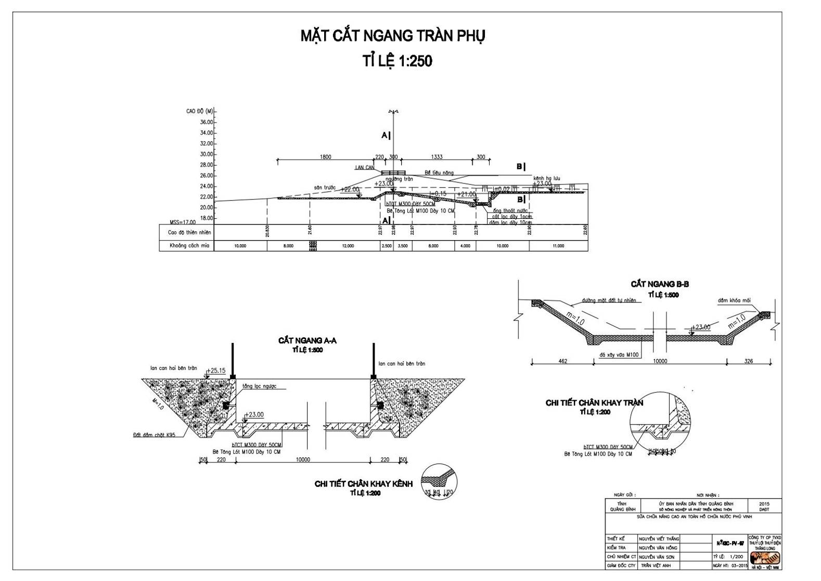

**Cross-section of auxiliary spillway**

**Rate 1 : 250**

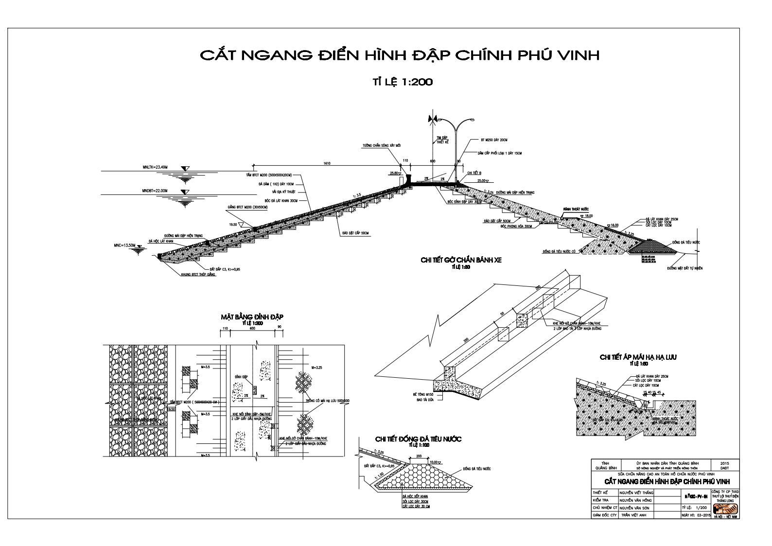

**Longitudinal section of left auxiliary dam**

**Vertical Rate 1 : 100**

**Horizontal Rate 1 : 1000**

**Longitudinal section of right auxiliary dam**

**Vertical Rate 1 : 500**

**Horizontal Rate 1 : 1000**

**Cross-section of main dam of Phu Vinh reservoir**

**Rate 1 : 200**

**General layout of repaired dam**

**Rate 1 : 1000**

**General layout of current dam**

**Rate 1 : 1000**

**Cross-section of outlet works**

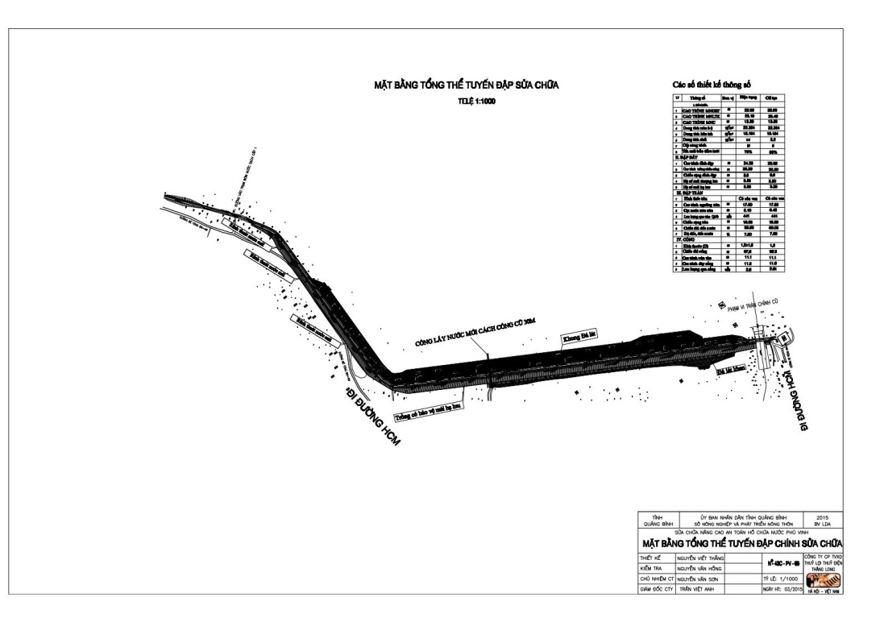

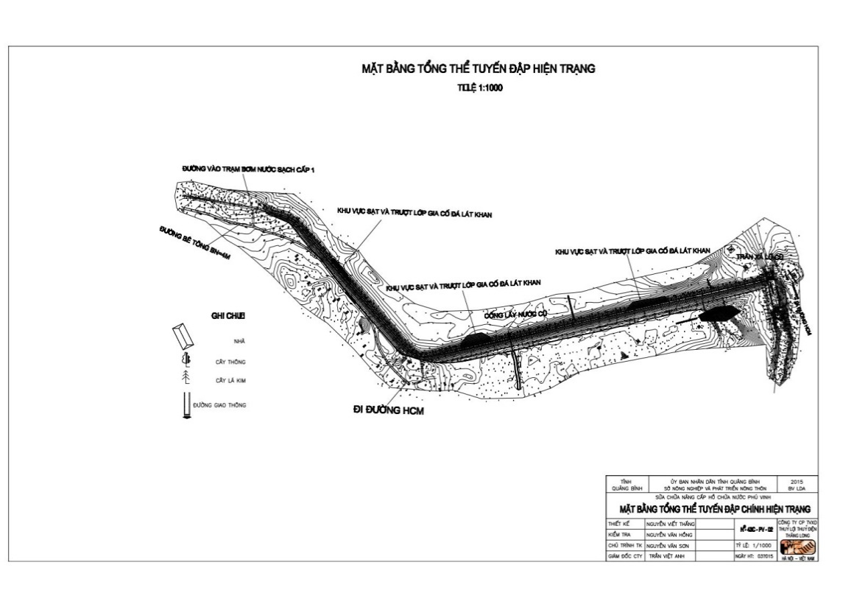

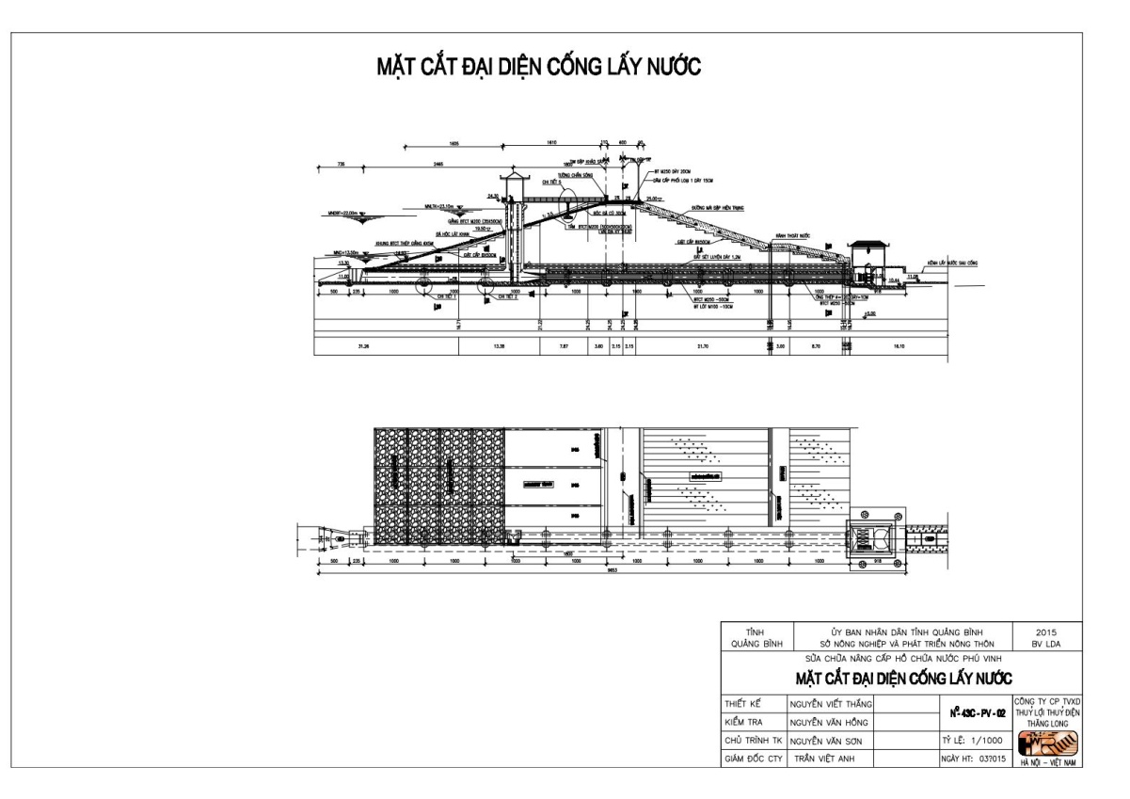

APPENDIX A2. POLICY FRAMEWORK, INSTITUTION AND REGULATION

1. **Legal Framework about the Environment**

* The Law on Environmental Protection No.55/2014/QH13 approved by the National Assembly on June 23th, 2014, with effect from January 1st, 2015;
* Decree No. 18/2015/ND-CP dated February 14, 2015, on environmental protection planning, strategic environmental assessment, environmental impact assessment and environmental protection plans;
* Circular No.16/2009/TT/BTNMT dated October 07, 2009 defining national technical regulations on environment;
* Circular No. 01/2012/TT-MONRE dated on March 16, 2012 of the Ministry of Natural Resources and Environment regulation on setting-up, assessment, approval, inspection and certification of the implementation of detailed environmental protection project; setting-up and registration of simple environmental protection project;
* Decision No.22/2006/QD-MONRE dated on December 18, 2006 on the compulsory application of Vietnam’s standards about the Environment;
* Instruction No.26/CT-Tg dated on August 25, 2014 of the Government on implementation the Law on Environment Protection;

1. **Legal Framework about using and requiring land in the investment projects**

* Land Law No. 45/2013/QH13 approved by the National Assembly on November 29th, 2013;
* Decree No. 43/2014/ND-CP dated on May 15, 2014 guiding in some articles of the Land Law 2013;
* Decree No. 44/2014/NĐ-CP dated on May 15, 2014 on land prices;
* Decree No. 47/2014/ND-CP dated May 15th, 2014 by the Government about regulation on compensation, assistance and resettlement when the Government acquires land’;
* Circular No.23/2014/TT-BTNMT dated on May 19, 2014 on land use right, owners of houses and other land-attached assets;
* Circular No. 37/2014/TT-BTNMT dated June 30th, 2014 about detailed regulation on compensation, assistance and resettlement when the Government acquires land.

1. **Legal Framework about managing and construction investment projects**

* Law on Construction No. 50/2014/QH13 approved by the National Assembly on August 18th, 2014;
* Decree No. 12/2009/ND-CP dated on February 10, 2009 on management of investment projects on the construction of works;
* Decree No.15/2013/ND-CP dated February 6, 2013 of the Government on quality management of construction works.
* Decree No. 207/2013/ND-CP dated on December 11, 2013 of the Government amending and supplementing a No. of Articles of the Decree No. 48/2010/ND-CP dated May 07, 2010 of the Government on contracts in construction activities
* Decree No.32/2015/ND-CP dated on March 25, 2015 on cost management of construction works;

1. **Legal Framework about related to the exploitation of water resources; protection forest, cultural heritage and biodiversity**

* Law on Cultural heritage No. 28/2001/QH10 of June 29, 2001 approved by the National Assembly on July12th, 2001;
* Law No. 20/2008/QH12 on Biodiversity dated November 13, 2008
* The Law on Water resources No.17/2012/QH13, approved by the National Assembly on June 21st, 2012
* Decree No. 149/2004/ND-CP dated on July 17, 2004 on the issuance of permits for water resource exploration, exploitation and use water resource and letting out water;
* Decree No. 112/2008/ND-CP dated on October 20, 2008 of the Government on management, protection and integrated exploitation of resources and environment of hydro-power and irrigation reservoirs;
* Decree No. 120/2008/ND-CP dated on December 01, 2008 of the Government on river basin management;
* Decree No.42/2012/ND-CP dated on May 11, 2012 of the Government on management and use of rice – farming land;

1. **National policies about Dam safety**

* Decree No.72/2007/ND-CP dated May 07, 2007 of the Government on Dam safety management;
* Decree No. 143/2003/ND-CP dated on November 28, 2003 detailing the implementation of a No. of articles of the ordinance on exploitation and protection of irrigation works;
* Circular No. 33/2008/TT-BNN dated on February 04, 2008 guiding the implementation of a No. of articles of the Decree No. 72/2007/ND-CP;
* Circular No. 45/2009/TT-BNN dated on July 24, 2009 on guiding making and approving the methods protecting irrigation works;
* Circular No. 65/2009/TT-BNN dated on October 12, 2009 on guiding operation and exploitation irrigation construction;
* Circular No. 34/2010/TT-BCT dated on October 07, 2010 on dam safety management of hydro-power works;
* Circular No. 40/TT/BNN dated on May 27, 2011 on capability of individuals and organizations when managing, exploiting irrigation construction;
* Decision No. 3562/QD-BNN-TL dated on November 13, 2007 on technical capacity demand of Dam management unit;
* Dam safety notebook of World Bank dated October, 2012;
* Dam safety status report No. 252/BC-KTCTTLL dated May 09, 2013 of Quang Binh Irrigation Construction Exploitation Co, Ltd;
* Report of Quang Binh Irrigation Construction Exploitation Co, Ltd on flood, storm control and prevention measures to ensure Dam safety for Phu Vinh reservoir in 2014;
* Report of Quang Binh Irrigation Construction Exploitation Co, Ltd on storm, flood prevention and control measures to ensure Dam safety in rainy season, 2014.

1. **Regulations regarding resettlement**

* The Constitution of Viet Nam in 2013;
* Land law No. 45/2013/QH13 taking effect on July 01, 2014;
* Decree No. 38/2013/ND-CP dated on April 23, 2013 of the Government of Viet Nam on management and use of official development assistance (ODA) and concessional loans of donors;
* Circular No. 30/2014/TT-BTNMT dated on June 02, 2014 regulating on dossier for land assignment, land lease, land use purpose conversion, land recovery;
* Circular No. 36/2014/TT-BTNMT dated 30 June, 2014, regulating method of valuation of land; construction, land price adjustment; specific land valuation and land valuation advisor;
* Decision No. 1956/2009/QD-TTg dated November 17, 2009 by the Prime Minister approving the Master Plan on vocational training for rural labors up to 2020;
* Decision No. 52/2012/QD-TTg dated November 16, 2012 of the Prime Minister on employment and vocational training support policies for labors subject to agricultural land recovery;
* Decision No. 22/2014/QD-UBND dated September 09, 2014 by Quang Binh PPC about the issue of Regulation on compensation, assistance and resettlement policies when the Government acquires land in Quang Binh province;
* Decision No. 36/2014/QD-UBND dated 22/12/2014 by Quang Binh PPC about regulation on prices of lands and classification of city area, commune, area, land position in Quang Binh province, period 2015-2019;
* Decision No. 37/2014/QD-UBND dated 31/12/2014 by Quang Binh PPC about issue of Prices for houses, construction works on land to compensate when the Government acquires land in Quang Binh province;
* Decision No. 08/2015/QD-UBND dated 10/02/2015 by Quang Binh PPC about the issue of Prices for vegetation, assistance on aquaculture, grave relocation to compensate when the Government acquires land in Quang Binh province;
* Decision No. 1665/TTg-CN dated October 17, 2006 of the Prime Minister on managing activities of site clearance and bomb, mine and explosive object sweeping to enable traffic construction projects;
* Resolution No. 100/2014/NQ-HDND dated December 11, 2014 on the land price list in Quang Bing province from 2015 to 2019.

1. **Regulations regarding gender**

* Law No. 52/2014/QH13 on Marriage and Family dated June 19, 2014;
* Law on Government arrangement No. 32/2001/QH10 dated December 25, 2001;
* Law No.73/2006/QH11 on Gender equality dated November 29, 2006;
* Law No. 02/2007/QH12 dated November 21, 2007 on domestic violence prevention and control;
* Decree No. 70/2008/ND-CP dated June 04, 2008 details the implementation of a number of articles of the law on gender equality;
* Decree No. 08/2009/ND-CP dated February 04, 2009 detailing and guiding the implementation of a number of articles of the law on domestic violence prevention and control;
* Decree No. 48/2009/ND-CP dated May 19, 2009 providing for measures to assure gender equality;
* Decree No. 55/2009/ND-CP dated June 10 on sanctioning of administrative violations of gender equality;
* Joint circular No. 40/2011/TTLT-BLDTBXH-BYT dated December 28 defining the adverse working conditions and job categories that are not used female employees, female employees who are pregnant or nursing children under 12 months old;
* Decision No. 2351/QD-TTg on December 24, 2010 approving the 2011-2020 national strategy for gender equality;
* Decision No.56/2011/QD-TTg dated October 14, 2011 on promulgation of the set of national indicators on gender-related development statistic;
* Decision No. 301/QD-MOLISA dated March 16, 2011 promulgating the Plan of MOLISA implementing National strategy about gender equality from 2011-2020;
* Resolution No. 11-NQ/TW dated April 27, 2007 of the Political Bureau on the works for women in the industrialization and modernization period;
* Resolution No. 57/ND-CP of the Government dated 15th December, 2010 on administrative procedure simplification under the management of MARD;
* Dispatch No. 664/MOLISA – BDG dated March 11, 2011 on guides of Ministries, departments during making National strategy implementation plan about gender equality;
* Dispatch No. 1854/MOLISA – BDG on giving opinions for guiding document draft for implementation preventing and mitigating negative impacts of gender violence.

1. **Regulations regarding hunger eradication and poverty reduction**

* Circular No. 06/TT-UBDT dated September 20, 2007 of Ethnic committee gilding service support, improvement livelihood of communities, support technique to enhance the law knowledge of citizen following Decision No. 112/2007/QD-TTg;
* Decision No. 33/2007/QD-TTg dated July 20, 2007 of Prime Minister on allowance policies to enhance the law knowledge of citizen following 135 program, period 02.

1. **Other documents relating to the subproject implementation**

* Decision No. 2139/QD-BNN-KH of Ministry of Agriculture and Rural development dated September 20, 2013 on allowance investment preparation and give project investment duty “Repair, upgrade Vuc Tron –Phu Vinh reservoir, Quang Binh province;
* Dispatch No. 1158/TCTL-XDCB dated October 07, 2013 of Irrigation general Department about making investment estimation outline and selecting consultation unit making investment project for the subproject “Repair, upgrade Vuc Tron – Phu Vinh reservoir, Quang Binh province;
* Report of investment project “Repair, upgrade Vuc Tron – Phu Vinh reservoir, Quang Binh province- work: Phu Vinh reservoir”;
* Notice No. 1230/BNN-VP dated January 30, 2015 of Ministry of Agriculture and Rural development about informing opinions of Ministry for implementing WB8 project in Quang Binh province;
* Dispatch No.137/CPO-WB8 dated January 30, 2015 of CPO on making ESIA implementation plan;
* Document No. 1469/VPUBND-KTTH dated July 31, 2014 of Quang Binh PPC on giving duties for project owner: “Dam Rehabilitation and Safety Improvement Project (WB8).

1. **Viet Nam regulations relating to Environment protection**

*(i) Water environment*

* QCVN 08:2008/BTNMT: National technique regulations on water surface quality;
* QCVN 09:2008/BTNMT: National technique regulations on underground water quality;
* QCVN 14:2008/BTNMT: National technique regulations on wastewater quality in water source;
* QCVN 01:2009/BTNMT: National technique regulations on drinking-water quality;
* QCVN 02:2009/BTNMT: National technique regulations on running-water quality;
* QCVN 39:2011/BTNMT: National technique regulations on water quality for irrigated agriculture;
* QCVN 40:2011/BTNMT: National technique regulations on industrial wastewater.

*(ii) Air environment*

* QCVN 07:2008: Air quality – Threatening of noxious substances in the air;
* QCVN 06:2009/BTNMT: Air quality - National technical regulation on hazardous substances in ambient air;
* QCVN 05:2013/BTNMT: Air quality - National technical regulation on ambient air quality;
* TCVN 6438:2001: Maximum permission limit of discarding exhausted gases.

*(iii) Land environment*

* QCVN 03:2008/BTNMT – National technique regulations on permitted limit of hard metal in land;
* QCVN 43:2012/BTNMT –National Technical Regulation on sediment quality.

*(iv) Solid waste management*

* TCVN 6696:2009: Solid waste – garbage cleaning. Common requirements for environmental protection;
* QCVN 07:2009: National technique regulations on clarifying harmful waste.

*(v) Vibration and noise*

* QCVN 26:2010/BTNMT – National technique regulations on noise). (replacing TCVN 5948:1999 Acoustics – Noise caused by transportation moving when speeding up – permitted calculation level);
* QCVN 27:2010/BTNMT – National technique regulations on vibration (replacing TCVN 6962:2001 – Vibration caused by construction work and factories – maximum permitted level in environment in public areas and residence zones).

*(vi) Health and labor safety*

* Decision No. 3733/2002/QĐ-BYT of Ministry of Health dated October 10th 2002 about applying article 21 on labor health and relating safety criterions for microclimate, noise, vibration, chemicals – permitted level in work place.

APPENDIX A3. ENVIRONMENTAL AND SOCIAL SCREENING

Table A-1: Screening and Environmental Categorization

| **Issues** | **Level** | **Descriptions** |
| --- | --- | --- |
| 1. ***Impacts on the Natural Environment*** | | |
| Loss or degradation of land and water areas where there are native species, and where human activity has not significantly alter the fundamental ecological functions | No Impact | The sub-project only improves the current status without widening and violating to nature reserve, the construction is only in a narrow scope compared with the water surface area of the reservoir. Also, there is no sensitive natural environment in the sub-project construction area. |
| Loss or degradation of natural habitats such as: important conservation areas, areas protected by traditional local communities (e.g. sacred forest), biodiversity; rare, vulnerable, migratory or endangered species. | No Impact | There is no natural reserve or biodiversity zone within 20km radius from the reservoir. The sub-project only implements around main works and conduct on the existing work items. Total permanently acquired area for the construction is 67,805.5 m2. |
| 1. ***Impact on Physical Cultural Resources*** | | |
| Loss or degradation of the material culture resource, structures, groups of structures, characteristics, natural landscape with importance of archaeology, palaeontology, history, architecture , religion, aesthetic, or other importance of culture. | No Impact | There is not any impact on material culture resource, structures, groups of structures, characteristics or natural landscapes, sites or structure with importance to archaeology, palaeontology, history, architecture, religion, and aesthetics within 2-km radius of the reservoir. |
| Result to conflict with national laws or international obligations under treaties or international environmental agreements, including the World Heritage Convention of UNESCO or affect famous, scientific and important heritage sites. | No Impact | There is no World Heritage, national heritage or local heritage sites or structures of great scientific or tourism potentials within and around the construction areas.  The sub-project will ensure national laws or international obligations under treaties and related environmental agreements are fully complied with. |
| 1. ***Impacts on land and related natural resources used by Ethnic Minorities*** | | |
| May result to impacts on land or traditionally owned territory, or used or customary tenure, and where access to natural resources, which is vital for the sustainability of the culture and livelihood of ethnic minorities. | No Impact | The sub-project will not use land or territory traditionally owned by ethnic minorities, or land under customary tenure. |
| Likely to lead to impact on cultural and spiritual values symbolized for the land and natural resources or impact on management of natural resources and the long-term sustainability of resources affected. | No Impact | The sub-project will not use land or territory traditionally owned by ethnic minorities, or land under customary tenure. |
| 1. ***Displacement of Home and/or Livelihood*** | | |
| Result to the displacement of people or land acquisition, property affecting their lives and difficulty in restoring livelihoods. | No Impact | - There is no relocating household. There are only 7 households having lands acquired, 24 households losing plants and 719m2 of fishpond.  - There is no household affected to accommodation.  - Acquisition of land and assets on land has insignificant impact on income of affected households since their incomes are from many other sources: hack-work, forestry, office-job, industrial job,… |
| 1. ***Dam Category*** | | |
| The operation of the sub-project depends on the efficiency of an existing large dam or large dam under construction. | No Impact | - Phu Vinh dam is operated separately. Water storage and discharge are not related to any other dam. |
| 1. ***Use or purchase of pesticides*** | | |
| Does the subproject lead to procurement or use of pesticides? | No Impact | The purchase or use of pesticides is not in the procurement plan of the sub-project. However, the improve reliability of the dam will also improve irrigation services from 1672 ha to 2825 ha (increasing by 1153 ha) to the farms downstream which may lead to increase use of pesticides |
| 1. ***Does the subproject have any potential impact that is irreversible or difficult to mitigate?*** | | |
| -Lead to loss of regional recharge aquifers, affecting the quality of water storage and water storage areas responsible for providing drinking water to large population centres | No Impact | The subproject aims to improve the water supply for agriculture. It does not affect to the water quality of any water storage area related to clean water supply for domestic purpose |
| -Lead to any impact occurring in relatively long period, affecting to large geographical area or intense impact. | No Impact | The construction activities including upgrading, repair of Phu Vinh reservoir is considered done in the dry season, the influence of water to benefit area during construction almost did not happen. The reservoir will be repaired to ensure the safety of the people at the downstream dam and provides stable and effective water contributing to community economic development. |
| 1. ***Does the subproject have potential to lead to a wide variety of significant adverse effects?*** | | |
| Many construction sites in various locations are affected, each impact cause loss of habitat, natural resources, land or significant depletion of resources quality. | No Impact | Construction works of the subproject only involve main dam, outlet works and spillway, within dam safety corridor. Thus, there is only 01 construction site.  - The subproject construction will take place in the small area. It does not affect to living environment, natural resources, land and natural resources quality decreased significantly. | |
| The significant potential adverse effects capable to expand beyond the construction site or works. | No Impact | - Residents, vegetation along transportation route from Hochiminh road to construction site and other transportation routes are affected by transportation activities.  - Transportation activities generate dust and emission, degrade infrastructures and potentially increase risk of road accident. | |
| The impact across the border (in addition to a small change in the waterway activities are taking place). | No Impact | - Subproject area locates 42km way from the Vietnam-Laos borderline and Ca Roong border gate and is separated from the borderlines by Truong Son range. | |
| The need for public road, tunnel, canal, power transmission corridor, new pipeline, or borrowed area and disposal areas in underdeveloped region. | No Impact | Subproject area uses electricity supply from the national grid.  - The subproject will expand dam top from 5m to 6m and concretise. | |
| Interrupt the cycle of migration of wildlife, wild animal or grazing animal, nomads or semi-nomads | Yes | Noise from construction activities can be affected to some terrestrial faunas and floras living surrounding the reservoir. However, there is no rare, vulnerable, migratory or endangered species at risk of extinction in surrounding the Phu Vinh reservoir. The subproject construction can affect to the living area of underwater species. However, this is interrupted and temporary impacts. | |
| 1. ***The subproject does not have precedent work, does it?*** | | | |
| No precedent at national level? | No | - Since the operation of Phu Vinh reservoir, there has never been any repair project at national level. | |
| No precedent at provincial level? | Yes | * A 100m-emergency-spillway at the left of main dam was constructed in 2000. * In 2014, the Province had arranged 3.2 billion VND to repair and temporary fix some severely eroded sections of dam face to ensure reservoir safety in flood season 2014. | |
| 1. ***Is subproject controversial and likely to attract the attention of NGOs and national or international social organizations?*** | | | |
| Considered as risk and likely to have special controversial aspects | No | There is not any negative point that leads to the attention of civil society organizations, NGOs. | |
| May lead to protests of those who wish to express or prevent construction. | No | Consultation results showed that both the local government and the people fully agreed and supported implementation of the subproject. The subproject will bring greatly efficiency in terms of environment and society to local people. | |

Table A2: Levels of Potential Environmental and Social Impacts to be addressed

|  |  |  |  |
| --- | --- | --- | --- |
|  | **Assess-ment** | **Description of Impact** | |
| The trespass on historical/cultural heritage. | No | There is NO any cultural works, heritage or grave are affected or relocated in subproject scope area. | |
| The trespass on ecosystem (e.g. natural sensitive living environment or nature reserve, natural park, etc.). | No | The subproject only improves current dam status without widening and violating to nature reserve. Furthermore, there is no nature reserve or natural sensitive environment in the distance of 20km from Phu Vinh reservoir. | |
| To deform landscape and increase waste. | Low | There are 03 solid waste sources arising from construction activities including: (i) construction waste likes deribs from surface levelling activities (plants, residual, fences, etc.), cement bags, oil barrels and (ii) domestic waste from tents of workers in construction site and (iii) superfluous excavated soil. In addition, mud waste from latrine can contain harmful bacteriums need to be treated during construction process.  The above impact is LOW and TEMPORARY because:   1. With type (i) and type (iii), the solid waste is unharmful, as for remaining material (with total estimated volume around 11,336 m3) has been collected and moved fast to the landfill. 2. For the waste type (ii):In the high-levelled construction period there are around 40 people working in construction site thus the amount of potential waste is not much, estimating around6–20 kg per day (around 0.3-0.5kg/person/day); waste water is 8.42 m3/day. 3. The amount of solid waste arising in construction period can be easily managed as per regulation on solid waste management. The domestic waste like mud of latrine will be treated conform to designed standards of Ministry of Health and the quantity of this mud can be used for planting as a fertilizer for soil. | |
| Demolish trees or vegetation cover | Low | Implementation of the subproject is based on the current status of the work, thus, there is no any vegetation cover be demolished or damaged. The permanently land recovers for building operation house and road must be cut down 3000 trees of Melaleucas and Acacias. The residual bare lands nearby reservoir managed by the Commune People’s Committee. | |
| Change quality of surface water or flow (e.g., increase water turbidity, wastewater discharged from camp and erosion, and construction waste). | Low | Spilled oil from machinery and construction equipment or water when washing machines can pollute and decline water quality and aquatic ecosystems.  Wastewater and oil compounds may be sunk into the ground and over time will gradually seep into aquifers and contaminate aquifers.  Besides, wastewater from toilets of worker camps if not applied properly can also influence water quality of nearby.  However, this impact is LOW and TEMPORARY because:   1. Location of camp, oil storage yard is far from water sources. 2. Construction of the subproject will take place in dry season when rain fall level is the lowest. Thus, the possibility of oil, grease or compounds washed and swept into water source is very little   Wastes from petroleum products can easily be stored in a safe place in the standard containers (ie. containers with lids), and the contractor will have to collect and dump waste and hazardous waste damage at right places. | |
| Increase the level of dirt or contaminants in the air during construction process | Low | During repair and upgrading of dam, outlet works and auxiliary works, some activities described below will cause negative impacts such as dust, emissions affecting lives of local people:   * The exploitation of earth fill materials. * The transportation of construction materials (earth fill, cement, sand, gravel, steel, etc) * Transportation of construction waste (soil weathering, surplus construction materials) * The operation of equipment and trucks and use of construction machinery   It is estimated that there are about 36 trucks transport on roads every day during the construction.  The amount of dust and emission can cause respiratory disease or lung diseases to people (such as sinusitis, asthma, etc.) if people, workers directly contact with the pollutant sources for long time.  However, this impact is LOW and TEMPORARY because:   1. The subproject area is in the valley. Dust that can easily be diluted in the air and blown by wind; 2. The transport road of construction materials and waste to landfill passes through one village, and residential area is also sparse. This impact is evaluated as very small 3. Number of vehicles/construction equipment especially vehicles/equipment causing noise is not much, about 20 trucks passing through residential areas will not generate a large amount of emissions. | |
| Increase noise/vibration. | Low | Noise can be caused by the transportation of construction materials and construction equipment (excavators, bulldozers, road rollers, compactors) affecting households and schools along the road section for construction   * Within 15m from source, noise level is from 70-96 dB. * At 250m distanced from source, noise level is at approved level by National Technical Regulation 26:2010/BTNMT. * There are about 43 households living nears construction site affected by noise. * Noise affects 80 households living along transportation route.   However, this impact is LOW and TEMPORARY because:   1. The subproject area is open space, with lots of plants and crops which may dilute the noise. 2. The residential area adjacent to the road and construction works are distributed fairly sparse, with a low population density. 3. The number of equipment / facilities construction generating noise is not significantly large. | |
| Resettlement of households? If yes, how many households? | No | There is no replaced household | |
| Use resettlement region being environmental and/or cultural sensitivity. | No | There is not any relocated household. Only the certain area of Landis recovered during the construction. | |
| The risk of disease infection from human to local people (and vice versa) | Low | - The temporary presence of workers residing in local households or in the camps and their interaction with local people can cause infectious diseases among workers with local people and vice versa.  - During construction process, the use of water without sanitary standards met of workers in the camps or at construction site may also cause gastrointestinal disease or the spread of disease transmission via insect (ie. dengue fever, malaria, etc.) when migrant infected workers are bitten by insects (mosquitoes) and then the disease is spreader to others. Besides, various social diseases such as HIV / AIDS, syphilis also a risk, etc. are also at risk.  - However, this impact is LOW and TEMPORARY because:  a) The large terrain leads to easily dispersed of dust in the wind;  b) The latrine is designed under standards of the Ministry of Health;  c) Controlling the spread of the pathogenic insect as well as propagating the prevention of pathogenic insect for workers;  d) The Contractor regularly checks the health for employees in the recruitment process;  e) The local government and Center of Health Services will have the propagandic activities when the signs of infectious disease appear in the province. | |
| Potential to cause conflict between construction workers and local people (and vice versa). | Low | - During construction period, approximately 40 technical workers from other provinces will be living and working locally. During this time, there may be conflict between the local labors and labors from elsewhere due to disagreements about the culture or communication or disputes on employment opportunities. However, these effects are LOW and TEMPORARY because:  i)According to state regulations, the contractor will have to declare temporary residence, temporary absence of all the local workers to live and work during the project implementation to Ngoc Son commune;  ii).Migrant workers are disseminated, guided by contractor on how to communicate, notify with local government and people. In addition, contractor shall develop provisions in management of workers  iii)A number of workers (30%) will be hired locally to perform simple tasks such as shoveling dirt, cutting trees, portering construction materials.  Location: Thuan Duc commune and Dong Son ward.  Period: 24months of contraction stage during dry seasons. | |
| Use explosives and toxic chemicals. | No | Explosives or toxic chemicals will not be used during construction process of the subproject. | |
| Use construction site where the accident happened due to blasting or explosive left over from war period. | No | Subproject will carry out with the existing situation of dam and reservoir where is never occurred mine accident or explosive materials since the Vietnam war. | |
| Construction activities may disrupt transport, roads, or navigation. | Low | - Construction period may impact on local travel, transportation, as well as the risk of accidents:a) increase risk of accidents due to the increase of the means through inter-commune roads and construction sites (where the excavation activities are carried out, and where the construction equipment, waste locate on or next to roads, works, etc.). It may danger local people, especially at night when visibility is limited; and suspended dust particles reduces visibility; b) the construction of the dam and auxiliary works such as management road will limit the ability of people to travel as well as access to social infrastructure such as schools, markets, etc.  However, these effects are LOW and TEMPORARY because:   1. The transportation routes of construction materials will pass through the sparsely populated areas. Thus, use of this routes for material transportation will not obstruct traffic much. 2. The number of vehicles/equipment for road construction is about 138 turns of trucks per day is negligible. 3. A part within the scope of the contractor is to ensure the health and safety on construction sites for individuals and construction site; it is not allowed to have the risk to the safety of people. Therefore, the contractor shall take measures to minimize the impact during construction process. 4. The transportation routes of construction materials will not pass through the CPC and the schools. Thus, use of this routes for material transportation will not obstruct traffic much. | |
| Construction activities may cause any damage to the local roads, bridges or other rural infrastructure? | Medium | - The construction materials or waste transportation on rural roads can damage the road if the trucks are overloaded and operate much in rainy season.  - Other rural infrastructures such as canal system, electric cable system, communication cable system are not affected by the construction of the subproject, because these work lie in the safety corridor of the main roads. There is no electric cable system or communication cable on the management road. The others are also far from construction area of the subproject. Thus, these social infrastructures are not likely to be affected by the construction activities.  The impact is LOW and TEMPORARY because:  i)The construction is carried out mostly in dry season, thus material transportation vehicles cause low impacts on quality of the road;  ii) The volume of construction materials and the number of vehicles transporting materials is small, about 138 turns of truck/day. | |
| Excavation during construction of the subproject can cause soil erosion. | Low | - Construction of dam face and outlet works may cause erosion on dam body or nearby location. However, this effect is LOW and TEMPORARY because (i) the repairing activities for dam face and outlet works will be carried out in the dry season and the girdle shaped dike will be constructed. The location of construction is located above the water level. It is difficult to cause soil erosion. | |
| Is it needed to create a temporary and permanent service road? | No | - It is no need to develop a temporary and permanent service road, because the current roads are capable to transport construction materials or waste. | |
| Divide or disintegrate habitat of animals and plants (faunas and floras). | No | + Flora and fauna in the reservoir will not be affected by the project and will not create an impact on water quality or water.  + For terrestrial flora: There is no position as habitat of flora and fauna around the subproject area and area indirectly affected. | |
| Long-term impact on air quality. | No | The sources of air pollution mainly rise from dust caused by the transportation of construction materials, waste transportation, etc. running on the roads in Ngoc Son commune. In addition, the air may be polluted by emission from construction machinery, vehicles. However, it is very few source of emission and it only appears in certain time. Therefore, there is NO long-term impact on air quality but a temporary impact on air environment. | |
| The risk of accidents for workers and communities in the construction stage. | Medium | - Construction process can make risk of accidents due to operating machinery, digging and filling soil or transporting materials in case that the workers do not comply with regulations on occupational safety. In addition, the construction can also cause accidents for community if the access of people into the construction area is not limited.  However, the impact is LOW and TEMPORARY because:  i) Number of construction machinery is few;  ii) Much activities will be carried out manually such as partnering material, concreting, etc. Thus, risk of accident will be reduced.  iii) Construction activities are mostly undertaken in dry season, accident is also reduced.  iv) Construction site is far from residential areas. | |
| Use hazardous or dangerous material and generate hazardous waste | No | There is no need to use hazardous or dangerous material or generate hazardous waste. Only a low amount of oil use for machinery can leak to environment. | |
| Risks to safety and human health. | Low | During construction, there may be accidents for communities in case of unlimited local people accessing the construction area. In addition, the waste during the construction handled not well can also cause negatively affects to the health of the local population. | |
| Affect to water supply and production during construction of work items | Low | Water supply can be affected during construction of dam face, spillway, especially outlet works. However, the impact is LOW and TEMPORARY because :  (i) Construction activities for outlet works will be carried out in the dry season and the girdle shaped dike will be constructed.  ii) Water is pumped from the reservoir through the canal to supply water for irrigation as required. | |
| Increase flooding, sediment transport in downstream area | Low | Phu Vinh reservoir is independent reservoir; its downstream area is irrigated areas. It will need to discharge water in reservoir to death water level at specific times during construction process. The water discharged may cause the localize flooding of agriculture areas. However, the area is supplied with good drainage system, thus this impact is considered as LOW and TEMPORARY. | |
| **Loss of land or loss of access to land/resources or livelihood** | | | |
| Land acquisition (temporary or permanent) of public land (public or private) for construction. | Low | - Permanent land acquisition: total area of land acquisition is 67,805.5m2, including 12,179.7m2 belongs to 07 households in Dong Son ward, consisted of (i) perennial agricultural land of 07 households; (ii) aquaculture area of 02 households. All other area (55,625.8m2) is managed by Quang Binh province’s Irrigation construction exploitation limited liability one member company.  There is no additional area to be temporarily acquired. | |
| Use land being currently possessed or used regularly for production purposes (e.g., gardening, farming, grazing, fishing, forest) | No | Implementation of the subproject will not acquire land for production, gardening and farm, etc. Because the upgraded items are based on the current situation and the enlarged area of safety corridors road/dam.  The recovery land areas are mainly land on dam safety corridor. | |
| Relocation of personal, family, or business. | No | Implementation of the subproject will not acquire land of any households or affect business operation, because construction activities are carried out around dam area and along the management road. There is no business along the road and next to the dam. | |
| Temporary or permanent loss of crops, fruit trees, house or infrastructure. | No | * Plants: 24 AH lose vegetation on land, including: (i) gum trees and acacia plants cluster (4.26ha); (ii) gum trees and acacia plants scatter (2,700 individuals); (iii) Jack fruit trees has been matured and can be harvested (10 individuals); (iv) Sour sop trees to be harvested (10 individuals); (v) Banana trees that have not matured (50 individuals); (vi) Rice field 1 season per year (11,673m2); * Fish pond: the subproject acquires 719m2 of fish pond belong to 02 households. * Accommodations: no HH is affected. * Auxiliary structures (fences, toilets,…): no HH is affected; * Cultural, historical or religious monuments: none affected; * Public assets: no asset affected. * Severely affected households: there is no severely affected household (losing from 20%, or 10% in term of poor or vulnerable HH, of total production land. | |
| Restrict compulsory access of people into preserved park and conservation area. | No | No preserved park or conservation area locating in subproject area, thus it is not likely impact. | |
| **Impact to ethnic minorities** | | | |
| The ethnic minority groups living within or near the subproject. | No | | Kinh people accounts for 100% of population of Thuan Duc commune and Dong Son ward - subproject area around Phu Vinh reservoir. Thus, the project will not affect minority groups locally. |
| Members of minority groups in the region may be benefited or harmed by the project | No | | Kinh people accounts for 100% in population of Thuan Duc commune and Dong Son ward - subproject area around Phu Vinh reservoir. Thus, the project will not affect minority groups locally. |
| **Dam Safety Issues** | | | |
| Relate to construction of a large dam? | No | | Phu Vinh dam is operated individually. Water storage and discharge of this dam is not related to any other dam. |
| Depend on water level supplied by a dam existing or under construction? | No | |

APPENDIX A4. ENVIRONMENTAL SAMPLING LOCATIONS

**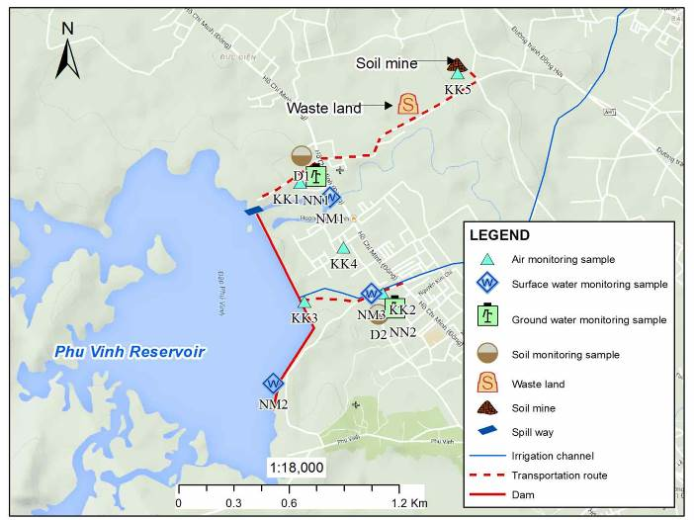**

**Figure 3 locations Map of monitoring air, water and soil**

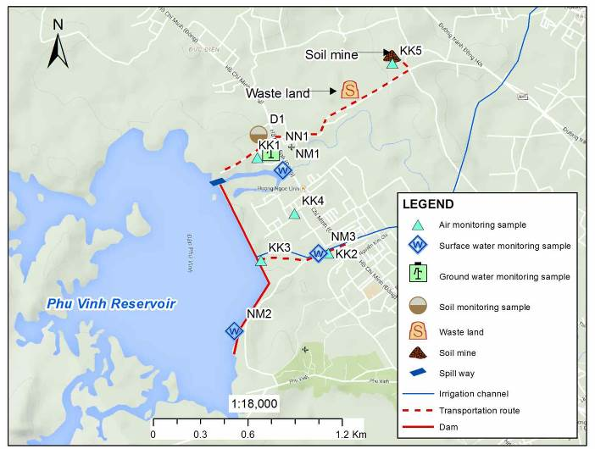

**Figure 4 Monitoring locations in construction phase**

**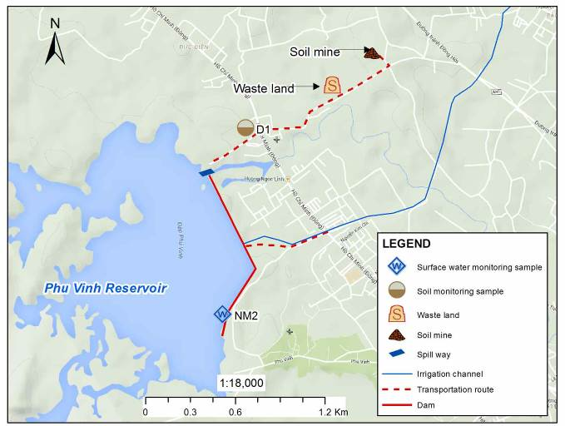**

**Figure 5 Monitoring locations in operation phase**

APPENDIX A5. COEFFICIENTS FOR CALCULATING EMISSIONS

Table 5‑1 Emission coefficients of some construction vehicles using Diesel

| **Vehicles** | **Emission coefficient kg/litre** | | | | |
| --- | --- | --- | --- | --- | --- |
| **SO2** | **CO** | **NOx** | **PM10** | **VOC** |
| Auto-shift truck | 0.00374 | 0.00993 | 0.0408 | 0.00288 | 0.00485 |
| Chain-wheeled bulldozer | 0.00373 | 0.00655 | 0.0517 | 0.00266 | 0.00153 |
| Chain-wheeled excavator 1.25 m3 | 0.00374 | 0.0102 | 0.031 | 0.00327 | 0.00228 |
| Bulldozer 108 CV | 0.00374 | 0.0147 | 0.0343 | 0.00177 | 0.00158 |
| Road roller | 0.00373 | 0.0226 | 0.0485 | 0.0029 | 0.0036 |
| Other vehicles | 0.00373 | 0.0184 | 0.0441 | 0.00361 | 0.00404 |

*Source: Documents of Australian Department of Environment and Heritage*

about the quantity of transportation vehicles and construction machines in construction sites and Circular 06/2005/ TT- BXD about price of a working shift of machines and construction equipment:

Table 5‑2 Capacity and fuel usage of construction machines and equipment

|  |  |  |  |  |  |  |
| --- | --- | --- | --- | --- | --- | --- |
| **No** | **Machine/equipment** | **Fuel. energy usage rate** | | **Quantity** | **Rate (\*)**  **litre/1kw** | **Amount of fuel use in a working shift (litre of DO/8h)** |
| **Fuel (litre)** | **Rate** |
| 1 | Chain-wheeled excavator with 1 dipper. volume 1.25m3 | Diesel | 82.62 | 4 | 1.08 | 356.91 |
| 2 | Bulldozer 108 CV | Diesel | 46.2 | 4 | 1.08 | 199.58 |
| 3 | Auto-shift truck load 6T | Diesel | 43.2 | 4 | 1.08 | 186.62 |
| 4 | Watering truck volume 5m3 | Diesel | 22.5 | 1 | 1.08 | 24.30 |
| 5 | Concrete mixer 250l | Diesel | 10.8 | 2 | 1.08 | 23.32 |
| 6 | Concrete vibrator 1.5Kw | Diesel | 6.75 | 4 | 1.08 | 29.16 |
| 7 | Auto-vibrator 25T | Diesel | 54.6 | 2 | 1.08 | 117.93 |
| 8 | Hole-driller | Diesel | 82.65 | 2 | 1.08 | 178.52 |
| 9 | Electric generator 8 Kw | Diesel | 7.56 | 1 | 1.08 | 8.16 |

*(\*): Average rate of fuel use in Diesel motor.*

The amount of some major construction machines and equipment are represented in the table below:

Table 5‑3 Emissions from construction machines and equipment (kg/day)

| **No** | **Machine/equipment** | **SO2** | **CO** | **NOx** | **PM10** | **VOCs** |
| --- | --- | --- | --- | --- | --- | --- |
| 1 | Chain-wheeled excavator with 1 dipper. volume 1.25m3 | 1.3349 | 3.6406 | 11.064 | 1.1671 | 0.8138 |
| 2 | Bulldozer 108 CV | 0.7444 | 1.3073 | 10.318 | 0.5309 | 0.3054 |
| 3 | Auto-shift truck load 6T | 0.698 | 1.8532 | 7.6143 | 0.5375 | 0.9051 |
| 4 | Watering truck volume 5m3 | 0.0906 | 0.4471 | 1.0716 | 0.0877 | 0.0982 |
| 5 | Concrete mixer 250l | 0.087 | 0.4292 | 1.0288 | 0.0842 | 0.0942 |
| 6 | Concrete vibrator 1.5Kw | 0.1088 | 0.5365 | 1.286 | 0.1053 | 0.1178 |
| 7 | Auto-vibrator 25T | 0.4399 | 2.17 | 5.201 | 0.4257 | 0.4765 |
| 8 | Hole-driller | 0.6659 | 3.2848 | 7.8729 | 0.6445 | 0.7212 |
| 9 | Electric generator 8 Kw | 0.0305 | 0.1502 | 0.3601 | 0.0295 | 0.033 |
|  | **Total** | 4.2 | 13.819 | 45.818 | 3.6124 | 3.5652 |
|  | **NTR 05:2013/BTNMT** | 0.003 | 0.24 | 0.0024 | 0.0036 |  |

Table 5‑4 Emission rate of trucks

| **Pollutant** | **Emissions by vehicle load (kg/1000km)** | | | | | |
| --- | --- | --- | --- | --- | --- | --- |
| Vehicle load < 3.5 tonnes | | | Vehicle load 3.5 - 16 tonnes | | |
| Urban area | Rural area | Highway | Urban area | Rural area | Highway |
| Dust | 0.20 | 0.15 | 0.30 | 0.90 | 0.90 | 0.90 |
| SO2 | 1.16S | 0.84S | 1.30S | 4.29S | 4.15S | 4.15S |
| NO2 | 0.70 | 0.55 | 1.00 | 1.18 | 1.44 | 1.44 |
| CO | 1.00 | 0.85 | 1.25 | 6.00 | 2.90 | 2.90 |
| VOC | 0.15 | 0.40 | 0.40 | 2.60 | 0.80 | 0.80 |

*Source:* WHO (*Assessment of Sources of Air, Water and Land Pollution -Part 1: Rapid Inventory Techniques in Environmental Pollution, WHO, 1993).*

Note: S: percentage of sulphur component in the fuel (%)

APPENDIX A6. SAMPLE OF CONSULTATION MEETING MINUTES

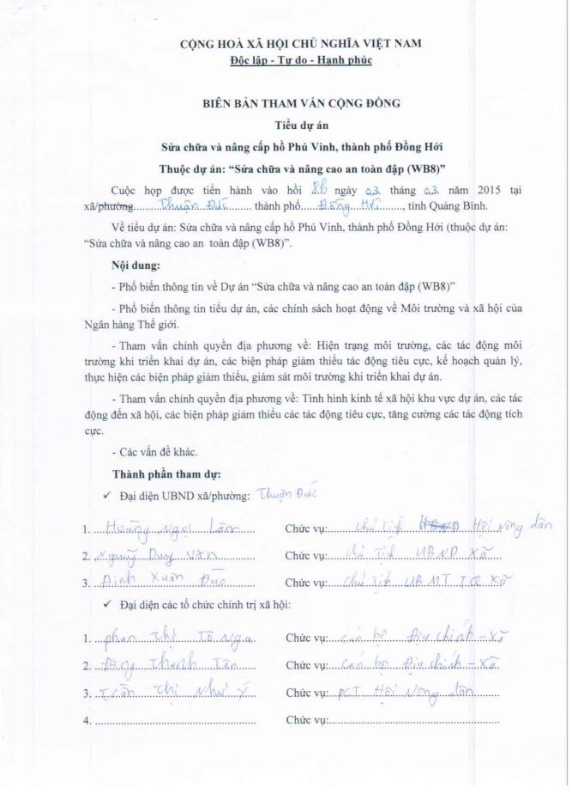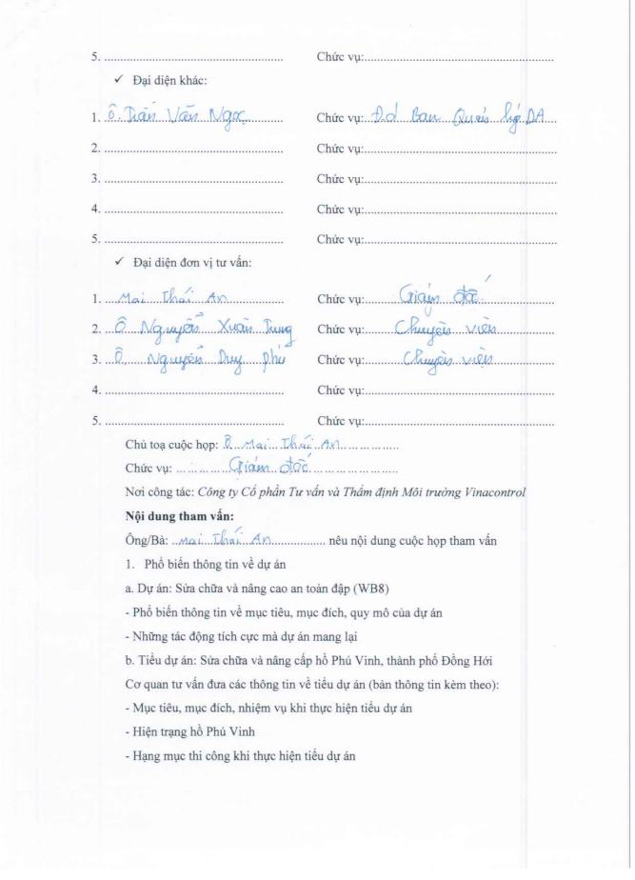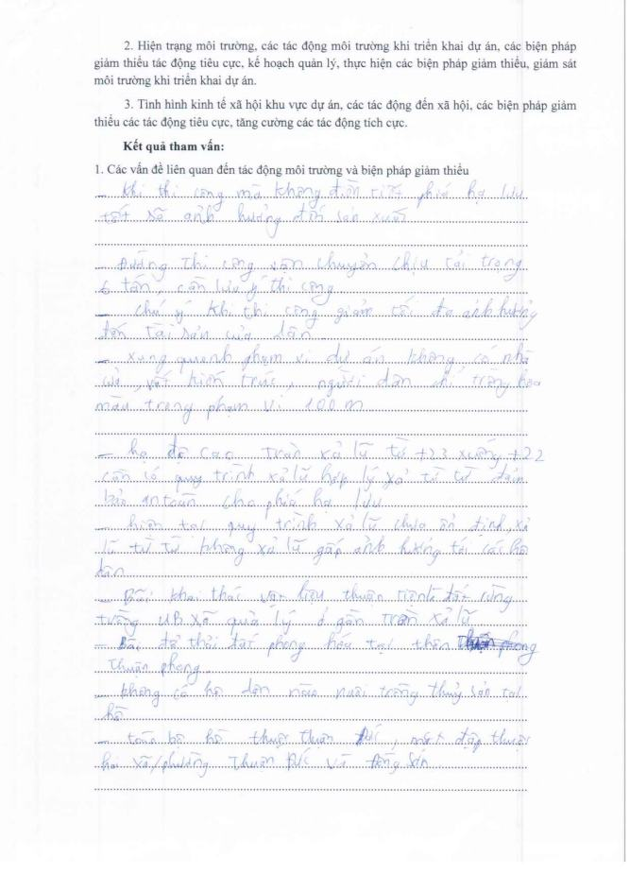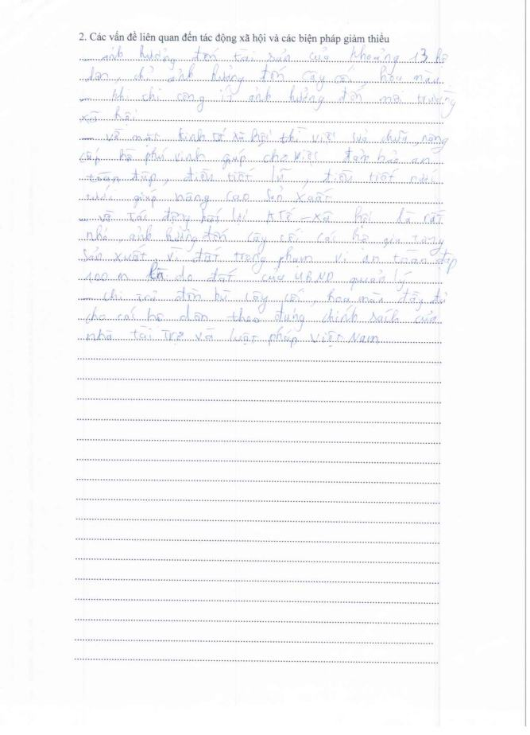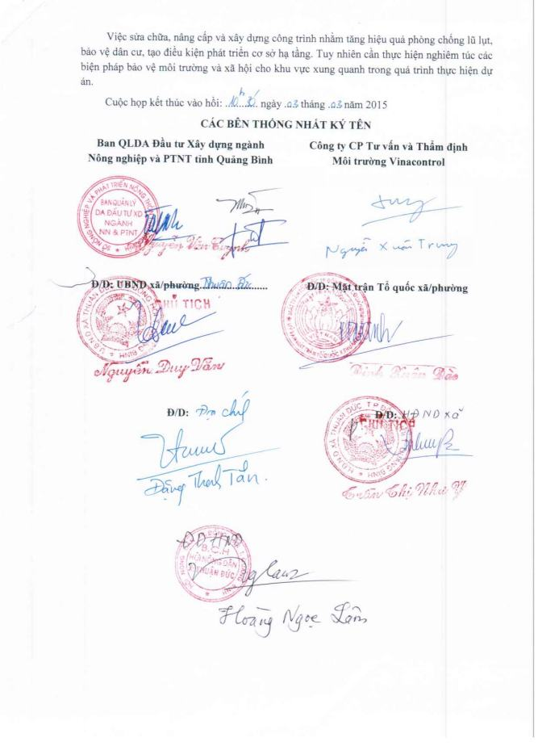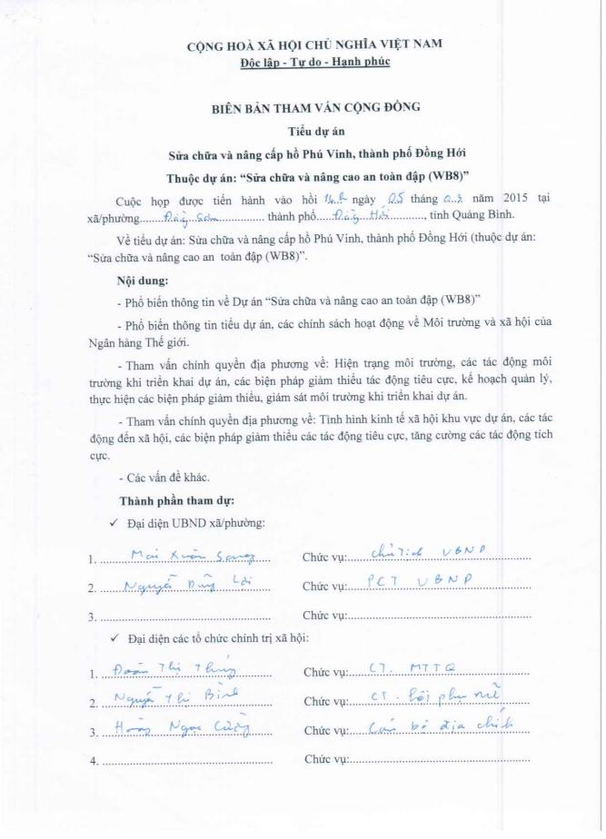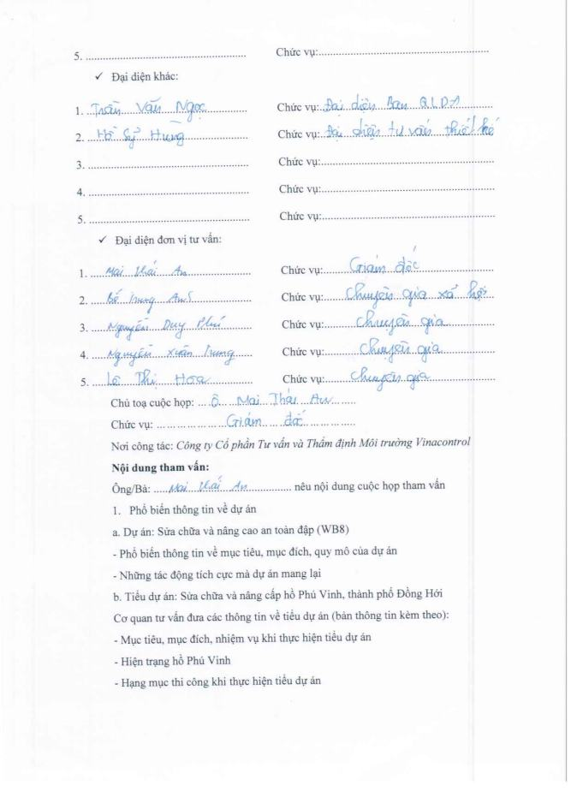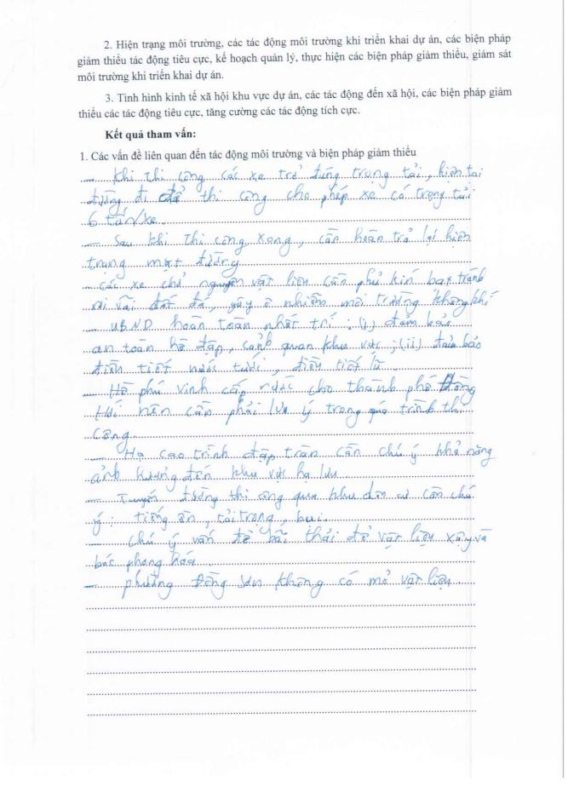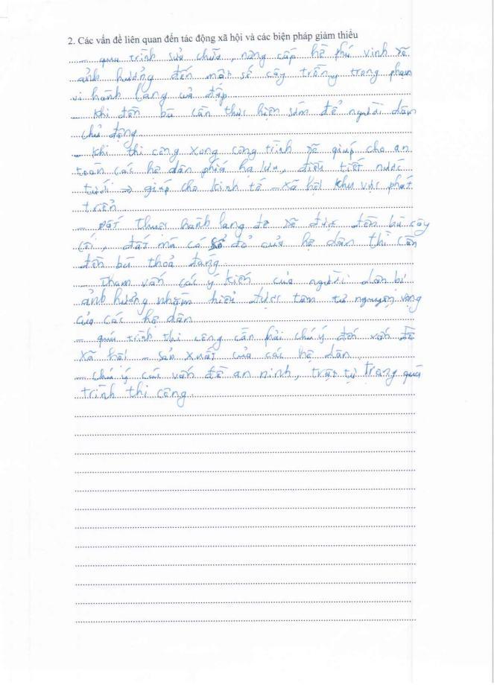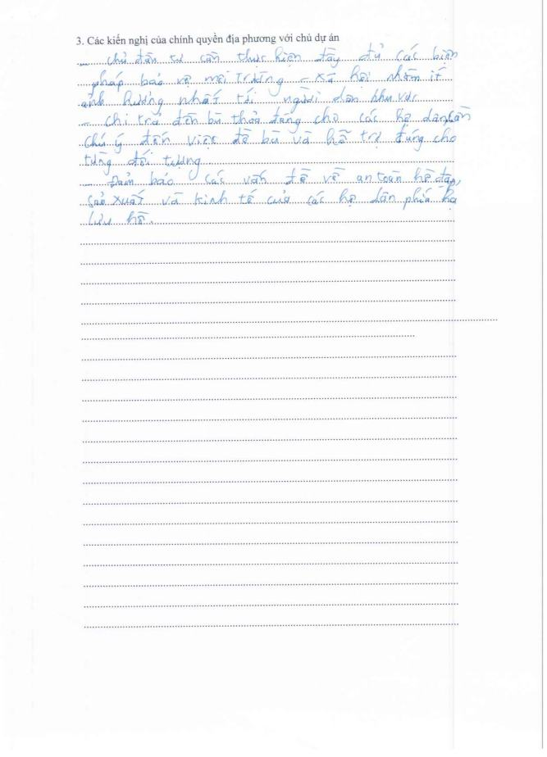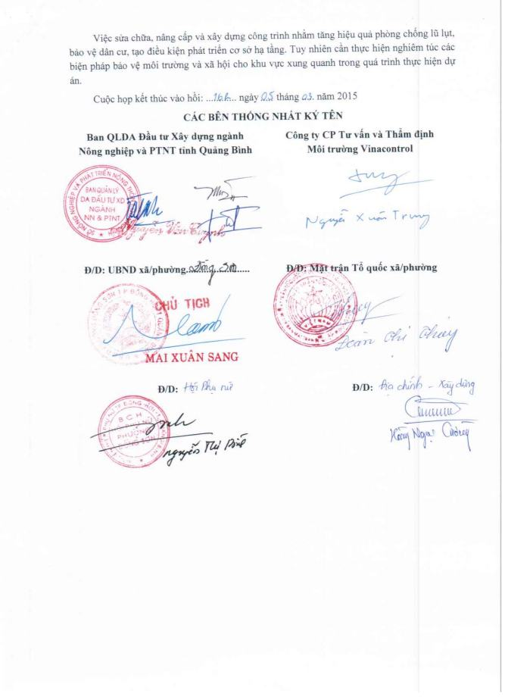

APPENDIX A7. PICTURE OF CURRENT STATUS OF SUBPROJECT AREA

|  |  |  |
| --- | --- | --- |
| **Description: Description: Description: D:\Project\WB8.QuangBinh\PhuVinh.QuangBinh\AnhKhaoSat\IMG_1119.JPG**  **Main dam** | Description: Description: Description: Description: C:\Users\SON\Desktop\anh phu vinh mua can\20140810_104717.JPG  **Upstream roof of main dam** | **Parapet wall Description: Description: Description: D:\Project\WB8.QuangBinh\PhuVinh.QuangBinh\AnhKhaoSat\ANH KHAO SAT PHU VINH Lan 1 - Hieu\IMG_20150302_143717.jpg** |
| **Outlet No 01 of spillway** Description: Description: Description: D:\Project\WB8.QuangBinh\PhuVinh.QuangBinh\AnhKhaoSat\cua xa tran 1.jpg | Description: Description: Description: D:\Project\WB8.QuangBinh\PhuVinh.QuangBinh\AnhKhaoSat\Tran xa lu.jpg  **Spillway** | Description: Description: Description: D:\Project\WB8.QuangBinh\PhuVinh.QuangBinh\AnhKhaoSat\ANH KHAO SAT PHU VINH Lan 1 - Hieu\IMG_20150303_084653.jpg  **Management house of outlet work** |

|  |  |
| --- | --- |
| **Description: Description: Description: D:\Project\WB8.QuangBinh\PhuVinh.QuangBinh\AnhKhaoSat\IMG_1171.JPG**  *(a) Downstream of dam* | **Description: Description: Description: D:\Project\WB8.QuangBinh\PhuVinh.QuangBinh\AnhKhaoSat\IMG_1170.JPG**  *(b) Dowstream near irrigation channel* |
| **Description: Description: Description: D:\Project\WB8.QuangBinh\PhuVinh.QuangBinh\AnhKhaoSat\ANH KHAO SAT PHU VINH Lan 1 - Hieu\IMG_20150302_143728.jpg**  *(c) Downstream near transportation route of Dong Son ward*  **Affected area by implementation of sub-project** | |

1. **Picture of public consultation**

|  |  |  |
| --- | --- | --- |
| Description: Description: Description: D:\Project\WB8.QuangBinh\PhuVinh.QuangBinh\AnhKhaoSat\ANH KHAO SAT PHU VINH Lan 1 - Hieu\IMG_20150303_092013.jpg | Description: Description: Description: D:\Project\WB8.QuangBinh\PhuVinh.QuangBinh\AnhKhaoSat\ANH KHAO SAT PHU VINH Lan 1 - Hieu\IMG_20150303_105351.jpg | |
| Description: Description: Description: D:\Project\WB8.QuangBinh\PhuVinh.QuangBinh\AnhKhaoSat\ANH KHAO SAT PHU VINH Lan 1 - Hieu\IMG_20150303_110443.jpg | Description: Description: Description: D:\Project\WB8.QuangBinh\PhuVinh.QuangBinh\AnhKhaoSat\ANH KHAO SAT PHU VINH Lan 1 - Hieu\IMG_20150303_093517.jpg | |
|  | | |
| Description: Description: Description: D:\Project\WB8.QuangBinh\PhuVinh.QuangBinh\AnhKhaoSat\Dong Son\IMG_1105.JPG  (a) Dong Son people’s committee | | Description: Description: Description: D:\Project\WB8.QuangBinh\PhuVinh.QuangBinh\AnhKhaoSat\Thuan Duc\IMG_1039.JPG  (b) Thuan Duc people’s committee |
| **Figure 0‑1 Pictures of 1st public consultation** | | |
| Description: Description: Description: D:\Project\WB8.QuangBinh\PhuVinh.QuangBinh\AnhKhaoSat\Tham van lan 2\Dong Son\IMG_1451.JPG  (a) Đồng Sơn CPC | | Description: Description: Description: D:\Project\WB8.QuangBinh\PhuVinh.QuangBinh\AnhKhaoSat\Tham van lan 2\Thuan Duc\IMG_1447.JPG  (b) Thuận Đức CPC |
| **Figure 0‑2 Pictures of 2st public consultation** | | |

APPENDIX A8. INTEGRATED PEST MANAGEMENT

**1. Objectives**

***a, General objectives***

Strengthening flora protection at local level, reducing pesticide use in the field, improving the efficiency of prevention, managing well pesticide and pesticide use process to reduce the risk of contamination pesticides on the environment and affect human health

***b, Specific objectives***

Support of the Department of Plant Protection of Quang Binh in strengthening pest management and pesticide management in accordance with the national action plan on food hygiene and safety, food security, adaptation to climate change and the concerned international conventions that the Government has approved;

* Strengthening the capacity of IPM in Quang Binh, including farmer groups to implement training IPM and research activities with farmers producing rice, vegetables ... to improve life, better and more sustainable crop production, minimizing the from pesticides.
* Strengthening environmental protection, food safety through strengthening the role of predators; reduce pesticide residues to ensure food hygiene and safety, reduce environmental pollution (water, land, air)
* Improving farmers' knowledge: distinguish the major pests, secondary; identify predators and their role in the field, clearly understand the effect of two colors of pesticides, property use, know how to survey pest and use threshold control; understand and apply pest control measures in IPM to increase income for farmers.

**2. The basic principles of IPM framework**

The following principles will be applied to all sub-project likely to increase the use of fertilizers and pesticides:

* "Prohibited list": As defined in the screening criteria in ESIA, the project will not finance the purchase of pesticides in large quantities. However, if there is a serious infestation of pests in the region, the project will support to buy small quantities of pesticides; the acquisition, pesticides, storage and transportation will be subjected to the provisions of the Government and without objection of the Bank, the purchase of pesticides can be done. The list of banned pesticides will not be used and circulated
* IPM program and project support: All the benefits of sub-project from the renovation of irrigation systems are supported by the project and implementation of IPM program is part of the ESMP for the sub-project. Support project will include technical assistance (consulting) to perform the non-chemical options, and priority support for agricultural extension services, including additional operating costs. The bank support fee for integrated prevention program of all sub-project and will be required or approved an independent program or as a part of ESMP. A proposed budget has been allocated for the implementation of IPM programs for the project area (in the component C). Detailed planning work will be completed through consultation close to farmers, local authority/PCP organization.
* The project will apply IPM programs as a method to minimize the potential negative impact of the increased use of fertilizers and chemicals. However, the improvement of knowledge and experience in the use of fertilizers and chemicals are through research surveys and training courses in the work as well as selecting safe use of non-chemicals, other techniques, is being investigated and/or applied in Vietnam. National IPM Program has also summarized the results of the implementation and the lessons of experience. The project will apply National IPM program results and detailed technical guidance.
* IPM Program subproject can be set up to support the implementation of the Government's policy and objectives focusing on reducing the use of chemical fertilizers and pesticides.
* In normal conditions, if pesticide use is considered to be a necessary option, only pesticides registered with the government and the international recognition in use and project will also provide technical and economic information for chemicals use demand. It should consider the options in the management of not harmful chemicals and can also reduce reliance on the use of pesticides. The measures will be incorporated into the project design to reduce risks related to the handling and use of pesticides to allowed possible level and managed by users
* The planning and implementation of mitigation measures and other activities will be carried out closely with the authorities, powers and stakeholders, including suppliers of chemicals, to facilitate cooperation and understanding each other.

**3. The approach of IPM**

Focus more on the risks of abuse and excessive use chemical of plant protection products. The concerned plant are rice, vegetables, tea ... these plants tend to be sprayed more of pesticides.

Focus on community education, the initial survey will be incorporated into the task with the aim of clarifying the root cause of the abuse and excessive use of plant protection products and the associated risks. Support the capacity building of the instructor (trainer) IPM. The current program will need to be reviewed and new modules will be supplemented to increase the portion related to reducing the risk of plant protection products. The training program will be enriched with the integration of many activities such as System Rice Intensification (System Rice Intensification - SRI), minimum tillage (minimum tillage), production community and use of bio-products replacing plant protection chemicals ... the training activities, the application will be made in the wide area application of the model.

To perform this content, it should perform the following steps:

* **Step 0**: Hiring consultants: A group of consultants (IPM consultants) will be hired to assist PMU in implementing IPM programs including ensuring results and cooperation among the agencies, farmers, and other stakeholders. The task for the consultant will be implemented at an early stage of project implementation.
* **Step 1**: Set up the basic requirements and register the program of farmers. This step should be implemented as soon as possible with appropriate questionnaire to establish base in 2013 for the use of fertilizers and of pesticides in the project area. Consultation with key agencies in the conduct of training, registration of participating farmers.
* **Step 2**: Set program goals and prepare a work plan. Based on the results from the questionnaire and consultation at Step 1, work plan and schedule will be prepared, including budgeting and implementation object. The work plan will be submitted to the PMU and approved by the World Bank for review and comment.
* **Step 3**: Implementation and annual review. After approval of the work plan, the activities will be implemented. Implementation progress will be included in the project progress reports. An annual evaluation report will be implemented by PMU and Sub- Department of Plant Protection.
* **Step 4**: Evaluate the impact. An independent consultant will be hired to carry out the impact assessment. This is to assess the performance of the project and to provide lessons. PMU will hire a national consultant to perform impact assessment of IPM the program

**4. The contents of the sub-project**

***(i) Collection of information and selection of solutions***

Before implementing IPM program, consultants must have the original investigation to have the necessary information such as:

* Survey to collect data on: staple crops have economic significance in the project area: seeds, crop, growth characteristics, farming techniques,
* Survey to collect data on soil conditions, gieology, local climate
* Investigate the situation of the pest, harmful rule arises, their economic damage causing on the major crops in the project area
* Investigate the role of natural enemies parasitic of pests on the major crops in the project area
* Investigate the actual situation of pest control measures, pesticide use and their effect at the local
* Investigate the socio-economic conditions, income, technical knowledge, and practices etc.

On the basis of these findings, a proposal to evaluate IPM measures will apply on specific crops in regions and localities implement the project through the following measures:

* Cultivation methods: Soil, field sanitation, crop rotation, intercropping, crop seasons, reasonable sowing and planting density, rational use of fertilizers; appropriate caring measures
* Using seed: the tradition seed and the proposed seed in use
* The biological measures: taking advantage of available natural enemies in the field, the economic threshold; 4 correct use of medicines;

***(ii) Develop of demonstration models IPM***

This section done by the Department of Crop Production, based on soil characteristics, climate, farming skills etc. Department of Crop Production will propose to the TDA of pilot field for agricultural development with the highly effective main crops. IPM activities in the pilot field will serve for sightseeing and guidance of practice.

Some of the main contents when building the IPM in the pilot field, as follows:

* Construction of demonstration models for applying IPM measures proposed above
* Building model involved by the people with the guidance of technical staff
* In the model, there need to build nuclear farmers, group leader
* In addition to technical assistance there should be support materials, ... for households participating in demonstration models
* Compiling IPM guiding documentation for major crops: rice, vegetables ...
* Scale of model: depending on crops, etc. specific economic conditions, models were constructed using different scales: 5-10 ha / model.

***(iii) Coaching and training of IPM staff***

TOT (Training of trainers) and Farmer Field School (FFS):

* Sub-project will organize workshops and staff training of IPM. The content of the training includes:
* Distinguish the major and secondary pests
* Identify the natural enemies of pests and diseases in the field
* Investigate methods to detect worms and diseases
* Understand the impact of two pesticides, using appropriate pesticides
* The techniques pest control under IPM principles
* Advanced farming techniques
* The understanding must be trained in theory and practical application in the field. The contents above can be trained under thematic groups: farming thematic, identification thematic and detection methods of pests and their natural enemies, the thematic of IPM techniques in production …
* Training object: The technical staff of the Department of Agriculture, Sub-department of plant protection, agricultural extension of districts, communes, and cooperatives. These students will train to the farmers in the project area, the implementing of models.
* The size of each class is from 20 to 30 students, held in each district. Learning time in each stage. According to the thematic training session, each session may last 3-5 days on both theory and practice.
* Lecturer: hire experts from University/Research institute/Agricultural Extension Center v.v

***(iv) Coaching and training of farmers***

Training of Farmers (TOF) follows Farmer Field School (FFS):

* Method: Combine theoretical training and base on practical fields of farmers and demonstration model on demonstration IMP in the pilot field;
* Contents are the same as IMP staff training;
* Participants: participating farmers, farmers who direct implement the models and farmers outside if interested;
* Classes are organized in each commune.
* Lecturer: staffs attended TOT classes

***(v) Evaluate and visit the field based on of demonstration models and field applied***

***of IPM following the models of farmers***

Visit the coast conference, farmers performing the demonstration models are reporters. The farmers implement the model directly with the participants; visiting farmers will calculate, compare economic performance and identify lessons, limitations and the work being done and not being done

***(vi) Scientific Seminar, evaluation of result and exchange of experience and***

***information, expand the model***

Invite experts in related fields participating in the assessment, analysis and additional evaluation, perfecting the processes; the mass media, the propaganda extension organization, expansion and transfer the result, the technical advances to farmers, and production areas with similar conditions

**5. The expected results and activities of the project**

The project is expected to achieve the following results:

* The risk of food safety and the environment are minimized through the implementation of existing regulations in business management and use of plant protection products and other provisions in national policy and the implementation.
* The capacity of the provincial PPD, farmer trainers are enhanced meeting training work, IPM training and IPM practice advocacy are maintained.
* Support for farmer groups after learning IPM to continue experiment to determine the application technical advances more effectively in production and popular in the community.
* Support for strengthening commune locality, strengthening pesticide management including the implementation and enforcement of legislation controlling plant protection products. Construction and distribution of a short list of specific plant protection products proposed use for rice and safe vegetables production.

**6. Implementation of IPM programs**

Currently, Vietnam is implementing the national IPM program, so sub-project requires coordinated planning and integration of the IPM program of the project with the National IPM program to perform more effectively within of sub-project.

* Central Project Office (CPO):
* Guide subprojects in building program of integrated pest management IPM
* Responsible for overall supervision and monitoring progress of the IPM program of subprojects.
* Provincial Project Management Unit PPMU:
* Developing and implementing IPM program
* To be responsible for the preparation of periodic reports on the implementation and submitting to CPO, WB. Final plan and budget will be completed and discussed with the CPO. All documents will be stored in the project file.
* Sub-Department of Plant Protection (BVTV):
* Provide policy and technical guidelines for the implementation of the IPM program.
* Join in IPM model building
* Join coaching and staff training IPM
* Plant Protection Station at district level
* Coordinate with IPM staff to implement coaching and trained of farmers implemented IPM through the approach and provide of knowledge, support for of farmers on the safe use of pesticides when necessary.
* Guide the list of banned pesticides
* Examine the distribution facility providing pesticides to ensure the provision of safe pesticides for farmers People’s committee at commune level
* Organizing for farmers decided to maintain the routine IPM was formed from a training course by organizing IMP-clubs or groups of farmers with the different levels of organization and structure, along with many activities (including the integration of the contents of cattle, credit, market access, etc.)
* Households in the project area:
* Implementing IPM program has trained
* The members of the IPM club support together to develop agricultural activities.
* They also play a central role in the task of organizing community IPM program and general agricultural planning of commune and district as well.
* Environmental Safety Monitoring Consultant
* Monitoring the implementation of IPM program of sub-project
* Guides local PMU in the implementation
* To recommend measures to improve the efficiency of implementation of IPM program of sub-project

**7. Funds for implementation of IPM program**

Funding estimates of the sub-project implement IPM program includes the following categories:

* Funds for research and initial testing
* Funds for Building of demonstration models
* Funds for coaching and IPM staff training: Calculated for the classes held in each district = unit price x number of district of sub-project
* Funds for coaching and training of farmers: Calculated for the organization of class in each commune = unit price x number of commune in sub-project
* Funds held assessment and the shore tours based on demonstration models and field applying IPM following models of farmers. Each district held a conference for shore tours in 1 day
* Scientific conference, evaluating results, information and experiences exchange, expanding the model. Each District held a scientific conference

Depending on the number of administrative units in sub-project which the provincial Department of Agriculture and the organization of training courses, seminars reasonable, economical and efficient.

APPENDIX A9. ENVIRONMENTAL SPECIFICATIONS (FOR INCLUSION IN BIDDING AND CONSTRUCTION CONTRACTS

**Construction Camp Management Plan**

*General Requirements*

The Contractor shall, wherever possible, locally recruit the available workforce and shall provide appropriate training as necessary. The Contractor shall consider all aspects of workforce management and address potential ethnic tensions between workers and the local communities, increased risk of prostitution and communicable diseases, theft, alcohol abuse, market distortion due to temporary inputs to local economy and other local tensions such as unemployment, ethnicity and divergent cultural values.

The following general measures shall be considered for construction camps:

1. The construction camp site will have to be approved by the local authority.
2. The Contractor shall present the design of the camps including details of all buildings, facilities and services for approval no later than two months prior to commencement of any construction work. Approvals and permits shall be obtained in accordance with applicable laws, applicable standards and environmental requirements for the building and infrastructure work for each camp area.
3. The Contractor shall provide adequate and suitable facilities for washing clothes and utensils for the use of contract labor employed therein.
4. Camp site selection and access roads shall be located so as to avoid clearing of major trees and vegetation as feasible, and to avoid aquatic habitats.
5. Camp areas shall be located to allow effective natural drainage and landscaped so as to avoid erosion.
6. The Contractor shall provide suitable, safe and comfortable accommodation for the workforce.
7. The Contractor shall provide adequate lavatory facilities (toilets and washing areas) for the number of workers expected on site, plus visitors. Toilet facilities should also be provided with adequate supplies of clean or potable water, soap, and toilet paper. Separate and adequate bathing facilities shall be provided for the use of male and female workers. Such facilities shall be conveniently accessible and shall be kept in clean and hygienic conditions at all times.
8. The Contractor shall implement effective sediment and erosion control measures during construction and operation of the construction work camps in accordance with the environmental requirements as stipulated by the EMP and SESIA, especially near rivers.
9. The Contractor shall provide recreational facilities to the workforce. Such facilities will help mitigate against potential conflict and impact on the local population as the incentive to go outside the camp will be reduced.
10. The Contractor shall provide safe potable water for food preparation, drinking and bathing.
11. The Contractor shall install and maintain a temporary septic tank system for any residential labor camp, without causing pollution of nearby watercourses. Wastewater should not be disposed into any water bodies without treatment, in accordance to applicable Vietnamese standards.
12. The Contractor shall establish a method and system for temporary storage and disposal or recycling of all solid wastes generated by the labor camp and/or base camp.
13. The Contractor shall not allow the use of fuel wood for cooking or heating in any labor camp or base camp and provide alternate facilities using other fuels.
14. The Contractor shall ensure that site offices, depots, and workshops are located in appropriate areas as approved by the appropriate the Dam Safety Project environmental officer or the Supervisory Engineer.
15. The Contractor shall ensure that storage areas for diesel fuel and lubricants are not located within 100 meters of watercourses, and are operated so that no pollutants enter watercourses, either overland or through groundwater seepage, especially during periods of rain.  A ditch shall be constructed around the area with an approved settling pond/oil trap at the outlet.
16. Areas for the storage of fuel or lubricants and for a maintenance workshop shall be fenced and have a compacted/impervious floor to prevent the escape of accidental spillage of fuel and or lubricants from the site. Surface water drainage from fenced areas shall be discharged through purpose designed and constructed oil traps. Empty fuel or oil drums may not be stored on site. Waste lubricants shall be recycled, and not disposed to land or adjacent water bodies.
17. The Contractor shall ensure that site offices, depots, and workshops are located in appropriate areas as agreed by local authorities and approved by the Dam Safety Project or supervisory engineer. They shall not be located within 200 meters of existing residential settlements.
18. Concrete batching plants shall not be located within 500 m of any residence, community or work place.
19. The Contractor shall provide medical and first aid facilities at each camp area; and
20. All medical related waste shall be disposed off in proper containers, or dealt with accordingly with established procedures for safe disposal.

*Security*

Security measures shall be put into place to ensure the safe and secure running of the camp and its residents. As a minimum, these security measures should include:

1. Access to the camp shall be limited to the residing workforce, construction camp employees, and those visiting personnel on business purposes.
2. Prior approval from the construction camp manager shall be required for visitor access to the construction camp.
3. Adequate, day-time night-time lighting shall be provided.
4. A perimeter security fence at least 2m in height shall be constructed from appropriate materials; and
5. Provision and installation in all buildings of firefighting equipment and portable fire extinguishers.

*Maintenance of Camp Facilities*

The following measures shall be implemented to ensure that the construction camp and its facilities will be organized and maintained to acceptable and appropriate standards:

1. A designated camp cafeteria shall be established under strict sanitary and hygiene conditions.
2. Designated meal times shall be established.
3. Cooking or preparation of food shall be prohibited in accommodation quarters;
4. Designated rest times shall be established.
5. Designated recreational hours shall be put in place.
6. Smoking shall be prohibited in the workplace.
7. Procedures shall be implemented to maintain the condition of the construction camp and facilities and ensure adequate cleanliness and hygiene.
8. The latrines and urinals shall be adequately lighted and shall be maintained in a clean sanitary condition at all times.
9. Water shall be provided in or near the latrines and urinals by storage in drums; and
10. A complaint register to receive and respond to complaints from the construction camp residents regarding facilities and services provided.

*Code of Conduct*

A major concern during a construction of a project is the potentially negative impacts of the workforce interactions with the local communities. For that reason, a Code of Conduct shall be established to outline the importance of appropriate behavior, drug and alcohol abuse, and compliance with relevant laws and regulations. Each employee shall be informed of The Code of Conduct and bound by it while in the employment of the Client or its Contractors. The Code of Conduct shall be available to local communities at the project information centers or other place easily accessible to the communities. The Code of Conduct shall address the following measures (but not limited to them):

1. All workers and subcontractors shall abide by the laws and regulations of Vietnam.
2. Illegal substances, weapons and firearms shall be prohibited.
3. Pornographic material and gambling shall be prohibited.
4. Fighting (physical or verbal) shall be prohibited.
5. Workers shall not be allowed to hunt, fish or trade in wild animals.
6. No consumption of bush meat shall be allowed in camp.
7. No pets shall be allowed in camp.
8. Creating nuisances and disturbances in or near communities shall be prohibited.
9. Disrespecting local customs and traditions shall be prohibited.
10. Smoking shall be prohibited in the workplace.
11. Maintenance of appropriate standards of dress and personal hygiene shall be in effect.
12. Maintenance of appropriate hygiene standards in accommodation quarters shall be set in place.
13. Residing camp workforce visiting the local communities shall behave in a manner consistent with the Code of Conduct; and
14. Failure to comply with the Code of Conduct, or the rules, regulations, and procedures implemented at the construction camp will result in disciplinary actions.

**Construction Impact Management Plan**

In order to reduce the impact of the construction activities on local communities and the environment, the Construction Contractor shall implement the following Sub-Plans in accordance with the following stipulations:

**Erosion and Sedimentation**

Site activities shall be carefully managed in order to avoid site erosion and sedimentation of downstream waterways. In order to minimize negative erosion impacts in the project area, the following activities shall be carried out by the Contractor:

1. Erosion and sedimentation shall be controlled during the construction. Areas of the site not disturbed by construction activities shall be maintained in their existing state.
2. Disturb as little ground area as possible, stabilize these areas as soon as possible, control drainage through the area, and trap sediment onsite. Install erosion control barriers around perimeter of cuts, disposal pits, and roadways.
3. Slope works and earth moving/excavation shall be conducted in order to minimize exposure of the soil surface both in terms of area and duration. Temporary soil erosion control and slope protection works shall be carried out in sequence to construction.
4. Conserve topsoil with its leaf litter and organic matter, and reapply this material to local disturbed areas to promote the growth of local native vegetation.
5. Apply local, native grass seed and mulch to barren erosive soil areas or closed construction surfaces.
6. Apply erosion control measures before the rainy season begins, preferably immediately following construction. Install erosion control measures as each construction site is completed.
7. In all construction sites, install sediment control structures where needed to slow or redirect runoff and trap sediment until vegetation is re-established. Sediment control structures include windrows of slash, rock berms, sediment catchment basins, straw bales, brush fences, and silt fences.
8. Control water flow through construction sites or disturbed areas with ditches, berms, check structures, live grass barriers, and rock.
9. The ground surface at the construction site offices shall be concreted or asphalted in order to minimize soil erosion.
10. Erosion control measures shall be maintained until vegetation is successfully re-established.
11. Water shall be sprayed as needed on dirt roads, cuts, fill material and stockpiled soil to reduce wind-induced erosion and dust.

**Particulate Emissions and Dust**

The Contractor shall propose methods and actions to control dust resulting from construction related activities, including quarry sites, crushing and concrete batching plants, earthworks including road construction, embankment and channel construction, haulage of materials and construction work camps. In particular the Contractor shall undertake the following:

1. Minimize production of dust and particulate materials at all times, to avoid impacts on surrounding communities, and especially to vulnerable people (children, elderly people).
2. Time removal of vegetation to prevent large areas from becoming exposed to wind.
3. Place screens around construction areas to minimize dust proliferation, paying particular attention to areas close to local communities.
4. Spray water as needed on dirt roads, cut areas and soil stockpiles or fill material. Spraying shall be carried out in dry and windy days, at least twice a day (morning and afternoon). The frequency of spraying near local communities shall be increased as needed.
5. Pave access roads with gravel in the sections which near the communities and other sensitive receptors to reduce generation of air-borne dust.
6. Provide an adequate ventilation system and other measures to control concentration of air pollutants within tunnels.
7. Transportation of materials by vehicles and construction of access roads shall be properly designed. For example, the access road can be constructed and paved by concrete/asphalt, or laid with small graded rocks, prior to major earthworks which may require transportation of substantial amount of materials on-site and off-site.
8. Ensure adequate maintenance of all vehicles. Construction plant/vehicles that generate serious air pollution and those which are poorly maintained shall not be allowed on site.
9. Transport of chemicals or materials such as cement, sand and lime shall be covered entirely with clean impervious material to ensure that these materials shall be contained. Overflow of material shall be avoided; and
10. The exhaust gases from construction machinery and vehicles are accepted. However, the engines shall be inspected and adjusted as required to minimize pollution levels.

**Noise**

To minimize noise the Contractor shall:

1. Maintain all construction-related traffic on project access roads at established speed limits.
2. Maintain all on-site vehicle speeds at or below 30 kph, or otherwise designated.
3. To the extent possible, maintain noise levels associated with all machinery and equipment at or below 90db.
4. In sensitive areas (including residential neighborhoods, hospitals, rest homes, schools, etc.) more strict noise abatement measures may need to be implemented to prevent undesirable noise levels.
5. Apply proper measures to minimize disruptions from vibration or noise coming from construction activities.
6. Design a transportation schedule for entry of construction materials to minimize the adverse impact on residents, as well as the traffic on the existing roads. The transportation vehicles shall be required to slow down and banned from using horns when passing sensitive areas. Transportation during peak hours should be minimized. The Contractor shall provide the transportation route in advance to the Engineering Supervisor.
7. Maintain the construction equipment in its best operating conditions and lowest noise levels possible.
8. Use temporary noise barriers to minimize the noise caused by construction equipment;
9. Provide hearing protection to workers who must work with highly noisy machines such as piling, explosion, mixing, etc., for noise control and workers protection.
10. Areas for the storage of fuel or lubricants fenced and have a compacted/impervious floor or other surface to prevent the escape of accidental spillage of fuel and/or lubricants from the site. Surface water drainage from fenced areas shall be discharged through an oil skimmer or other appropriate device to remove hydrocarbons. Empty fuel or oil drums may not be stored on site. Proper MSDS labeling shall be in place and training provided to workers handling these materials.
11. The construction supervision team shall be equipped with portable noise detection devices to monitor the noise level at the sensitive receptors.
12. Materials leaving the construction site shall be transported during non-peak hours in order to minimize traffic noise due to the increase in traffic volumes.
13. Use of properly designed silencers, mufflers, acoustically dampened panels and acoustic sheds or shields, etc. shall be made. Mufflers and other noise control devices shall be repaired or replaced if defective.
14. Use of electric-powered equipment when applicable instead of diesel-powered or pneumatic-powered equipment.
15. Equipment known to emit a strong noise intensity in one direction, shall when possible, be oriented to direct noise away from nearby sensitive receptors.
16. Machines and equipment that may be in intermittent use shall be shut down between work periods or throttled down to a minimum operation.

**Earthworks, Cut and Fill Slopes**

The contractor shall ensure that the following procedures are undertaken:

1. All earthworks shall be properly controlled, especially during the rainy season.
2. The Contractor shall maintain stable cut and fill slopes at all times and cause the least possible disturbance to areas outside the prescribed limits of the works.
3. The Contractor shall complete cut and fill operations to final cross-sections at any one location as soon as possible and preferably in one continuous operation to avoid partially completed earthworks, especially during the rainy season.
4. In order to protect any cut or fill slopes from erosion, in accordance with drawings, cut off drains and toe-drains shall be provided at the top and bottom of slopes and be planted with grass or other plant cover. Cut off drains should be provided above high cuts to minimize water runoff and slope erosion.
5. Any excavated cut or unsuitable material shall be disposed of in designated disposal areas as agreed to by the Supervisory Engineer, and
6. Disposal sites should not be located where they can cause future slides, interfere with agricultural land or any other properties, or cause runoff from the landfill towards any watercourse. Drains may need to be dug within and around the landfills, as directed by the Supervisory Engineer.

**Stockpiles and Borrow Pits**

The Contractor shall prepare and overall Stockpiles and Borrow Pits Management Plan for the total works. Operation of a new borrowing area, on land, in a river, or in an existing area, shall be subject to prior approval of the Environmental Supervisor, and the operation shall cease if so instructed by the Supervisory Engineer.

Borrow pits shall be prohibited where they might interfere with the natural or designed drainage patterns. River locations shall be prohibited if they might undermine or damage riverbanks, or carry too much fine material downstream.

The location of crushing plants shall be subject to the approval of the Supervisory Engineer, and not be adjacent to environmentally sensitive areas, or to existing residential settlements, and shall be operated with approved fitted dust control devices.

Rock or gravel taken from a river shall be far enough removed to limit the depth of material removed to one-tenth of the width of the river at any one location, and not to disrupt the river flow, or damage or undermine the riverbanks.

The Plan shall include:

1. A map showing the extent of the area to be developed.
2. A method statement defining the proposed working methods.
3. The proposed access and haulage routes between the borrow pits and the destination for the extracted materials.
4. A justification for the quantities of materials to be extracted, an estimation of the waste material to be generated and disposal details for such waste materials.
5. Details of the measures taken to minimize the borrow pit areas and their visual impact on the surrounding area, and
6. Details of the measures to be taken for the long-term rehabilitation of the borrow pit areas in order to avoid situations that could constitute a threat to health and safety and cause environmental degradation.

In general terms, the Contractor shall:

1. Identify and demarcate locations for stockpiles and borrow pits, ensuring that they are 15 meters away from critical areas such as steep slopes, erosion-prone soils, and areas that drain directly into sensitive water bodies.
2. Limit extraction of material to approved and demarcated borrow pits.
3. Stockpile topsoil when first opening the borrow pit. After all usable borrow has been removed, the previously stockpiled topsoil should be spread back over the borrow area and graded to a smooth, uniform surface, and adequately sloped for drainage. On steep slopes, benches or terraces may have to be established to help control erosion.
4. Excess overburden should be stabilized and re-vegetated. Where appropriate, organic debris and overburden should be spread over the disturbed site to promote re-vegetation. Natural re-vegetation is preferred to the best extent practicable.
5. Existing drainage channels in areas affected by the operation should be kept free of overburden.
6. Once the job is completed, all construction -generated debris should be removed from the site to an approved disposal location.
7. The Contractor shall ensure that all borrow pits used are left in an appropriate condition with stable side slopes, re-establishment of vegetation, restoration of natural water courses, avoidance of flooding of the excavated areas wherever possible so no stagnant water bodies are created which could breed mosquitoes, and
8. When the borrow pits or the local depressions created by the construction activities cannot be refilled or reasonably drained, the Contractor shall consult with the local community to determine their preference for reuse such as fish farming or other community purposes.

**Disposal of Construction Waste**

The Contractor shall carry out the following activities:

1. Establish and enforce daily site clean-up procedures, including maintenance of adequate disposal facilities for construction debris.
2. Debris generated due to the dismantling of the existing structures shall be suitably reused, to the best extent feasible (e.g. as fill materials for embankments). The disposal of remaining debris shall be carried out only at sites identified and approved by the Supervisory Engineer. The Contractor should ensure that these sites (a) are not located within designated forest areas; (b) do not impact natural drainage courses; and (c) do not impact endangered/rare flora. Under no circumstances shall the Contractor dispose of any material in environmentally sensitive areas.
3. In the event any debris or silt from the sites is deposited on adjacent land, the Contractor shall immediately remove such, debris or silt and restore the affected area to its original state to the satisfaction of Supervisory Engineer.
4. All arrangements for transportation during construction including provision, maintenance, dismantling and clearing debris, where necessary, will be considered incidental to the work and should be planned and implemented by the contractor as approved and directed by the Supervisory Engineer.
5. Consult with local communities, if any, living close to spoil disposal sites that may be affected. The consultation shall provide local stakeholders with detailed information of the potential spoil disposal site, and provide an opportunity for them to express their opinions and concerns with the proposed plans. Information and feedback from the consultation process shall be incorporated into the final design for each spoil disposal site.
6. Include provisions for incorporating the most appropriate stabilization techniques for each disposal site.
7. Assess risk of any potential impact regarding leaching of spoil material on surface water.
8. Include an appropriate analysis to determine that the selected spoil disposal sites do not cause unwanted surface drainage, and
9. Stabilize spoil disposal sites to avoid erosion in accordance with the requirements of the Landscape and Re-vegetation Plan.

**Demolition of Existing Infrastructure**

The Contractor shall implement adequate measures during demolition of existing infrastructure to protect workers and public from falling debris and flying objects. Among these measures, the Contractor shall:

1. Set aside a designated and restricted waste drop or discharge zones, and/or a chute for safe movement of wastes from upper to lower levels.
2. Conduct sawing, cutting, grinding, sanding, chipping or chiseling with proper guards and anchoring as applicable.
3. Maintain clear traffic ways to avoid driving of heavy equipment over loose scrap.
4. Use of temporary fall protection measures in scaffolds and out edges of elevated work surfaces, such as hand rails and toe boards to prevent materials from being dislodged.
5. Evacuate all work areas during blasting operations, and use blast mats or other means of deflection to minimize fly rock or ejection of demolition debris if work is conducted in proximity to people or structures.
6. Provide all workers with safety glasses with side shields, face shields, hard hats, and safety shoes.

**Other Management Plans**

The contractor shall be responsible for preparing the following management plans in accordance with the stipulated terms of reference:

**Waste Management Plan**

During the construction stage, the Contractor shall prepare a Waste Management Plan before commencement of project works. The Plan shall include:

*Water and Wastewater*

* A review of the preliminary site drainage design prepared during the detailed design.
* An update of the preliminary design based on the actual construction program and site specific conditions (e.g. the geographical conditions, location of slopes and the nature of construction work).
* Detailed design including drawings, location maps, specifications of drainage collection channels and wastewater treatment facilities.
* Proposed discharge locations and treatment standards.
* A detailed implementation program of the proposed drainage system.
* As part of the design of the site drainage system, surface runoff within the construction site shall be diverted in order to avoid flushing away soil material and the water is treated by device such as sediment trap before discharge.
* Domestic sewage from site offices, toilets and kitchen shall either be collected by a licensed waste collector or treated by on-site treatment facilities. Discharge of treated wastewater must comply with the discharge limits according to Vietnamese legislation.
* A Wastewater treatment device such as a sediment tank can be installed near each of the constructions activities that may generate wastewater. Alternatively, sedimentation ponds can be constructed on-site to settle out excessive suspended solids (SS) before discharging into a discharge outlet.
* Retaining walls and sandbags barriers shall be constructed surrounding the bored piling machine in order to trap bentonite and wastewater within the piling location. The collected spent bentonite or the wastewater shall be pumped for treatment before discharge.
* Prior to the rainy season, all exposed surfaces and slopes shall be properly covered or landscaping shall be provided to minimize run-off of sediment laden. Slope protection can be carried out in sequence to construction and in advance of the rainy season.
* Drainage control devices such as sediment traps shall be installed at each discharge outlet, and they shall be cleaned regularly, and
* Chemical toilets can be provided on each work site employing 5 workers or more.
* At least one toilet shall be installed per 25 workers. Domestic sewage collected from the site office and chemical toilets shall be cleaned up on regular basis. Only licensed waste collectors shall be employed for this disposal. The sludge shall be treated according to the requirements of the Contractor’s Waste Management Plan.

*Solid Wastes*

Waste such as those listed below are expected due to construction activities:

* Surplus excavated materials requiring disposal due to earth moving activities and slope cutting.
* Disposal of used lumber for trenching works, scaffolding steel material, site hoarding, packaging materials, containers of fuel, lubricant and paint.
* Waste generated by demolition of existing houses / buildings affected by the project or breaking of existing concrete surfaces.
* Waste from on-site wastewater treatment facility (e.g. treatment of bentonite from tunneling works by sedimentation process), and
* Domestic waste generated by construction workers, construction campsite and other facilities.

The above wastes must be properly controlled through the implementation of the following measures:

* Minimize the production of waste that must be treated or eliminated.
* Identify and classify the type of waste generated. If hazardous or chemical wastes are generated, proper procedures must be taken regarding their storage, collection, transportation and disposal. (See Emergency Plan for Hazardous Materials and Chemical Waste Management Plan).
* Identify and demarcate disposal areas clearly indicating the specific materials that can be deposited in each, and
* Control placement of all construction waste (including earth cuts) to approved disposal sites (>300 m from rivers, streams, lakes, or wetlands). Collect and recycle and dispose where necessary in authorized areas all of garbage, metals, used oils, and excess material generated during construction, incorporating recycling systems and the separation of materials.

The Contractor shall make a commitment to waste recycling and re-use methods in consideration of the following;

* A method statement on waste recycling, re-use and minimization of waste generation.
* Excavated material shall be re-used on-site or the nearby road segment / other projects as far as possible in order to minimize the quantity of material to be disposed of.
* Recyclable materials such as wooden plates for trench works, steel, scaffolding material, site holding, packaging material, etc. shall be collected and separated on-site from other waste sources. Collected recyclable material shall be re-used for other projects or sold to waste collector for recycling, and
* Collected waste shall be disposed of properly through a licensed waste collector.

**Pollution Prevention Plan**

*Emergency Plan for Hazardous Materials*

If the construction site is expected to have or suspected of having hazardous materials (chemicals, asbestos, hydrocarbons, or other similar hazardous materials), the Contractor will be required to prepare a Hazardous Waste Management Plan and Emergency Response Plan to be approved by the Environmental Supervisor. Removal and disposal of existing hazardous wastes in project sites should only be performed by specially trained personnel following national or provincial requirements, or internationally recognized procedures.

The Contractor shall:

* Make the Hazardous Waste Management Plan available to all persons involved in operations and transport activities.
* Hazardous waste (or chemical waste) shall be properly stored, handled and disposed of in accordance with the local legislative requirements. Hazardous waste shall be stored at designed location and warning signs shall be posted.
* Inform the Environmental Supervisor, or Construction Supervisor of any accidental spill or incident in accordance with the plan.
* Prepare a companion Emergency Response Plan outlining all procedures to be undertaken in the event of a spilled or unplanned release.
* Initiate a remedial action following any spill or incident; and
* Provide a report explaining the reasons for the spill or incident, remedial action taken, consequences/damage from the spill, and proposed corrective actions. The Emergency Plan for Hazardous Materials shall be subsequently updated and submitted to the PEO for no objection.

*Chemical Waste*

During construction there will be a potential for pollution to adjacent habitat areas and watercourses caused by chemical wastes such as spent waste oil, spent lubricant, contaminated soil material due to leakage of hydraulic oil, fuel from construction plant or vehicles, etc. The following measures shall be put into place in order to minimize the damage caused by chemical waste:

* All refueling of heavy equipment and machinery shall be undertaken by a service vehicle to prevent any spillage or contamination by chemical wastes such as maintenance oils, lubricants, etc.
* All the fuel and hazardous material storage shall be adequately enclosed to prevent any spillage problems.
* Storm water runoff from open workshops, repair areas, and enclosed storage areas shall be collected and treated in hydrocarbon separation pits/tanks before discharge to drains and waterways.
* All explosives shall be transported, stored and handled in accordance with applicable laws and good design engineering and constructions practices. The contractor shall provide details of proposed storage and security arrangements.

*Maintenance of Construction Equipment*

The Contractor shall:

* Identify and demarcate equipment maintenance areas (>15m from rivers, streams, lakes or wetlands). Fuel storage shall be located in proper areas and approved by the PEO.
* Ensure that all equipment maintenance activities, including oil changes, are conducted within demarcated maintenance areas; never dispose spent oils on the ground, in water courses, drainage canals or in sewer systems, and
* All spills and collected petroleum products shall be disposed of in accordance with standard environmental procedures/guidelines. Fuel storage and refilling areas shall be located at least 100m from all cross drainage structures and important water bodies or as directed by the PEO.

**Vegetation Clearing and Salvage**

*Clearing of Construction Areas*

Areas proposed for clearing shall be included in the Vegetation Clearing and Salvage Plan. Only those proposed areas shall be cleared in accordance with the Plan and approved by the Engineering Supervisor. The Vegetation Clearing and Salvage Plan shall consider the existing usage of the project land to allow its existing usage to continue as long as is practicable, without interference with the Contractor’s activities. Vegetation shall not be disturbed in those areas not submitted with the Plan.

The Contractor shall also arrange to coordinate with local communities as part of the Livelihoods Development Plan to clear the reservoir area.

The following measures shall be implemented:

* Large or significant trees in camp areas and access roads should be preserved wherever possible.
* The application of chemicals for vegetation clearing shall be minimized. To the best extent possible, non-residual chemicals shall be selected and with negligible adverse effects on human health.
* Herbicides use in the project shall be shown to be effective against the target vegetation species, have minimum effect on the natural environment, and be demonstrated to be safe for inhabitants and domestic animals in the treated areas, as well for personnel applying them.
* The design of roads, including temporary and permanent access roads shall avoid crop areas where reasonable and practical.

*Landscape, Visual impacts and Re-vegetation*

The construction program of the project shall be executed in phases, particularly in those locations where severe or high landscape and visual impacts are expected.

The following measures shall be implemented:

* Construction shall be programmed in sequence so that the scale of earth moving activities and area of exposed surface can be minimized.
* Re-vegetation shall start at the earliest opportunity. Appropriate local species of vegetation shall be used.
* The requirement of compensatory planting shall be included in the design and project contract. A Master Landscaping Plan and requirements of ecological monitoring or survey during different stages of the project shall be prepared during the design stage that shall be implemented during the construction and maintained during operation.
* Facilities and structures shall be located according to the terrain and geographical features of the project site.
* Restoration, of cleared areas such as borrow pits no longer in use, disposal areas, construction roads, construction camp areas, stockpiles areas, working platforms and any areas temporarily occupied during construction of the project works shall be accomplished using landscaping, adequate drainage and re-vegetation.
* Existing trees and plants within the construction boundaries shall be tagged to indicate whether the trees are to be retained transplanted or removed. Transplantation of existing trees affected by the project works shall be carried out prior to the commencement of construction.
* Excavations shall avoid damage to the root systems. Mitigation measures are also required to prevent damage to trunks and branches of trees.
* Temporary hoarding barriers shall be of a recessive visual appearance in both color and form.
* Upon completion of the construction, the affected areas shall be immediately restored to their original condition, including the re-creation of natural and rocky shoreline, footpath and re-establishment of disturbed vegetation.
* At the highly visually sensitive zones, construction may be scheduled where possible at the low tourist seasons.
* Construction trucks shall operate at night when possible and kept cleaned and covered when shipping bulk materials.
* Construction sites shall be surrounded with fence if located at the scenery zones to avoid direct visual sights of the construction sites.
* There shall not be construction camps in scenic areas.
* Random disposal of solid waste in scenic areas shall be strictly prohibited.
* All mixing stations and concrete batching plants shall not be located near rivers or in scenic areas. The stockpiles shall be located in hidden areas, and outside of the sight from tourists;
* Use the existing roads as access road if possible to minimize the need for new access roads which lead to damage existing landforms and vegetation.
* Land use for agricultural activity prior to use for construction activities shall be, as much as possible, restored to a state to allow the same agricultural activity to continue.
* Spoil heaps and excavated slopes shall be re-profiled to stable batters, and grassed to prevent erosion.
* Topsoil stripped from the work areas shall be used for landscaping works, and
* Watercourses, which have been temporarily diverted by the construction activities, shall be restored to their former flow paths.

*Site Restoration*

* At the completion of construction work, all construction camp facilities shall be dismantled and removed from the site and the whole site restored to a similar condition to that prior to the commencement of the works, or to a condition agreed to with local authorities and communities.
* Remedial actions that cannot be effectively carried out during construction shall be carried out on completion of the restoration works (and before issuance of the acceptance of completion of works).

Various activities to be carried out for site restoration are:

* The construction campsite shall be grassed and trees cut replaced with saplings of similar tree species.
* All affected areas shall be landscaped and any necessary remedial works shall be undertaken without delay, including grassing and reforestation.
* Water courses shall be cleared of debris and drains and culverts checked for clear flow paths.
* All sites shall be cleaned of debris and all excess materials properly disposed.
* Borrow pits shall be restored.
* Oil and fuel contaminated soil shall be removed and transported and buried in waste disposal areas.
* Saplings planted shall be handed over to the community or the land owner for further maintenance and watering, and
* Soak pits and septic tanks shall be covered and effectively sealed off.

**Safety during Construction**

The Contractor’s responsibilities include the protection of every person and nearby property from construction accidents. The Contractor shall be responsible for complying with all national and local safety requirements and any other measures necessary to avoid accidents, including the following:

* Present details regarding maximum permissible vehicular speed on each section of road.
* Establish safe sight distance in both construction areas and construction camp sites;
* Place signs around the construction areas to facilitate traffic movement, provide directions to various components of the works, and provide safety advice and warning. All signs shall be in English and Vietnamese language and be constructed according to Vietnamese specifications.
* Estimate maximum concentration of traffic (number of vehicles/hour).
* Use selected routes to the project site, as agreed with the PEO, and appropriately sized vehicles suitable to the class of roads in the area, and restrict loads to prevent damage to local roads and bridges used for transportation purposes.
* Be held responsible for any damage caused to local roads and bridges due to the transportation of excessive loads, and shall be required to repair such damage to the approval of the PEO.
* Not use any vehicles, either on or off road with grossly excessive, exhaust or noise emissions. In any built up areas, noise mufflers shall be installed and maintained in good condition on all motorized equipment under the control of the Contractor.
* Maintain adequate traffic control measures throughout the duration of the Contract and such measures shall be subject to prior approval of the PEO.
* Carefully and clearly mark pedestrian-safe access routes.
* If school children are in the vicinity, include traffic safety personnel to direct traffic during school hours.
* Maintain a supply for traffic signs (including paint, easel, sign material, etc.), road marking, and guard rails to maintain pedestrian safety during construction.
* Conduct safety training for construction workers prior to beginning work.
* Provide personal protective equipment and clothing (goggles, gloves, respirators, dust masks, hard hats, steel-toed boots, etc.) for construction workers and enforce their use.
* Provide post Material Safety Data Sheets for each chemical present on the worksite.
* Require that all workers read, or are read, all Material Safety Data Sheets. Clearly explain the risks to them and their partners, especially when pregnant or planning to start a family. Encourage workers to share the information with their physicians, when relevant.
* Ensure that the removal of asbestos-containing materials or other toxic substances be performed and disposed of by specially trained workers.
* During heavy rains or emergencies of any kind, suspend all work; and
* Brace electrical and mechanical equipment to withstand seismic events during the construction.

**Environmental Training for Construction Workers**

During construction there will be a potential for workers to damage protected areas and waterways adjacent to camps and work areas. The Contractor shall prepare an Environmental Training Plan for all construction workers: the Plan shall address the following items:

* All Contractor’s employees shall be required to comply with environmental protection procedures and they shall be able to provide evidence that they attended the training sessions detailed in the Plan.
* The Plan shall educate all construction workers on the following issues but not limited to them: fire arm possession, traffic regulations, illegal logging and collection of non-timber forestry products, non disturbance of resettlement communities, hunting and fishing restrictions, waste management, erosion control, health and safety issues, all prohibited activities, the Code of Conduct requirements and disciplinary procedures, and general information on the environment in which they will be working and living;
* Establishment of penalties for those who violate the rules; and

**Proposed methods for conducting the training program, which shall include formal training sessions, posters, data in newsletters, signs in construction and camp areas and ‘tool box’ meetings.**

APPENDIX A10. CHANCE FIND PROCEDURES

The project works could impact sites of social, sacred, religious, or heritage value. “Chance find” procedures would apply when those sites are identified during the design phase or during the actual construction period.

Cultural property includes monuments, structures, works of art, or sites of significant points of view, and are defined as sites and structures having archaeological, historical, architectural, or religious significance, and natural sites with cultural values. This includes cemeteries, graveyards and graves.

In the event of finding of properties of cultural value during construction, the following procedures for identification, protection from theft, and treatment of discovered artifacts should be followed and included in standard bidding document.

* Immediately stop the construction activities in the area of the chance find.
* Delineate the discovered site or area.
* Secure the site to prevent any damage or loss of removable objects.
* Notify the supervisory Engineer who in turn will notify the responsible local authorities.
* Responsible local authorities and the relevant Ministry would be in charge of protecting and preserving the site before deciding on subsequent appropriate procedures.
* Decisions on how to handle the finding shall be taken by the responsible authorities and the relevant Ministry. This could include changes in the layout (such as when finding an irremovable remain of cultural or archeological importance), conservation, restoration and salvage.
* Implementation of the authority decision concerning the management of the finding shall be communicated in writing by the relevant Ministry of Cultural, Sport and tourist.
* Construction work could resume only after permission is given from the responsible local authorities and the relevant Ministry concerning safeguard of the heritage.
* The World Bank needs to be notified by PMU on the issues and actions taken.
* These procedures must be referred to as standard provisions in construction contracts. During project supervision, the Site Engineer shall monitor the above regulations relating to the treatment of any chance find encountered.
* Relevant findings will be recorded in World Bank Supervision Reports and the overall effectiveness of the project’s cultural property mitigation, management, and activities will be assessed.

APPENDIX A11. EMERGENCY PREPAREDNESS PLAN

In dam safety activities, emergency preparedness plans (EPP) is playing an important role. However, this EPP has not been built to this reservoir currently. At this moment, single member limited liability company Quang Binh has been making plans for annual food control in which detail:

* Management and operation alternative.
* Technical alternative.
* Labor and emergency force alternative.
* Communication altenative.
* Material and logistic alternative.
* Evacuation alternative.

**Comments:**

Although EPP report and flood condition assessment has not been built yet, the company has got flood protection plan which meets partially emergency action requirements in case of dam failure happened. However, EPP still needs to be built completely and soon, it will help company be able to react in emergency cases.

# APPENDIX B – SOCIAL

1. Methodological note
2. Public health intervention plan
3. Public consultation, Participation and communication strategy
4. Gender Action Plan
5. Grievance Redress Mechanism
6. Information disclosure, accountability and monitoring
7. Results of Quantitative and Qualitative Surveys

APPENDIX B1. METHODOLOGICAL NOTE

1. **Materials collection**

Summary of work in the process of project preparation by stakeholders; Feasibility studies, provincial project proposals, prepared materials of subprojects; Provincial socio - economic development reports, related current legal documents; available documents on customs, habits of the locals...

1. **Fieldwork**

Fieldwork in the project area, questionnaire interview combined with field observations and group discussions, in-depth interviews with local leaders, representatives of AH and relocation groups. This activity will help collect general information of the socio-economic situation, socio-economic characteristics of people/ localities in the project area, as the basis to propose appropriate measures in minimizing the adverse impacts directly and indirectly by the project.

*- Socio-economic survey at household level by quantitative questionnaires:* Consultant unitconduct a social-economic survey on 60 households in the subproject area (including 24 directly affected households and others belongs to irrigation and dowstream areas). Interviews were conducted to collect information according to a designed questionnaire including available possible answers; there are also open questions for further comments, while serving for information assessment and reliability verification of information, considering needs for support, rehabilitation and risks of forced relocation.

*- How to select the sample of households interviewed:* Villages/hamlets affected directly by the subproject including Thuan Ha, Tieu Khu 10 and Con Chua in Thuan Duc commune, Dong Hoi city, Quang Binh provinc. Total households of those are 286 households. Consultant unit selected 60/286 households (equivalent to 21% of households being danger of affected by the subprioject).

*- In-depth interview:* Interviewers will include: PMU, DRC; Local government officials; Officials of local unions; affected households; representatives of beneficiaries.

*- Group Discussion (FGD):* The consultant worked with local leaders, subproject holders to plan key FGDs. Each group consisted of 5-8 people. FGD invited participants were selected from representatives of households under the following criteria: APs (direct, indirect), representatives of beneficiary households, female headed households, especially difficult households (the elderly, disabled, policy families...).

*- Observations:* The Consultant took fieldworks, photographs of the situation and talked to people, to clarify the results of in-depth interviews, focus group discussions as evidence for assessment results.

*- Participatory rapid assessment (PRA):* The Consultant used tools of participatory rapid assessment to assist communities to easily identify the issues that need priority attention on settlement related to raising awareness of objectives, potential positive and negative impacts of the project. Qualitative survey work includes in-depth interviews, focus group discussions, consultations with objects selected in the table below:

**Table B1-1: Results of interviews and consultations during SA process**

|  |  |  |  |
| --- | --- | --- | --- |
| **Objects** | **In-depth interviews** | **FGD** | **Consultation** |
| 1. Affected households (direct, indirect) and representatives of beneficiary households | 60 households | 03 sessions | 24households |
| 2. Management, operation officials | 01 individuals |  | 02 individuals |
| 3. Local leaders | 02 people |  |  |
| 4. Social – political organizations, village head |  | 03 sessions | 05 organizations |
| 5. Irrigation officers (CPC) | 02 individuals |  |  |
| 6. Local State management agencies for agriculture, irrigation (DARD, Sub-project) |  |  | 03 agencies |
| 7. Others (health agencies, media …) |  |  | 02agencies |
| **Total** | 10 staff and 60 hhs | 03 FGDs | 15 staff, agencies and 60 hhs |

APPENDIX B2. PUBLIC HEALTH INTERVENTION PLAN

1. **The necessity of the construction of puplic health management plan**

The activities of the subproject will generate impacts on the surroundings quality: air, water and soil environment, in addition it may arise disease. All these factors will affect directly 40 workers, the entire population around the project area (45 households) and households along the transport route (80 households). The consequence of these effects lead to increase occupational accidents, traffic accidents, diseases related to respiratory and intestinal system and eyes.

There are 125 households and 40 workers will directly contact with sources of pollution and disease from the activities of the project, although subproject have had measures to limit pollution such as dust, emissions, wastewater and epidemics, but there are potential impacts that we do not see immediately, so need to take measures for early detection of disease and sources of disease. The plan indicates the measures to minimize and prevent those impacts.

1. **Objective**

To control and prevent diseases, raise awareness of the people and the workers to protect health yourself; help people access fully medical services. Organize regularly medical examination to detect early disease due to impacts of the subproject; to build treatment plans for incidents related to diseases, occupational accidents and traffic.

1. **Measure and content of public health management**

* To train and raise awareness, prevent impacts on health
* Organize regularly medical examination for workers and people in the subproject region
* Build plan to minimize the impact on public health
* Build plan to prevent and treat diseases

1. **Role and responsibility of agencies, organizations and individuals**

**Department of Agriculture and Rural Development (DARD)/ Project Management Unit (PMU):**

* DARD and PMU are responsible for building materials about public health safety training.
* Coordinate all levels of authorities in Dong Son ward, Thuan Duc commune (local authorities, Fatherland Front, Women's Union, Farmers’ Union, Youth Union, hamlet representative) organize propagandic activities about health safety.

**Department of Health, Dong Hoi city Preventive Medicine Center**

* To train and raise awareness for all basic levels, contractors and residents about prevention measures and treatments of diseases;
* Check the medical examination process;
* To direct promptly when epidemics appear, resolving incidents related to public health.

**People’s Committee, Social Organizations**

* To direct, guide and organize the health safety work; to coordinate closely with contractor, Department of Health and Preventive Medicine Center when epidemics appear.

**Health Station:** To pPrepare the medical examination plan and guide water pollution treatment, epidemic prevention and treatment.

1. **Implementation Schedule**

Public Health Management Plan implemented at 3 stages of the subproject and extended 6 months at operation stage.

**Table B2-1 Implementation Schedule of “Public Health Management Plan”**

| **No** | **Measure** | **Content** | **Responsible unit** | **Cost** | **Time** |
| --- | --- | --- | --- | --- | --- |
| 1 | To train and raise awareness, prevent impacts on health | - Identify the impact of air and water environment, food safety.  - Preventable measures (using a comforter when entering the affected area, treat water pollution by alum and chloramine B)  - Cleaning household sector, ranch house | - DARD  - (PMU)  - Dong Hoi city Preventive Medicine Center  - Health Station at commune/ ward  - Contractor | 15 millions VND | 2 stages in the early and the mid-stage of the project |
| 2 | - Organize regularly medical examination for workers and people in the subproject region | - Check the health of workers 3 months/ time, residents in the affected areas 6 months / time  - The diseases related to respiratory system, intestinal tract, eyes  - To consult the affected people during examination  - Advise or handle when the detection of abnormalities related to the impact of subproject (timely notify to the authorities and functional units) | - Department of Agriculture and Rural Development (DARD)  - Project Management Unit (PMU)  - Dong Hoi city Preventive Medicine Center  - Health Station at commune/ ward  - Contractor | Budget of Dong Hoi City | 3 months/ time from the start of construction to 6th month |
| 3 | * Build plan to minimize the impact on public health | - Medical staffs at commune/ ward monitor regularly the implementation of the mitigation measures of construction units.  - To treat timely occupational accidents and traffic  - To vaccinate completely children, pregnant woman | - DARD  - PMU  -city Preventive Medicine Center  - Health Station at commune/ ward  - Contractor  - Women's Union  - Fatherland Front | Budget of Dong Hoi City and contractor | Continuously during the construction time |
| 4 | Build plan to prevent and treat epidemic | - To spray fly and mosquito- spray in the project area with the frequency of 3 months/ time.  - To guide the water sanitation; use chloramine B for pretreatment of wastewater on work site and households.  - When appearing epidemic, we need localize epidemic, isolate infectious objects and spray chloramine B to disinfect. | - Department of Agriculture and Rural Development (DARD)  - Project Management Unit (PMU)  - Dong Hoi city Preventive Medicine Center  - Health Station at commune/ ward  - Contractor  - Women's Union  - Fatherland Front | Budget of Quang Binh province (Department of Health) and contractor | Continuously during the construction time (18 months) |

APPENDIX B3. PUBLIC CONSULTATION, PARTICIPATION AND COMMUNICATION STRATEGY

1. **The necessity of the construction of communication plan**

The subproject “Repair and rehabilitation Phu Vinh reservoir, Dong Hoi city” cause impacts: (i) positive impacts: ensure safely for 250 households in the downstream area, ensure stability source of domestic water supply for 75% of households in Dong Hoi city, 510 ha of rice in winter-spring season, 929 ha of rice in summer-autumn season, 116 ha of crop in winter-spring season, 116 ha of crop in summer-autumn season, 60 ha of aquaculture; (ii) negative impacts: acquire land and assets on land of 24 households, affect economy and public health, impact on gender equality…

The communication and public consultation plan is done throughout from the establishment of the investment project to the project operation. This helps local communities and managers to understand and visualize the entire impacts (positive, negative) to provide mitigation measures the impact on the natural environment and society, especially vulnerable objects include children, the elderly, women and sensitive ecosystem.

Information from communication and public consultation plan help managers, local authorities, monitoring unit to give decisions quickly or change timely decisions or plans during the project implementation.

1. **Objective**

To publish information about sub-project and provide all materials on the action plan to government at various levels, social organizations, unions and resident in sub-project areas. To consult local communities and organizations for the plan will be made for each stage of the project. The feedback helps the investors and the management level to improve plans to meet practical needs prior to the implementation of the action plan.

1. **Contents**

* Information on the subproject and policies of interest will be disseminated to people by Project Management Unit (PMU);
* Environmental and Social Management Plan: (i) the PMU and consultancy units provide information of impacts and mitigation measures; (ii) To consult the local authorities and social organizations, unions, people around the project area.
* Resettlement Action Plan: Provides information about land acquisition, resettlement, compensation cost apply framework and support policies of the subproject and the provisions of Quang Binh Province and government at various levels, affected people
* Gender Action Plan: provides information about gender equality for the local authorities and social organizations, unions, people around the project area.
* Public Health Management Plan: provides information on the solutions, disease prevention plan, medical examination periodically.
* Social security, traffic safety, social evils: provide information about law, legal education for workers, people around the subproject area.
* Dam Safety: disseminate plans when occurring dam safety incidents in the construction process and the rainy season.
* Operate mining and flood discharge: provide information and detailed plans for the flood discharge to people around the project area and downstream area; make protection plan for the people, the buildings in downstream of the dam.

1. **Forms of communication, community consultation**

In order to organize the effective communication activities, need understand the basic elements of the communication process and public relations of them.

Message

Receiver

Decode

Encode

Subject

Media

Disturbance

Reply

Feedback

**Diagram B3-1: The elements of the communication process**

* Organize meetings to disseminate information for local authorities, social organizations, unions, people of the subproject region (Thuan Duc commune, Dong Son ward);
* Through the mass media, basis loudspeakers, commune and village boards.
* Issue brochures, consultative questionnaires to local authorities, unions, people of the subproject area;
* Through the activities of organizations and clubs;
* Training;
* Other media and information forms.

1. **Role and responsibility of agencies, organizations and individuals**

Department of Agriculture and Rural Development represents Quang Binh province people’s committee is an investor, and Project Management Unit for investment and construction in Agriculture and Rural development of Quang Binh province is the project implementation unit.

**(DARD)/ Project Management Unit (PMU):**

* DARD and PMU are responsible for building materials about communication plan and participatory public consultation.
* Coordinate government at various levels in Thuan Duc commune, Dong Son ward (local authorities, Fatherland Front, Women's Union, Farmers’ Union, Youth Union, hamlet representative) organize propaganda activities for this plan.

**People’s Committee, Social Organizations**

* To direct, guide and organize the propaganda activities and disseminate contents of communication, participatory public consultation.
* Direct news agencies, local propaganda agencies to spend the appropriate time for disseminating plans and the impact of the subproject.

**Land Clearance Committee**

* Provide information about land acquisition, resettlement, compensation cost apply framework and support policies of the subproject and the provisions of Quang Binh Province and government at various levels, the affected people.

Health Station: disseminate information on the disease prevention plan, medical examination periodically, solutions when having epidemic.

1. **Implementation Schedule**

The communication plan and participatory public consultation implemented under stages of the subproject; to provide completely information for local people and government at various levels.

**Table B3-1 Implementation Schedule of “Communication Plan, Consultation with Community Participation”**

| **No** | **Stage** | **Content** | **Form** | **Responsibility** | **Receptive unit** | **Note** |
| --- | --- | --- | --- | --- | --- | --- |
| **1** | **Preparation** | Disseminate information, consult the authorities about subproject: scale, type of investment, the main works, incidence, benefits of the subproject. | Organize meeting at government at various levels, mass organizations. | DARD and PMU | Quang Binh PPC, DPI, DOF, DONRE, Dong Hoi CPC, Government of Thuan Duc commune- Dong Son ward. |  |
| Disseminate information about policies, compensation plan, the draft of resettlement action plan. | Meetings, leaflets, consultation votes at all government levels, the affected households around the subproject area. | PMU coordinate with design consultancy unit, resettlement action plan consultancy unit. | Dong Hoi CPC, Thuan Duc commune, Dong Son Ward, Women's Union, Fatherland Front, Farmers’ Union, Cadastral Division of commune/ ward, 60 households in the project area. | Perform 2 times: to prepare and present a draft of resettlement action plan |
| Disseminate information about project, present the draft of ESIA and ESMP reports, gender plan, public health, communication, etc. | Meetings, leaflets, consultation votes at all government levels, the affected households around the subproject area | PMU coordinate with design consultancy unit, ESIA consultancy unit | Dong Hoi city People’s Committee, Thuan Duc commune, Dong Son Ward, Women's Union, Fatherland Front, Farmers’ Union, Cadastral Division of commune/ ward, 60 households in the project area. | Perform 2 times: to prepare and present a draft of resettlement action plan. |
| Compensation and resettlement | Organize meetings to disseminate information about measure, counting, compensation plan, post information in noticeboard of commune/ ward and village/ urban groups. | PMU coordinate with Compensation, Assistance and Resettlement Board | Thuan Duc CPC (Dong Son Ward), Women's Union, Fatherland Front, Farmers’ Union, Cadastral Division of commune/ ward and 24 affected households. | Implement according to Resettlement Action Plan report. |
| **2** | **Construction and Operation** | Gender Action Plan | Meetings, leaflets, basic broadcasting, consultation votes at government at various levels, the affected households around the subproject area | PMU and Social Supervising Consultant | Thuan Duc CPC (Dong Son Ward), Women's Union, Fatherland Front, Farmers’ Union, Cadastral Division of commune/ ward and 60 affected households. | Implement in 3 phases of the subproject. |
| Public Health Management Plan |
| Social Management Plan |
| Environmental Management Plan | PMU and Environmental Supervising Consultant | DONRE, Thuan Duc CPC (Dong Son Ward), Women's Union, Fatherland Front, Farmers’ Union, Health Station, Cadastral Division of commune/ ward and 60 affected households. | Implement in 3 phases of the subproject |
| Public order and social evils | PMU and contractor | Thuan Duc CPC (Dong Son Ward), Women's Union, Fatherland Front, Farmers’ Union, Health Station, Cadastral Division and Police of commune/ ward . |  |
| Traffic Safety and Fire Prevention and Extinction |  | Construction Stage. |

Monitoring Assessment: PMU make a monitoring report of communication plan and participatory public consultation to control communication content, synthesize feedback from the Supervising Consultant Unit, local government, social organizations, unions and citizens to supplement or amend policies and measures of the management plan to suit each stage of the subproject.

1. **Implementation Cost**

The implementation cost of this plan is integrated with other plans (communication content and methods will be acquired and build by other plans. Social Management Plan chairs other plans related to social issue. Cost of this phase focuses primarily for broadcasting and organizations, the expected cost is 50,000 million (fifty million VND) in 18 months.

APPENDIX B4. GENDER ACTION PLAN

A gender action plan is needed to facilitate the full participation of women in the subproject construction stage, providing new opportunities for women to boost their income, without increased burden on their lives, and contributing to the enhancement of women’s role and status in the subproject area. The objectives of this plan include:

* The local contractors will employ at least 30% of female workers in maintenance, construction and repair works;
* For a similar type of work, female workers should be paid as much as male workers;
* Safety conditions must be equal to both men and women;
* The local contractors will not use child labor;
* The use of local labors is encouraged and the establishment of labor camps will be avoided;
* The Women’s Group and Union will be consulted about the information of subsubproject;
* Training on gender gender will be provided for national, provincial and local authorities (i.e. PMUs, and other stakeholders);
* Training and capacity building is provided for women to engage in public decision-making and sub-subprojects in a way that makes the most sense;);
* The involvement of women in subproject study tours is ensured.
* The agricultural extension services aimed at women are designed and delivered to women;
* The awareness enhancement campaign on HIV/AIDS will be launched before the start of civil works. PMU is responsible for monitoring including the participation of women, target works and trainings, and HIV prevention campaigns;
* At least one woman shall be involved in the Supervision Board of a commune (about 1/3 of the members).

**The Subproject’s Gender Action Plan**

| **Achievements** | **Tasks and Indicators** | **Responsibility** | **Phase** |
| --- | --- | --- | --- |
| **Achievement 1: Improvement of dam safety and irrigating conditions.** | The contractors prioritize unskilled labor (through subcontracting); at least 30% of the total labor force is local unskilled ones; Among this 30% local labor, female workers shall be prioritized; Male and female labor will receive the same wages for the same type of work; The Contractors shall not employ children; | PMU/Subproject Coordinator l ensure these terms are in the Contract; the list of registered labor submitted by communal officials the Contractor; |  |
|  | Those locals wish to work for the subproject shall register at their villages/hamlets. Then, these registrations shall be provided by the Head of the villages and communes to the Contractors for selection in favor of poor and vulnerable households. | The communal Women association shall ensure the involvement of local female workers in the subsubproject. | construction |
| **Achievement 2: capacity building** | At least 30% of women shall participate in agricultural extension courses. | Staff of Provincial PMU,  District staff,  Communal staff. | During construction stage |
| **Achievement 3:**  **Raise awareness on potential social evils of vulnerable objects, especially women and ethnic minorities** | Programmes on HIV/AIDS and human trafficking.  Programmes on community-based risk mitigation.  Information about risk mitigation will be transferred to the communes and villages affected by the Subproject using the participatory approach with a focus on the poor and vulnerable households (e.g. ethnic groups, households headed by women, households with elderly and disabled people) The documents and information should be appropriate in terms of language, culture and gender, and especially translated into ethnic languages in the region;  Women's Union, the representative of Centre for HIV/AIDS prevention and communal staff shall give training to communicators in each commune/village in the subproject area.  The programs will be implemented at the communes and villages by two communicators (village chief and a member of the WU. | The Provincial and Communal Women's Union organize the program (training and preparation of materials) in collaboration with district/commune health center.  Village’s Women’s Union popularize and communicate information.  The district/ commune Health Centres support the communal Women’s Union.  Subproject coordinator provide local and international gender experts and specialists on Ethnic Minorities. | Monthly, before and during construction stage |
|  | The program will be implemented in the villages and on market-days through distribution of subproject/program materials and use of loudspeakers  **Program on risk mitigation during subproject construction stage:**  PMU and the contractor will coordinate closely with the health services in communes and districts to implement programs on awareness enhancement and education on disease prevention, diagnosis and treatment for laborers.  All programs and documents are built with integration of gender issues, including vulnerability and needs of men and women.  The Contractor shall:  Implement awareness enhancement programs workers and communities, including education and communication on HIV infection and preventive measures.  Provide free consulting services and encourage employees to do HIV tests so that they all know about their health status.  Support the access to health services and encourage HIV-infected patients to admit their status;  Provide medical equipment (free condoms) for workers in the camps; | Gender experts and specialists on EM shall review existing materials and supplement the required ones for the Program.  PMU  The Contractor  Local Health Centre  Communal staff  The Women’s Union shall perform general coordination for better HIV prevention. | During construction stage. |
| **Subproject Management** | Guidelines on Gender and Development and Education shall be provided for PMU staff, local agencies and Contractors.  All capacity enhancement activities shall include the involvement of women and ethnic minorities. | * Subproject implementation consultant * PPMU | During design and initial implementation stages |

To perform this task, CPMU and PMU with assistance from consultants for protect socio / gender, will establish and implement an effective management system. This system will provide feedback on a number of indicators to show that is to avoid or mitigate the social risks associated with the subproject properly.

**Estimated funding for implementation of the gender action plan**

|  |  |  |  |  |
| --- | --- | --- | --- | --- |
| **No.** | **Content** | **Detail** | **Unit** | **Total** |
| 1 | Women's group meetings (3-4 meetings / hamlet) | Package, 3 hamlets x 1,000,000 VND / hamlet | 1,000,000 VND / hamlet | 3,000,000 |
| 2 | Training for hamlet women officers | 2 people/ hamlet x 3 hamlets | 500,000 | 3,000,000 |
|  | **Total** |  |  | **6,000,000** |

APPENDIX B5. GRIEVANCE REDRESS MECHANISM

1. **Key principles of grievance redress mechanism**

During the subproject implementation, ethnic minority people, local communities and related units can send their complaints to the implementation or local authority. Therefore, the grievance mechanism will be applied to persons or groups that are directly or indirectly affected by a project, as well as those that may have interests in a project and/or have the ability to influence its outcome either positively or negatively. In order to ensure that the grievance mechanism brings positive impacts to affected ethnic minority communities, the consultation with local authorities and affected people about the mechanism will be implemented for all subprojects/activates. Key principles of the mechanism contains:

* The basic rights and interests of PAPs are protected
* PAPs have the rights to lodge grievances and get their grievances settled for free of charge
* The grievance procedure will be an important part of the conflict resolution mechanism that is community-based, involving representatives of other vulnerable groups.

The grievance mechanism should be disclose publicly for affected communities as well as they need to be informed the address of organizations being responsible for resolving their complaints. Grievances related to any aspect of the Project will be handled through negotiation aimed at achieving consensus.

1. **Grievance Redress Mechanism**

The mechanism is established to resolve complaints of ethnic minority people. Complaints will pass through 3 stages before they could be elevated to a court of law as a last resort.

***First stage, CPC***: An aggrieved affected household may bring his/her complaint before the receiving department of the CPCto be received and guided for necessary procedures. The CPC will meet personally with the aggrieved affected household and will have 5 days following the lodging of the complaint to resolve it (Note: in remote and mountainous areas, the complaint should be resolved within 15 days). The CPC secretariat is responsible for documenting and keeping file of all complaints that it handles Upon issuance of decision of CPC, the complainants can make an appeal within 30 days. If the second decision has been issued and the household is still not satisfied with the decision, the household can elevate his/her complaint to the DPC.

***Second stage, DPC***: Upon receipt of complaint from the household, the DPC will have 15 days following the lodging of the complaint to resolve the case. The DPC is responsible for documenting and keeping file of all complaints that it handles. Upon issuance of decision of DPC, the complainants can make an appeal within 30 days. If the second decision has been issued and the household is still not satisfied with the decision, the household can elevate his/her complaint to the PPC.

***Third stage, PPC***: Upon receipt of complaint from the household, the PPC will have 30 days (or 45 days in remote and mountainous areas) following the lodging of the complaint to resolve the case. The PPC is responsible for documenting and keeping file of all complaints. Upon issuance of decision of PPC, the household can make an appeal within 45 days. If the second decision has been issued and the household is still not satisfied with the decision, the household can elevate his/her complaint to the court within 45 days.

***Final stage, Province Court of Law Arbitrates***: Should the complainant file his/her case to the court and the court rule in the right of the complainant, then Provincial government agency will have to increase the compensation at a level to be decided by the court. In case the court will rule in favor of PPC, the complainant will have to receive compensation as described in the approved compensation plan and obey all requirements of land clearance.

To assure that the mechanism described above is pragmatic and acceptable to PAPs, consultation with local authorities and affected communities about this mechanism is needed, particularly consultation with vulnerable groups.

APPENDIX B6. RESULTS OF QUALITATIVE AND QUANTIATIVE SURVEYS

**Annex A: Summary of survey results**

**Table 1: Members of Households**

|  |  |  |  |  |
| --- | --- | --- | --- | --- |
|  | Proportion of households by number of members (%) | | | |
| 1-2 people | 3-5 people | 6-8 people | More than 9 people |
| Number of HH | 2 | 46 | 11 | 1 |
| Percentage (%) | 3.33 | 76.67 | 18.33 | 1.67 |
| Thuan Duc commune (%) | 1.67 | 33.33 | 13.33 | 1.67 |
| Dong Son precinct (%) | 1.67 | 43.33 | 5.0 | 0 |

**Table 2: Main occupation of households**

|  |  |  |  |  |  |  |
| --- | --- | --- | --- | --- | --- | --- |
| **Occupation** | **Agriculture Forestry and Aquaculture** | **Trade, services** | **Small handicraft** | **Government officer** | **Freelance** | **Other** |
| Percentage (%) | 20 | 30 | 21.66 | 8.33 | 11.67 | 8.33 |
| Thuan Duc (%) | 15 | 11.67 | 8.33 | 1.67 | 6.67 | 6.63 |
| Dong Son (%) | 5 | 18.33 | 13.33 | 6.67 | 5 | 1.67 |

**Table 3: Education of household’s member**

|  |  |  |  |  |
| --- | --- | --- | --- | --- |
|  | **Elementary school** | **Secondary school** | **Highschool** | **College. university** |
| Percentage (%) | 11.5 | 57.5 | 24.7 | 6.3 |
| Thuan Duc (%) | 6.5 | 27.5 | 10 | 2.3 |
| Dong Son (%) | 5 | 30 | 14.7 | 4 |

**Table 4: Number of households by water source for domestic demands**

|  |  |  |  |  |  |
| --- | --- | --- | --- | --- | --- |
| **Water source** | | **Well water** | **City water** | **Rain water** | **Lakes. ponds and rivers** |
| Percentage (%) | | 53.33 | 25 | 11.67 | 10 |
| Number of households | | 32 | 15 | 7 | 6 |
| Thuan Duc | Number of HH | 17 | 5 | 3 | 5 |
| (%) | 28.33 | 8.33 | 5 | 8.33 |
| Dong Son | Number of HH | 15 | 10 | 4 | 1 |
| (%) | 25 | 16.67 | 6.67 | 1.67 |

**Table 5: Type of toilets used**

|  |  |  |  |  |  |  |
| --- | --- | --- | --- | --- | --- | --- |
| **Type of toilet** | **Do not have** | **Compost/semi-compost toilet** | **2-section- toilet** | **Simple toilet** | **Toilet on pond. lake** | **Other** |
| Number of households | 3 | 24 | 16 | 10 | 3 | 4 |
| (%) | 5 | 40 | 26.67 | 16.67 | 5 | 6.66 |
|  |  |  |  |  |  |  |
| Thuan Duc (%) | 3.33 | 11.67 | 15 | 10 | 5 | 5 |
| Dong Son (%) | 1.67 | 28.33 | 11.67 | 6.67 | 0 | 1.67 |
|  |  |  |  |  |  |  |

**Table 6: Fuels for cooking demands**

|  |  |  |  |  |  |  |
| --- | --- | --- | --- | --- | --- | --- |
| **Fuel type** | **Wood** | **Coal** | **Other** | **Gas** | **Dried lives and plants** | **Electricity** |
| Percentage (%) | 10 | 3.33 | 1.67 | 56.67 | 3.33 | 25 |
| Number of HH | 6 | 2 | 1 | 34 | 2 | 15 |
| Thuan Duc | 6.67 | 1.67 | 1.67 | 23.33 | 3.33 | 13.33 |
| Dong Son | 3.33 | 1.67 | 0 | 33.33 | 0 | 11.67 |

**Table 7: Household applicants (Percentage of household owning)**

|  |  |  |  |  |
| --- | --- | --- | --- | --- |
| **Household applicants** | | | **Thuan Duc commune (%)** | **Dong Son precinct (%)** |
| **Type** | **Number of HH** | **Percentage (%)** |
| Television | 58 | 96.67 | 46.67 | 50 |
| Internet | 8 | 13.33 | 5 | 8.33 |
| Motorbike / electric bicycle | 38 | 63.33 | 30 | 33.33 |
| Home phone | 32 | 53.33 | 25 | 28.33 |
| Fridge | 27 | 45 | 16.67 | 28.33 |
| Electric fan | 59 | 98.33 | 48.33 | 50 |
| Electric washing machine | 15 | 25 | 8.33 | 16.67 |
| Air conditioner | 3 | 5 | 1.67 | 3.33 |
| CD player | 15 | 25 | 11.67 | 13.33 |
| Water heater | 12 | 20 | 8.33 | 11.67 |

**Table 8: Income level of households surveyed**

|  |  |  |  |
| --- | --- | --- | --- |
| **Income (million VND)** | **1 - 3 million VND** | **3 - 5 million VND** | **>5 million VND** |
| Percentage (%) | 55 | 30 | 15 |
| Number of households | 33 | 18 | 9 |
| Thuan Duc (%) | 31,67 | 13,33 | 5 |
| Dong Son (%) | 23,33 | 16,67 | 10 |

**Table 9: Self-assessment of living condition**

|  |  |  |  |  |  |
| --- | --- | --- | --- | --- | --- |
|  | **Rich** | **Average** | **Below average** | **Poor** | **No response/ Unknown** |
| (%) | 11.66 | 58.33 | 18.33 | 3.34 | 8.33 |
| Number of HH | 7 | 35 | 11 | 2 | 5 |
| Thuan Duc (%) | 3.33 | 25 | 13.33 | 1.67 | 6.66 |
| Dong Son (%) | 8.33 | 33.33 | 5 | 1.67 | 1.67 |

**Table 10: Food shortage in the past 12 months**

|  |  |  |  |  |  |
| --- | --- | --- | --- | --- | --- |
|  | **Yes, short for 1-2 months** | **Yes, short for 3-4 months** | **Yes, short for more than 4 months** | **No shortage** | **No response/ unknown** |
| Number of HH | 5 | 1 | 0 | 47 | 7 |
| (%) | 8.33 | 1.67 | 0 | 78.33 | 11.67 |
| Thuan Duc (%) | 6.67 | 1.67 | 0 | 33.33 | 8.33 |
| Dong Son (%) | 1.67 | 0 | 0 | 45 | 3.33 |

**Table 11: Changes of elements in the past 3 years**

|  |  |  |  |  |  |  |  |
| --- | --- | --- | --- | --- | --- | --- | --- |
| **No** | **Aspect** | **Thuan Duc commune** | | | **Dong Son precinct** | | |
| Better | Same | Worse | Better | Same | Worse |
| 1 | Healthcare services | 84.6 | 11.5 | 3.8 | 82.5 | 17.5 | 0 |
| 2 | Education | 92.3 | 7.7 | 0 | 80 | 20 | 0 |
| 3 | Domestic water supply | 17.3 | 80.8 | 1.9 | 10 | 82.5 | 7.5 |
| 4 | Irrigation | 9.6 | 40.4 | 50 | 10 | 15 | 75 |
| 5 | Infrastructures (bridge. inlets. roads) | 86.5 | 7.7 | 5.8 | 45 | 42.5 | 12.5 |
| 6 | Diseases | 30.8 | 44.2 | 25 | 15 | 45 | 40 |
| 7 | Natural hazards (floods. droughts. extreme cold weather) | 11.5 | 69.2 | 19.2 | 17.3 | 25 | 57.7 |
| 8 | Agricultural supporting services | 82.7 | 13.5 | 3.8 | 67.3 | 23.1 | 9.6 |

**Table 12: Accessibility to social-cultural services of household member in the past month**

|  |  |  |  |  |  |  |  |  |  |
| --- | --- | --- | --- | --- | --- | --- | --- | --- | --- |
|  | **Activity** | **Thuan Duc commune** | | | | **Dong Son precinct** | | | |
| Regular | Sometimes | Hardly | Never | Regular | Sometimes | Hardly | Never |
| 1 | Read newspaper, magazines | 10.5 | 24.5 | 36.4 | 28.6 | 16.7 | 33.3 | 46.7 | 3.3 |
| 2 | Watching TV | 73.3 | 16.7 | 6.7 | 3.3 | 76.7 | 16.7 | 6.7 | 0.0 |
| 3 | Listening to radio | 10.0 | 16.7 | 36.7 | 36.7 | 16.7 | 26.7 | 40.0 | 16.7 |
| 4 | Travelling | 0 | 16.7 | 6.7 | 76.7 | 13.3 | 26.7 | 23.3 | 36.7 |
| 5 | Go to temple/church | 13.3 | 30.0 | 50.0 | 6.7 | 20.0 | 36.7 | 40.0 | 3.3 |
| 6 | Attending festival | 10.0 | 36.7 | 46.7 | 6.7 | 16.7 | 40.0 | 33.3 | 10.0 |

**Table 13: Health condition and childcare**

|  |  |  |  |  |  |
| --- | --- | --- | --- | --- | --- |
| **Health issue** | **Percentage (%)** | **Number of cases** | **Percentage (%)** | **Thuan Duc commune** | **Dong Son precinct** |
| Cold/flu | 65 | 39 | 65 | 38.33 | 26.67 |
| Respiratory diseases | 46.67 | 28 | 46.67 | 26.67 | 20 |
| Malaria | 20 | 12 | 20 | 11.67 | 8.33 |
| Cholera | 30 | 18 | 30 | 10 | 20 |
| Hepatities | 1.67 | 1 | 1.67 | 1.67 | 0 |
| Food poison | 51.67 | 31 | 51.67 | 23.33 | 28.33 |
| Accident | 3.33 | 2 | 3.33 | 1.67 | 1.67 |

**Table 12: Place for healthcare and treatment**

|  |  |  |  |
| --- | --- | --- | --- |
| **No** | **Place for treatment** | **Thuan Duc** | **Dong Son** |
| 1 | Commune’s healthcare center | 40.0 | 46.7 |
| 2 | Inter-commune healthcare center (general practice) | 0.0 | 60.0 |
| 3 | District hospital | 80.0 | 66.7 |
| 4 | Province hospital | 40.0 | 50.0 |
| 5 | Central hospital | 13.3 | 13.3 |
| 6 | Local private healthcare practice | 56.7 | 60.0 |
| 7 | Buy medicines from pharmacy themselves | 80.0 | 40.0 |
| 8 | Use Chinese medicines | 6.7 | 10.0 |
| 9 | Self-treatment or use herbal/ traditional medicine | 0.0 | 0.0 |
| 10 | Other | 0.0 | 0.0 |
| 11 | No treatment | 6.7 | 0.0 |

**Table 13: Factors affecting resident’s health**

|  |  |  |  |
| --- | --- | --- | --- |
| **No** | **Affecting factors** | **Thuan Duc (%)** | **Dong Son (%)** |
| 1 | Unsafe foods and fruits | 83.3 | 73.3 |
| 2 | Pollution of domestic water | 50.0 | 40.0 |
| 3 | Standing water | 0.0 | 6.7 |
| 4 | Lack of domestic water | 20.0 | 6.7 |
| 5 | Air/noise pollution | 0.0 | 16.7 |
| 6 | Local diseases | 16.7 | 10.0 |
| 7 | Other: weather change | 73.3 | 80.0 |

**Table 14: Plan for economic activities in the near future**

|  |  |  |  |  |
| --- | --- | --- | --- | --- |
| **No** | **Plan** | **Thuan Duc** | **Dong Son** | **Total** |
| 1 | Continue same current activities | 66.7 | 80.0 | 73.3 |
| 2 | Expand current productive activities | 50.0 | 60.0 | 55.0 |
| 3 | Reduce current productive activities | 0.0 | 0.0 | 0.0 |
| 4 | Stop production | 0.0 | 0.0 | 0.0 |
| 5 | Change production model | 73.3 | 33.3 | 53.3 |
| 6 | No plan | 16.7 | 26.7 | 21.7 |

**Table 19: Loan purposes**

|  |  |  |  |  |  |  |
| --- | --- | --- | --- | --- | --- | --- |
| **Purpose** | **agriculture/ forestry & aquaculture** | **Small handicraft** | **Investment in trades/services** | **Education** | **Healthcare** | **Other purpose** |
| (%) | 13.51 | 18.92 | 16.22 | 32.43 | 8.11 | 10.81 |
| Number of HH | 5 | 7 | 6 | 12 | 3 | 4 |
| Thuan Duc (%) | 10.81 | 10.81 | 5.41 | 21.62 | 5.41 | 2.7 |
| Dong Son (%) | 2.7 | 8.11 | 10.81 | 10.81 | 2.7 | 8.11 |

**Table 20: Source of loans**

|  |  |  |  |  |
| --- | --- | --- | --- | --- |
| **No** | **Source of loan** | **Thuan Duc** | **Dong Son precinct** | **Total** |
| 1 | Family members. neighbors. friends | 10.0 | 13.3 | 11.7 |
| 2 | Loan services | 0.0 | 0.0 | 0.0 |
| 3 | Community/group credit loan | 16.7 | 20.0 | 18.3 |
| 4 | Agribank | 30.0 | 10.0 | 20.0 |
| 5 | Banks (social services) for poor people | 0.0 | 0.0 | 0.0 |
| 6 | Other banks | 0.0 | 0.0 | 0.0 |
| 7 | Development programs | 0.0 | 0.0 | 0.0 |
| 8 | Poverty-reduction fund | 0.0 | 0.0 | 0.0 |
| 9 | Women union and other community groups | 13.3 | 10.0 | 11.7 |
| 10 | Other sources | 0.0 | 0.0 | 0.0 |
|  |  |  |  |  |

**Table 21: Source of help in difficult times**

|  |  |  |  |  |  |  |  |  |  |
| --- | --- | --- | --- | --- | --- | --- | --- | --- | --- |
|  | **Parents** | **Sisters/ bother** | **Offspring** | **Other sibling** | **Neighbor** | **Friends** | **Govt. / community** | **None** | **Other** |
| (%) | 13.33 | 25 | 18.33 | 10 | 3.33 | 1.67 | 11.67 | 8.33 | 8.33 |
| Number of HH | 8 | 15 | 11 | 6 | 2 | 1 | 7 | 5 | 5 |
| Thuan Duc | 8.33 | 13.33 | 6.67 | 5 | 1.67 | 0 | 5 | 5 | 5 |
| Dong Son | 5 | 11.67 | 11.66 | 5 | 1.67 | 1.67 | 6.67 | 3.33 | 3.33 |

**Table 22: Psychological help in difficult times**

|  | **Parent** | **Sisters/ bother** | **Offspring** | **Other siblings** | **Neighbor** | **Friends** | **Govt./ community** | **None** | **Other** |
| --- | --- | --- | --- | --- | --- | --- | --- | --- | --- |
| Percentage (%) | 16.67 | 38.33 | 13.33 | 6.67 | 8.33 | 5 | 3.33 | 5 | 3.33 |
| Number of HH | 10 | 23 | 8 | 4 | 5 | 3 | 2 | 3 | 2 |
| Thuan Duc | 10 | 21.67 | 3.33 | 1.67 | 3.33 | 3.33 | 1.67 | 3.33 | 1.67 |
| Dong Son | 6.67 | 16.67 | 10 | 5 | 5 | 1.67 | 1.67 | 1.67 | 1.67 |

**Table 23: Demands for support from the subproject or the Government**

|  |  |  |  |  |  |
| --- | --- | --- | --- | --- | --- |
| **No** | **Support type** | **Demand (%)** | | **Number of household** | |
| **Thuan Duc** | **Dong Son** | **Thuan Duc** | **Dong Son** |
| 1 | Loan for production | 30 | 40 | 9 | 12 |
| 2 | Support for landuse change | 23.3 | 10 | 7 | 3 |
| 3 | Assistance for construction/ upgrade of accommodation | 10 | 20 | 3 | 6 |
| 4 | Assist new vocational training | - | - | - | - |
| 5 | Training for agricultural production | - | - | - | - |
| 6 | Assistance for children’s education | 16.7 | 16.7 | 5 | 5 |
| 7 | Health insurance for people with longterm sickness. elders and children older than 6 years old | 6.7 | 10 | 2 | 3 |
| 8 | Assist for adequate water supply | - | - | - | - |
| 9 | Assistance for building toilet | 3.3 | - | 1 | - |
| 10 | Assist to connect to electric grid | - | - | - | - |
| 11 | No demand | 10 | 3.3 | 3 | 1 |
| 12 | Other | - | - | - | - |
|  |  | 100 | 100 | 30 | 30 |

**Table 24: Plan to use compensation and assistance allowance from the subproject**

|  |  |  |  |  |  |
| --- | --- | --- | --- | --- | --- |
| **No** | **Plan to use allowance** | **Percentage (%)** | | **Number of household** | |
| **Thuan Duc** | **Dong Son** | **Thuan Duc** | **Dong Son** |
| 1 | Purchase productive land | 10 | 3.3 | 3 | 1 |
| 2 | Purchase residential land | 3.3 | 6.7 | 1 | 2 |
| 3 | Construct new accommodation | 13.3 | 6.7 | 4 | 2 |
| 4 | Repair/upgrade accommodation | 10 | - | 3 | - |
| 5 | Invest in trade, services, non-agricultural production | 16.7 | 23.3 | 5 | 7 |
| 6 | Investment in agricultural production/ forestry | 13.3 | 3.3 | 4 | 1 |
| 7 | Train for non-agriculture vocation | - | - | - | - |
| 8 | Put in saving | 3.3 | 6.7 | 1 | 2 |
| 9 | Pay debt | 40 | 33.3 | 12 | 10 |
| 10 | Daily expense | 6.7 | 3.3 | 2 | 1 |
| 11 | Buy expensive family applicants | 6.7 | 13.3 | 2 | 4 |
| 12 | Health treatment | - | - | - | - |
| 13 | Invest in children’s education | 16.7 | 23.3 | 5 | 7 |
| 14 | Support offspring & siblings | - | - | - | - |
| 15 | Other |  |  | - | - |
|  |  | 140 | 123.2 | 42 | 37 |

**Table 25: Source of information on STDs/HIV/AIDS**

|  |  |  |  |  |  |
| --- | --- | --- | --- | --- | --- |
| **No** | **Source of information** | **Percentage (%)** | | **Number of households** | |
| **Thuan Duc** | **Dong Son** | **Thuan Duc** | **Dong Son** |
| 1 | Newspaper/radio/Internet | 6.67 | 10 | 4 | 6 |
| 2 | Television | 28.33 | 26.67 | 17 | 16 |
| 3 | Meetings | 3.33 | 5 | 2 | 3 |
| 4 | Ministry of Health | 5 | 8.33 | 3 | 5 |
| 5 | Other | 6.67 | 0 | 4 | 0 |

**Table 26: Work distribution among family mebers**

|  |  |  |  |  |  |  |  |
| --- | --- | --- | --- | --- | --- | --- | --- |
|  |  | **Thuan Duc (%)** | | | **Dong Son (%)** | | |
| No | Activity | Both | Male | Female | Both | Male | Female |
| **Production** | | | | | | | |
| 1 | Planting | 100 | - | - | 100 | - | - |
| 2 | Animal farming | 13.3 | 10 | 76.7 | - | - | 100 |
| 3 | Forestry | - | - | - | - | - | - |
| 4 | Forest exploitation | 33.3 | 13.3 | - | 23.3 | 3.3 | - |
| 5 | Aquaculture | - | - | - | - | - | - |
| 6 | Workers/hired work | 16.7 | 23.3 | 10 | 6.7 | 16.7 | 16.7 |
| 7 | Trade | 6.7 | - | - | - | - | - |
| 8 | Work somewhere else (not regularly stay at home) | - | - | - | - | - | - |
| **Household activities** | | | | | | | |
| 1 | Take care of children | - | - | 100 | - | - | 100 |
| 2 | Cleaning | - | - | 100 | - | - | 100 |
| 3 | Cooking | - | - | 100 | - | - | 100 |
| **Community work** | | | | | | | |
| 1 | Participate in community meetings | - | 90 | 10 | - | 96.7 | 3.3 |
| 2 | Participate in production training | - | 83.3 | 16.7 | - | 90 | 10 |
| 3 | Participate in political-social groups | - | 76.7 | 23.3 | - | 83.3 | 16.7 |
| **Decision-making** | | | | | | | |
| 1 | Decision on a big expense in the family | - | 86.7 | 13.3 | - | 96.7 | 3.3 |
| 2 | Decision on children’s education/vocation | - | 86.7 | 13.3 | - | 96.7 | 3.3 |

**Annex B: Qualitative results and consultation**

In the preparation process of Social Assessment of the subproject “Repair and rehabilitation Phu Vinh reservoir, Dong Hoi city”, PPMU had cooperated with consultant unit to conduct 02 public consultation campaigns in March 2015 using several different methods: consultation meetings, deep interview and group discussion.

**Campaign 1: Consultation on the subproject implementation – from March 2nd to 9th, 2015**

*Consultation program:*

* Step 1: Social experts notify participants on the Project and the subproject
* Step 2: Experts discuss with participants on the following contents:
* Project information
* Current issue of the local in agricultural production and building new-rural: health, rural infrastructures, public services such as hospitals, schools, economic development conditions, other issues,…
* Demand for supporting programs in building new rural; improving rural traffic system, in-field roads, in-field irrigation structures, drainages; expanding 2-season rice field; managing the operation of irrigation structures; improving rural environment; developing high-efficient production; developing non-agricultural jobs,…
* Access to clean water in dry season, flood season and water supply for production;
* Request to address issues on land acquisition of affected households/hamlet in subproject construction area; for example: satisfied compensation for land and houses affected so that affected households can buy replacement land and rebuild new houses;
* Request for social supports, vocational trainings, improvement of production, living condition and incomes of women, ethnic minority people, trainings and employment opportunities;
* Activities with community participation during the preparation and execution of the subproject;
* Readiness of the local in the subproject and support for the subproject.

**Campaign 2: Consultation on Social Assessment draft – March 26th to 28th, 2015**

After collecting sufficient information on affected households and other feedbacks of local communities, SA consultant unit – representatives of PPMU – prepares a Social Assessment draft, disseminates and presents to local communities and interest groups. After disclosure the draft, PPMU in cooperation with consultant unit had conducted a consultation meeting in affected communes (Thuan Duc commune and Dong Song precinct) to consult local officers and residents about the draft. During the meeting, representatives of consultant unit presented in details about:

* Contents of Social Assessment of the subproject “Repair and rehabilitation Phu Vinh reservoir, Dong Hoi city”;
* Benefits of the subproject and measures to maximize investment efficiency;
* Adverse impacts of the subproject and mitigation measures;
* Execution plan, including institutional arrangement, grievance readdress and implementation schedule.
* Contents and feedbacks of public meetings are summarized in the following table:

**Table 1: Results of public meeting in Thuan Duc commune and Dong Son precinct**

| **No** | **Location** | **Time** | **Participants** | **Feedbacks** |
| --- | --- | --- | --- | --- |
|  | Thuan Duc commune people’s committee | 8am March 3rd, 2015 | Mr Tran Van Ngoc (PPMU);  Mr Nguyen Duy Van (President of CPC);  Mr Hoang Ngoc Lam (President of Farmer Union);  Mrs Tran Thi Nhu Y (Vice-president of Farmer Union);  Mr Dang Thanh Tan (Cadastral officer);  Mrs Phan Thi To Nga (Cadastral officer);  Mr Mai Thai An (Representative of consultant unit);  Mr Be Trung Anh (consultant). | * In 2014: planting area of the whole commune was 28 ha of rice field in Winter-Spring season. Most residents in the commune used water from the reservoir to produce; * The repair and rehabilitation works of Phu Vinh reservoir will ensure sufficient water supply for irrigation and domestic demands; * The construction works of the subproject will affect assets of 13 households. * The execution of the subproject will contribute to secure dam safety, flood regulation and irrigation regulation to enhance productive outputs; * Impacts of land acquisition and subproject execution are insignificant because the land is within dam safety corridor and is managed by the CPC; * Request to be compensated for affected trees and crops in compliance with policies of sponsor and the Government of Vietnam. * Local government totally supports the execution of the subproject |
|  | Thuan Duc commune people’s committee | 9am on March 26th, 2015 | Mr Tran Van Ngoc (PPMU);  Mr Nguyen Duy Van (President of CPC);  Mr Hoang Ngoc Lam (President of Farmer Union);  Mrs Tran Thi Nhu Y (Vice-president of Farmer Union);  Mrs Phan Thi To Nga (Cadastral officer);  Mr Mai Thai An (consultant);  Mr Be Trung Anh (consultant)  Mr Nguyen Thanh Kiem (head of Thuan Ha hamlet) | * 100% local residents are Kinh ethnic. * Investment project helps to expand irrigation area, improve domestic water supply; * Before acquiring land and assets of affected people, investment owner has to clearly identify area of acquisition, sufficiently inventory affected assets; * Ensure to compensate accurately, satisfyingly for affected people according to legal policies; * Maintain social security, social safety during the construction phase of the subproject; * Local authorities and residents fully support and will facilitate the implementation of the subproject. |
|  | UBND Dong Son precinct | 2pm on March 5th, 2015 | Mr Tran Van Ngoc (PPMU);  Mr Mai Xuan Sang (President of CPC);  Mr Ho Sy Hung (Representative of designing unit) ;  Mr Nguyen Dung Loi (Vice-president of CPC)  Mrs Nguyen Thi Binh (President of Woman Union) ;  Mr Hoang Ngoc Cuong (Cadastral officer) ;  Mr Mai Thai An (Representative of consultant unit);  Mr Be Trung Anh (Representative of consultant unit). | * In recent years, value of agricultural products has increased gradually. In 2014, value of VAC-model-agricultural products attained 8.9 billion VND; average income was 22,000,000 VND/person/year. * Percentage of poor households in the precinct in 2014 was 1.5%; * When the construction is completed, the safety of residents living in downstream areas and irrigation are secured, thereby, the economic development is stabilised and encouraged; * Dong Son precinct does not have material mine; * Procedure of repair and rehabilitation Phu Vinh reservoir will affect some plants in dam safety corridor; * Consult affected residents to understand their expectations; * Area belonged to dam safety corridor will be compensated for affected plants and lands with landuse certificate; * Pay attention to social and production issues of residents during construction phase; * Pay attention to social security during construction phase; * Transportation vehicles have to carry correct load. Currently the transportation routes allow vehicles upto 6 tonnes. Avoid degrading transportation routes. * After completing constructions, return the transportation routes to original state. * Material transporting vehicles have to be covered, avoid material dropping and air pollution. |
|  | UBND Dong Son precinct | 14h 26/03/2015 | Mr Tran Van Ngoc (PPMU);  Mr Mai Xuan Sang (President of CPC);  Mrs Doan Thi Thuy (President of Fatherland front);  Mrs Nguyen Thi Binh (President of Woman Union) ;  Mr Hoang Ngoc Cuong (Cadastral officer) ;  Mr Nguyen Hung Cuong (Head of Con Chua hamlet);  Mr Bui Van Hieu (Head of Section 10);  Mr Mai Thai An (Representative of consultant unit);  Mr Nguyen Xuan Trung (Representative of consultant unit). | * Subproject’s impact extent in Dong Son precinct belongs to 2 sections: Section 10 and Con Chua hamlet. * 100% affected residents in 2 sections are Kinh Ethnic. * Main occupation of residents of Dong Son precinct and these 02 sections are freelance and temporary hire. In addition, people also earn income from small trades, animal farming and gardening. * During subproject construction phase, the presence of workers increases risk of social evils: alcohol use, gambling,… Therefore, investment owner has to ensure social security in the area during construction works. * Compensate accurately, sufficiently and satisfyingly for affected people in compliance with the government’s policy. Conduct compensation early so affected people can actively arrange production; * Local authorities and residents completely support the subproject. |

**Table 2: Results of focus group discussion**

|  |  |  |  |  |  |
| --- | --- | --- | --- | --- | --- |
|  | | Location | | | Time |
| **1** | | **Thuan Ha hamlet - Thuan Duc commune** | | | **March 25th, 2015** |
| Participants:   * Mrs Tran Thi Nhu Y (vice president of Farmer Union); * Mrs Phan Thi To Nga (Cadastral officer); * Mr Mai Thai An (Representative of consultant unit); * Mr Nguyen Thanh Kiem (Head of Thuan Ha hamlet); * Mr Truong Ngoc Cuong (Representatives of local community)   Results (brief):   * 100% residents of Thuan Ha hamlet are Kinh ethnic; * Most residents of Thuan Ha work in agricultural sector. Irrigation is sourced from Phu Vinh reservoir; * Invest in the subproject construction will enable expansion of irrigated area, enhance water supply for domestic demands; * Construction area may affect some households due to construction works of the reservoir system and canals; * Support the community in vocational training, construction and building beneficial production model; * Local people support and want the project to be executed soon. | | | | | |
| **2** | **Con Chua hamlet – Dong Son precinct** | | | **March 27th, 2015** | |
| * Mr Nguyen Hung Cuong (Head of Con Chua hamlet); * Mr Hoang Ngoc Cuong (Cadastral officer); * Mr Nguyen Xuan Trung (Representative of consultant unit); * Mr Nguyen Chi Vinh (Representatives of local community).   Results (brief):   * Main income of residents of Con Chua hamlet is from freelance works, trades and services. Some households are planting crops using irrigation water from Phu Vinh reservoir; * Main sources of water for domestic activities are from drilled/dig wells and pumped water. Some households use rainwater for cooking and daily activities; * The implementation of the subproject will ensure safety for the construction, ensure supply of irrigation and domestic water in dry season; * Regarding impacts from land acquisition, the authorities will apply methods such as community meeting, propaganda and information disclosure to encourage community’s support for the subproject; * Local residents all support and will facilitate the implementation. | | | | | |
| **Section 10, Dong Son precinct** | | | **March 27th, 2015** | | |
| Participants:   * Mr Mai Xuan Sang (President of CPC); * Mr Bui Van Hieu (Head of Section 10); * Mr Be Trung Anh (Representative of consultant unit);   Results (brief):   * The project “Repair and rehabilitation Phu Vinh reservoir, Dong Hoi city” will ensure sufficient water supply for irrigation and domestic activities during dry season in Dong Hoi city; * Repairing works are conducted on the existing structures so the area requiring acquisition is not large. The main impacts of the subproject are from construction phase; * Construction phase of the subproject will affect land and plants of some households in Section 10 that live near the dams; * Local residents fully support the project. | | | | | |

1. Handbook of Emission of WHO [↑](#footnote-ref-1)